# GETTING STARTED

## Setting up development environment

* Download and install JDK and Java Runtime Environment
* Download and install IDEA (IntelliJ)

## Anatomy of a Java Program

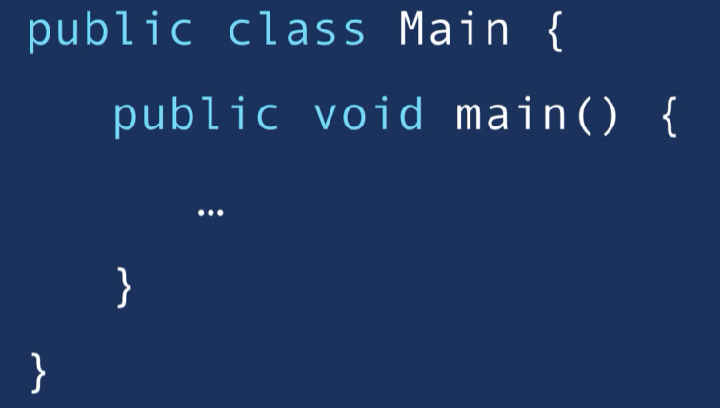

### Naming Conventions:

* Classes
  + PascalNamingConvention
* Methods
  + camelNamingConvention

## How Java Code Gets Executed

Two Steps:

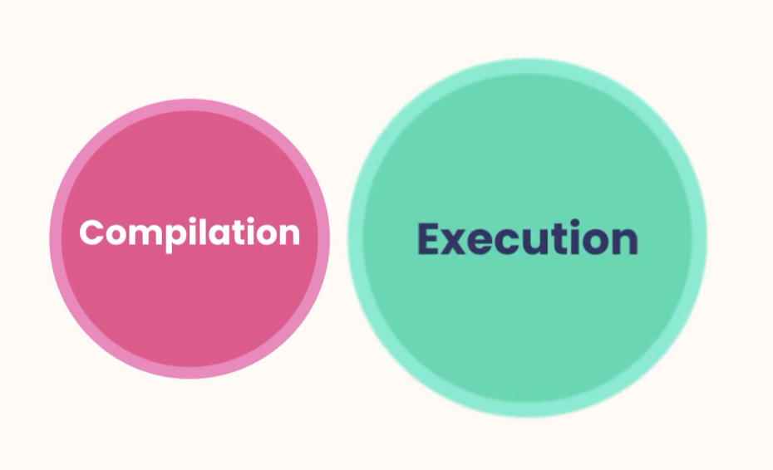

## Compilation

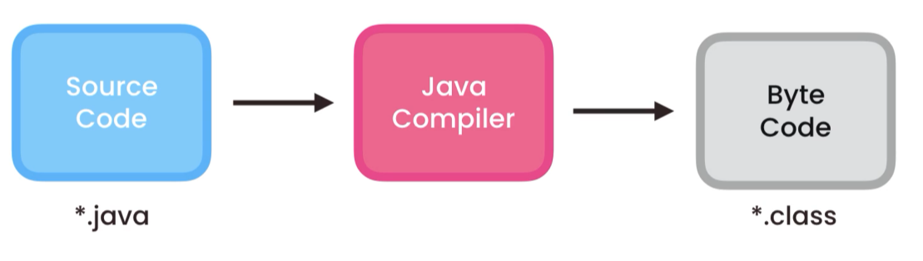

Note: Java compiler comes in the JDK

We could run in the terminal,

* right click on Main.java
* cmd javac Main.Java (javac = compiler)
* Main.class it is created – Byte Code

## Java Runtime Environment

The byte code can run in any environment Windows, Mac OS, Linux as long as it has a Java Runtime Environment JRE (Java)

The JRE has a Java Virtual Machine **JVM** that translate our byte code to the OS.

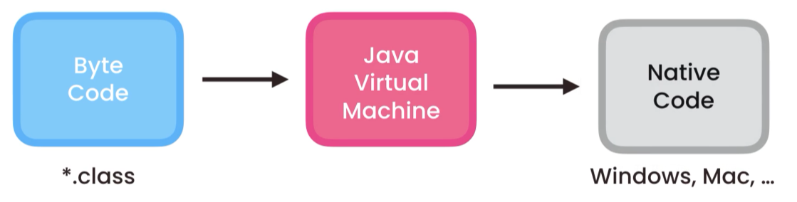

#### Invoking JVM

In terminal go to src repo after compiling

* CMD java fullPath to Our Main Class file (ByteCode)
  + Example: java ca.adrian.Main

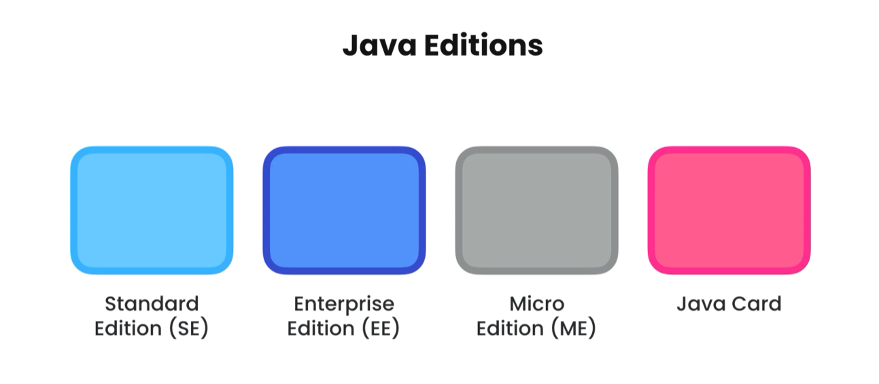

# TYPES

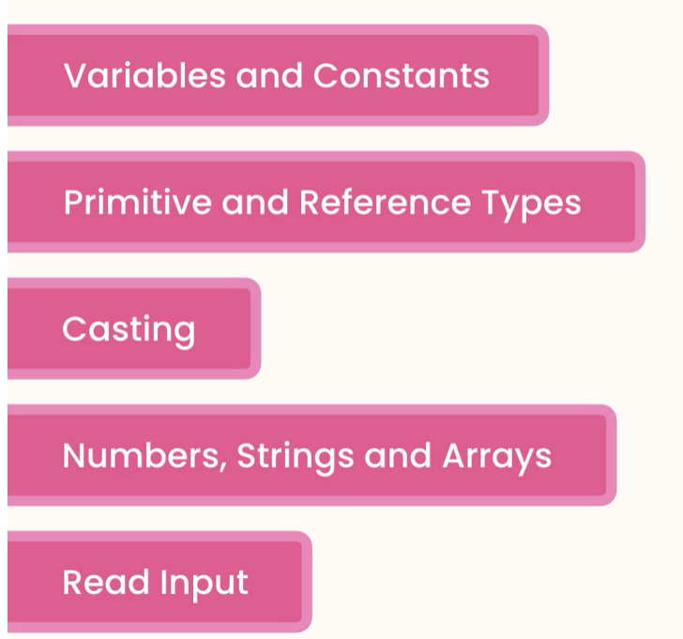

# Variables

Variables use camelConvetionNaming

### Table Description automatically generatedPrimitive Types

Examples Declaration and Initialization:

byte age = 38;

long viewsCount = 3_123_456_789L;

float price = 10.99F;

char letter = 'A';

boolean isEligible = true;

## Reference Types

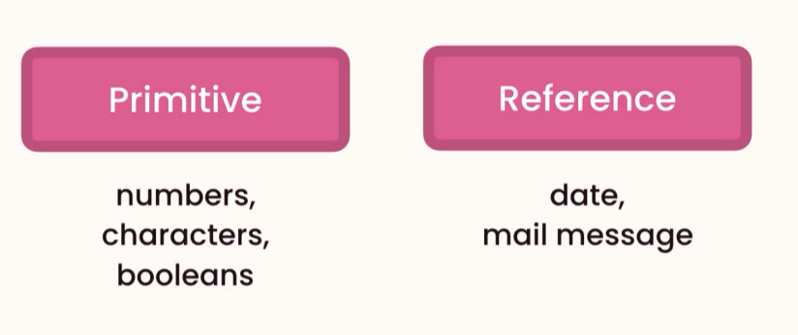

*// Reference Type*Date now = new Date(); // instance of Date class  
System.*out*.println(now);

new allocates memory for the new object

### Primitive vs Reference Types

**Memory Management**

**Primitive Type**: Are completely independent from each other since they have different memory locations

int x = 1;  
int y = x;  
x = 5;  
System.*out*.println(y);

output: 1

Primitive types are copied by their values.

#### **Reference Type:** Are dependent of each since they are referring the same object by memory location address

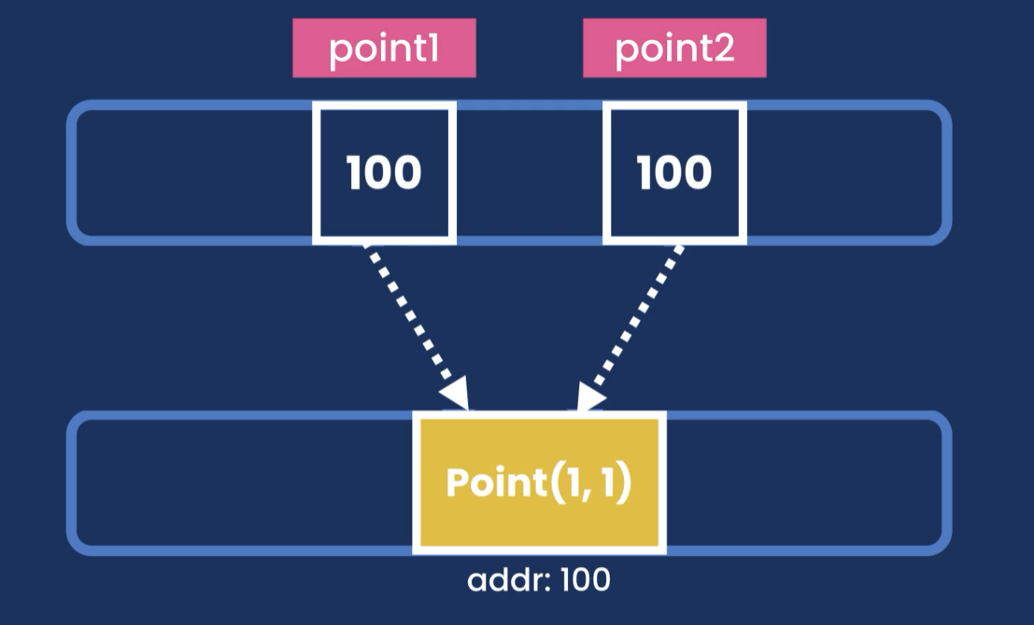

Point point1 = new Point(1,1);  
Point point2 = point1;  
point1.x = 2;  
System.*out*.println(point2);

output: 2

Reference types are copy by their references (Address in the heap memory)

## Strings

String are immutable, cannot be changed.

All methods that modify a string will return a new String object.

String message = "Hello World" + "!!";  
String message2 = message.replace('!', '?');

System.*out*.println(message2); -> Hello World??  
System.*out*.println(message); -> Hello World!!

## Scape Sequences

\” -> “

String message = "Hello \"Adrian\"";

Hello “Adrian”

\\ -> \String path = "C:\\Users\\adria\\OneDrive\\Documents";  
System.*out*.println(path);

C:\Users\adria\OneDrive\Documents

\n -> newline

\t -> Tab

## Arra ys

Arrays are reference types, so we need to use new keyword to allocate memory in the heap

Declaring and initializing an array using

**Old syntax**

int[] numbers = new int[5];

We can access each individual item by index  
numbers[0] = 1;  
numbers[1] = 2;

System.*out*.println(Arrays.*toString*(numbers));

Output: [1, 2, 0, 0, 0]

**New syntax**

int[] numbers = {2, 3, 5 , 1, 4};

System.*out*.println(numbers.length);

Numbers of items in a array: 5

In Java arrays have a fixed size, once created we can not add or remove.

**FIX LENGTH**

### Multi dimensional arrays MATRIX

We use Arrays. deepToString(array) -> to print multidimensional arrays

Each row is an array itself

**Old syntax**int[][] numbers = new int[2][3]; *// 2 rows and 3 columns*numbers[0][0] = 1;  
System.*out*.println(Arrays.*deepToString*(numbers));

output: [[1, 0, 0], [0, 0, 0]]

-----------------------------------------------------------------------------

**New syntax**

int [][] numbers2 = {{1,2,3},{4,5,6}};  
System.*out*.println(Arrays.*deepToString*(numbers2));

output: [[1, 2, 3], [4, 5, 6]]

## Constants

We use the keyword: final

final float PI = 3.14F;

The values of a constant cannot be changed in another part of the code.

## Arithmetic Expressions

In Java we have the following arithmetic operations

* +, -, *, /, %

When dividing two whole numbers java will give a result of a whole number

We need to cast explicit casting to get the desired decimal result

Example:

double result = (double)10 / (double)3;  
System.*out*.println(result);

Output: 3.3333333333333335

We have increment and decrement operators

* ++
* --

We can apply the operators as post fix or prefix

Example

++x;

x++;

int x = 1;  
int y = x++;  
System.*out*.println(y);

output 1;

int x = 1;  
int y = ++x;  
System.*out*.println(y);

output : 2

##### Augment | compound operators.

* +=, -=, *=, /=

Example:

x += 2;  
System.*out*.println(x);

output: 3

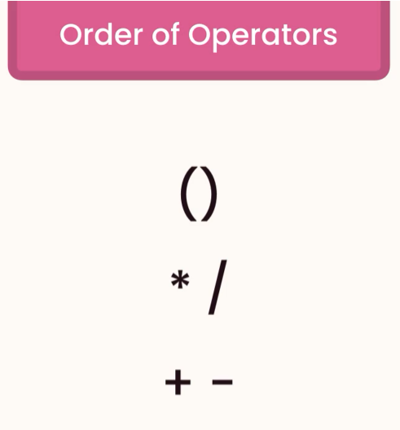

## Casting

*// Implicit Casting - automatic  
// byte > short > int > long > float > double*double x = 1.1;  
double y = x + 2; *// converts 2 > 2.0 then sum*

Output: 3.1

// Explicit casting

double x = 1.1;  
int y = (int)x + 2; *// x > int = 1*

output = 3

Implicit casting can happen only between compatible types

Examples:

All numbers (*byte > short > int > long > float > double*)

We can use Wrapper classes to parse from string to number

Integer, Float, Double, …

And use the method parse

Example:

String x = "1";  
int y = Integer.*parseInt*(x) + 2;

# The Math Class

Java.lang package

Reference: <https://docs.oracle.com/javase/8/docs/api/java/lang/Math.html>

This class is packed with static methods to use in different mathematical calculation

Example of some static methods:

int resultCeil =(int) Math.*ceil*(1.1F);  
int resultMax =(int) Math.*max*(3, 5);  
int resultRandom = (int)Math.*round*(Math.*random*()*100);

# Formatting Numbers

Class: **NumberFormat** can be used to format numbers, this class is an abstract class so we cannot instantiate it using the new keyword, instead we use get factory methods.

NumberFormat currency = NumberFormat.*getCurrencyInstance*();

java.text.NumberFormat

Example:

NumberFormat currency = NumberFormat.*getCurrencyInstance*();  
NumberFormat percentage = NumberFormat.*getPercentInstance*();  
String resultPercentage = percentage.format(234.5666);  
String resultCurrency = currency.format(123456.789);

# Reading Inputs SCANNER CLASS

Scanner scanner = new Scanner(System.*in*); *// we must specify where are reading the data from terminal | file*System.*out*.print(question);  
byte age = scanner.nextByte();  
System.*out*.println("\nYou are " + age + " years old.");

System.*out*.print("Name: ");  
String name = scanner.nextLine().trim();  
System.*out*.println("Your full name is " + name + ".");

# Project- Mortgage Calculator

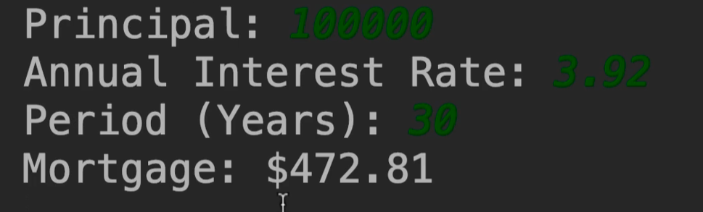 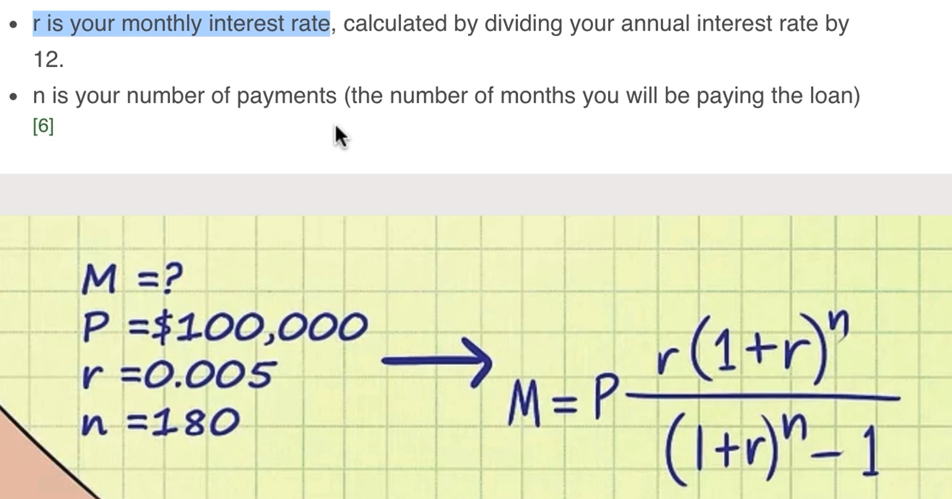

private static void getMortgagePayment() {  
 final byte MONTHS_IN_YEARS = 12;  
 final byte PERCENT = 100;  
 Scanner scanner = new Scanner(System.*in*);  
 float principal;  
 float monthlyInterestRate;  
  
 System.*out*.print("Principal: ");  
 principal = scanner.nextFloat();  
  
 System.*out*.print("Annual Interest Rate: ");  
 monthlyInterestRate = scanner.nextFloat() / PERCENT / MONTHS_IN_YEARS;  
  
 System.*out*.print("Period (Years): ");  
 byte years = scanner.nextByte();  
 int numberOfPayments = years * MONTHS_IN_YEARS;  
  
 float mortagePayment = (float) (principal  
 * (monthlyInterestRate * Math.*pow*(1 + monthlyInterestRate, numberOfPayments))  
 / (Math.*pow*(1 + monthlyInterestRate, numberOfPayments) - 1));  
  
 *// formatting number* String mortagePaymentFormatted = NumberFormat.*getCurrencyInstance*().format(mortagePayment);  
 System.*out*.println("Mortgage:" + mortagePaymentFormatted);  
  
}

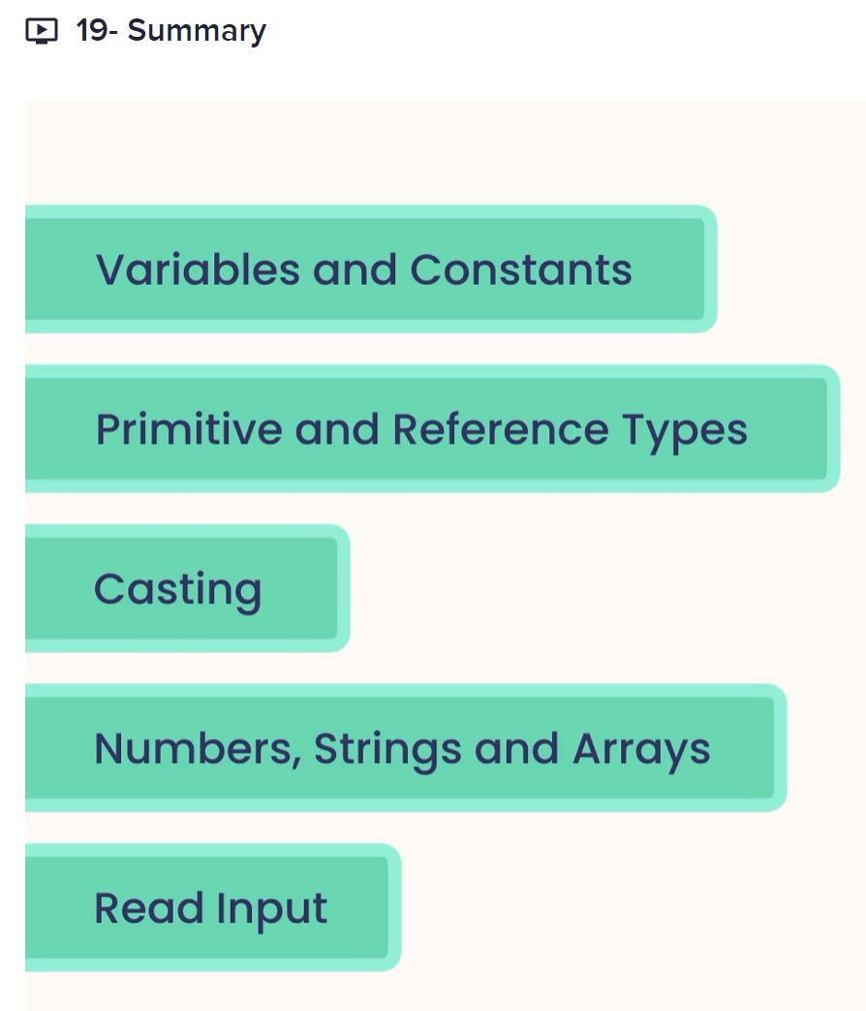

# CONTROL FLOW

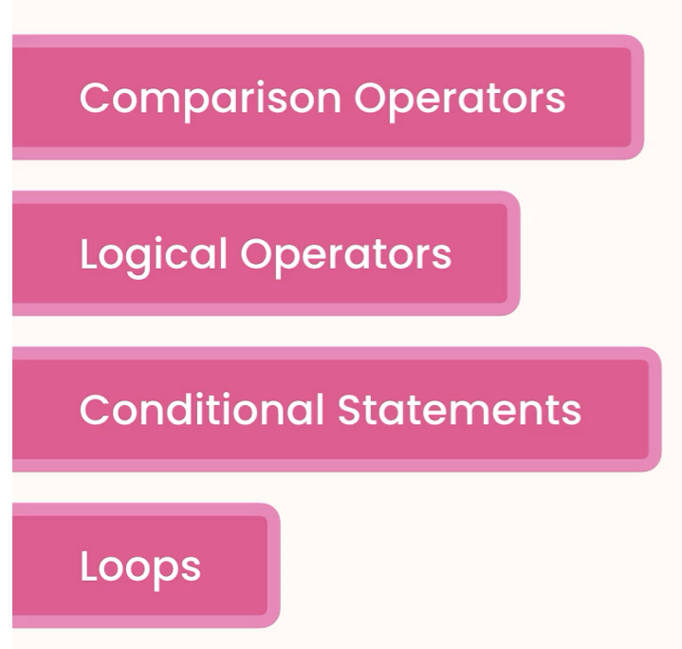

# Comparison Operators

We use comparison operators to compare primitive values.

* !=
* ==
* >
* >=
* <
* <=

# Logical Operators

* &&
* ||
* !

Example

int temperature = 22;  
boolean isWarm = temperature > 20 && temperature < 30; *// both condition must be true*System.*out*.println(isWarm);  
  
boolean hasHighIncome = true;  
boolean hasGoodCredit = true;  
boolean hasCriminalRecord = false;  
boolean isEligible = (hasHighIncome || hasGoodCredit) && !hasCriminalRecord; *// if one condition is true then returns true*System.*out*.println(isEligible);

# IF Statements

Implement using if statements the following:

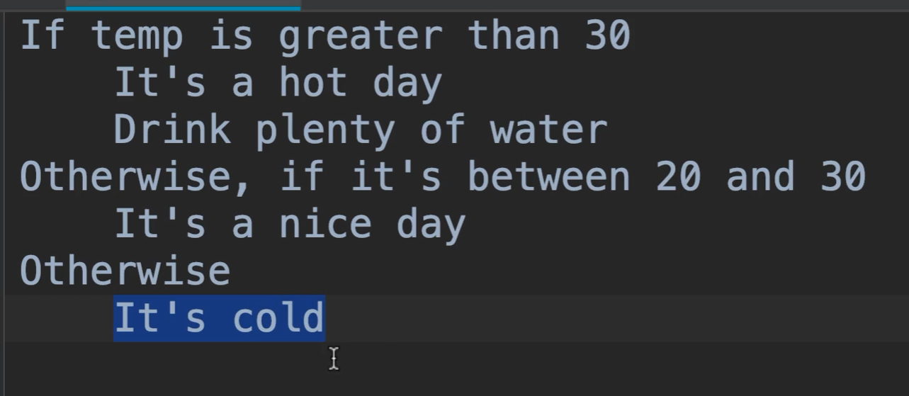

int temp = 19;  
  
if (temp > 30){  
 System.*out*.println("It is a hot day\nDrink plenty of water.");  
} else if (temp > 20 && temp < 30){  
 System.*out*.println("It is a nice day.");  
} else{  
 System.*out*.println("It is cold.");  
}

## Simplifying if statements

int income = 120_000;  
boolean hasHighIncome = (income > 100_000);

## The Ternary Operator

int income = 120_000;  
String className = income > 100_000? "First" : "Economy"; *// syntax condition? true : false;*

# Switch Statements

*// Switch Statements*String role = "admin";  
  
switch (role){  
 case "admin":  
 System.*out*.println("You are an admin.");  
 break;  
 case "moderator":  
 System.*out*.println("You are a moderator.");  
 break;  
 default:  
 System.*out*.println("You are a guest.");  
}

FizzBuzz

*/*  
 If number is divisible  
 by 5: Fizz  
 by 3: Buzz  
 by both 5 && 3: FizzBuzz  
 not divisible bye either: get the number  
 */*public static void fizzBuzz(){  
 Scanner scanner = new Scanner(System.*in*);  
  
 System.*out*.print("Number: ");  
 int number = scanner.nextInt();  
  
 if (number % 5 == 0 && number % 3 == 0)  
 System.*out*.println("FizzBuzz");  
 else if (number % 5 == 0)  
 System.*out*.println("Fizz");  
 else if (number % 3 == 0)  
 System.*out*.println("Buzz");  
 else  
 System.*out*.println(number);  
}

# For Loops

*// For Loops – used when knowing the times we will repeat the loop*for (int i = 5; i > 0; i--)  
 System.*out*.println("Hello World " + i);  
  
for (int i = 0; i < 6; i++)  
 System.*out*.println("Hello Adrian " + i);

For(counter (1) ; boolean expression (2); counter increment | decrement (4)){

… (3)

}

# While Loops

While loops are used in a situation where we do not know how many times we will repeat the loop

Example:

Scanner scanner = new Scanner(System.*in*);  
String input = "";  
int counter = 0;  
  
while (!input.equals("quit")){  
 System.*out*.println("\nType one of the following options and press ENTER");  
 System.*out*.println("1. Quit");  
 System.*out*.println("2. Print new line.");  
  
 int userRequest = scanner.nextInt();  
  
 if (userRequest < 1 || userRequest > 2){  
 System.*out*.println("Enter correct value");  
 continue;  
 }  
  
 switch (userRequest){  
 case 1:  
 System.*out*.println("Bye");  
 input = "quit";  
 break;  
 case 2:  
 counter++;  
 System.*out*.println("Hello user!!!" + counter);  
 continue;  
 }  
  
}

# Do While Loops

int i = 10;  
do {  
 System.*out*.println(i);  
 i--;  
}while (i > 0);

# Break and Continue Statement

**break** => Java ignores everything after and terminates the loop.

**continue** => goes back to start another loop.

Scanner scanner = new Scanner(System.*in*);  
String input = "";  
  
while (true){  
 System.*out*.print("Input: ");  
 input = scanner.next().toLowerCase();  
  
 if (input.equals("pass"))  
 continue;  
  
 if (input.equals("quit"))  
 break;  
  
 System.*out*.println(input);  
}

# For-Each Loop

*// For-Each Loop*String [] fruits = {"Apple", "Mango", "Orange"};  
  
for (String fruit: fruits){  
 System.*out*.println(fruit);  
}

Syntax:

For(ArrayType variableName: Array){

System.*out*.println(variableName);

}

Limitations:

* Can iterate forward only
* No access to the index

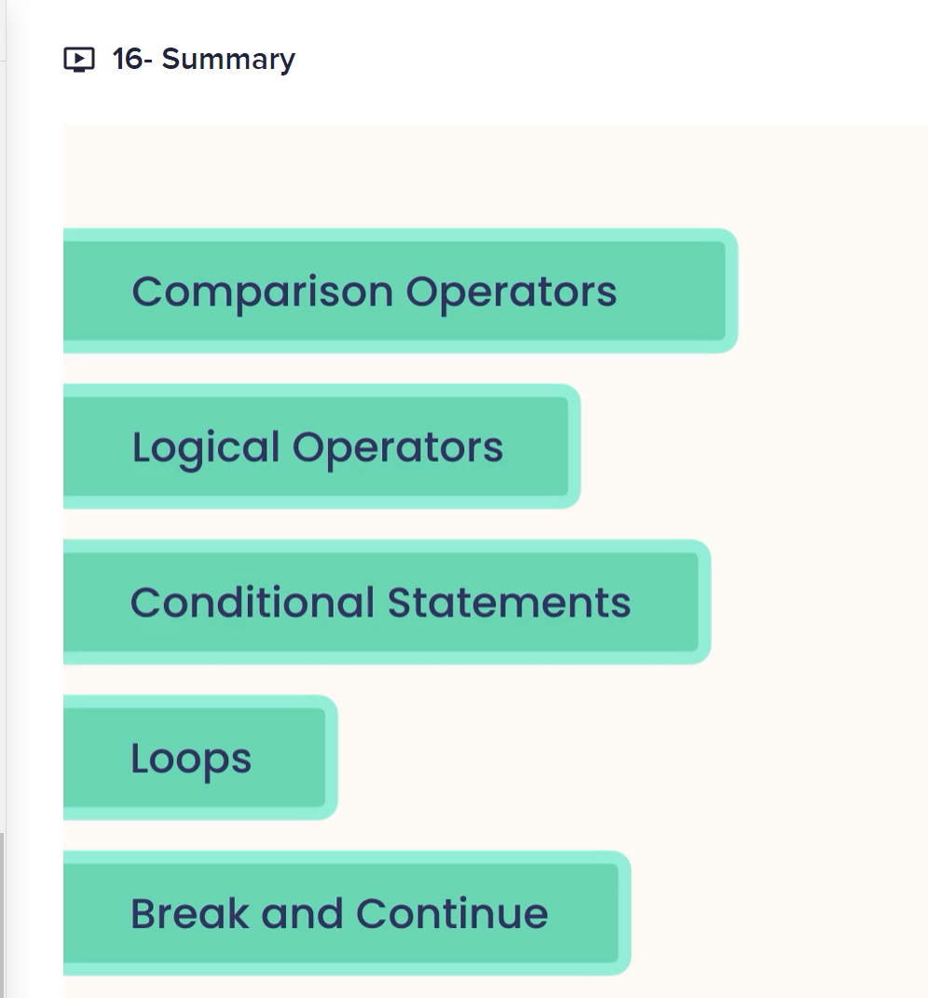

# CLEAN CODING

**Refactoring:** Changing the structure of our code without changing its behavior

**Methods:** should be 5 – 20 lines of code

**DRY** -> Don’t repeat yourself

When we are going to refactor, we should look at the lines of codes that always go together.

We extract methods whenever possible

# DEBUGGING AND DEPLOYING JAVA APPLICATIONS

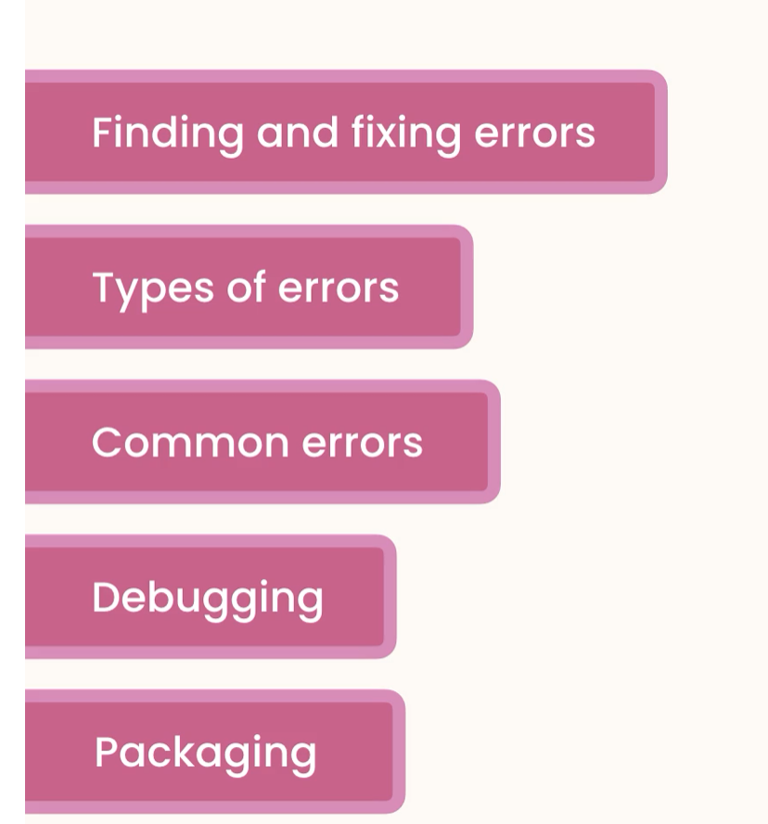

## Types of Errors

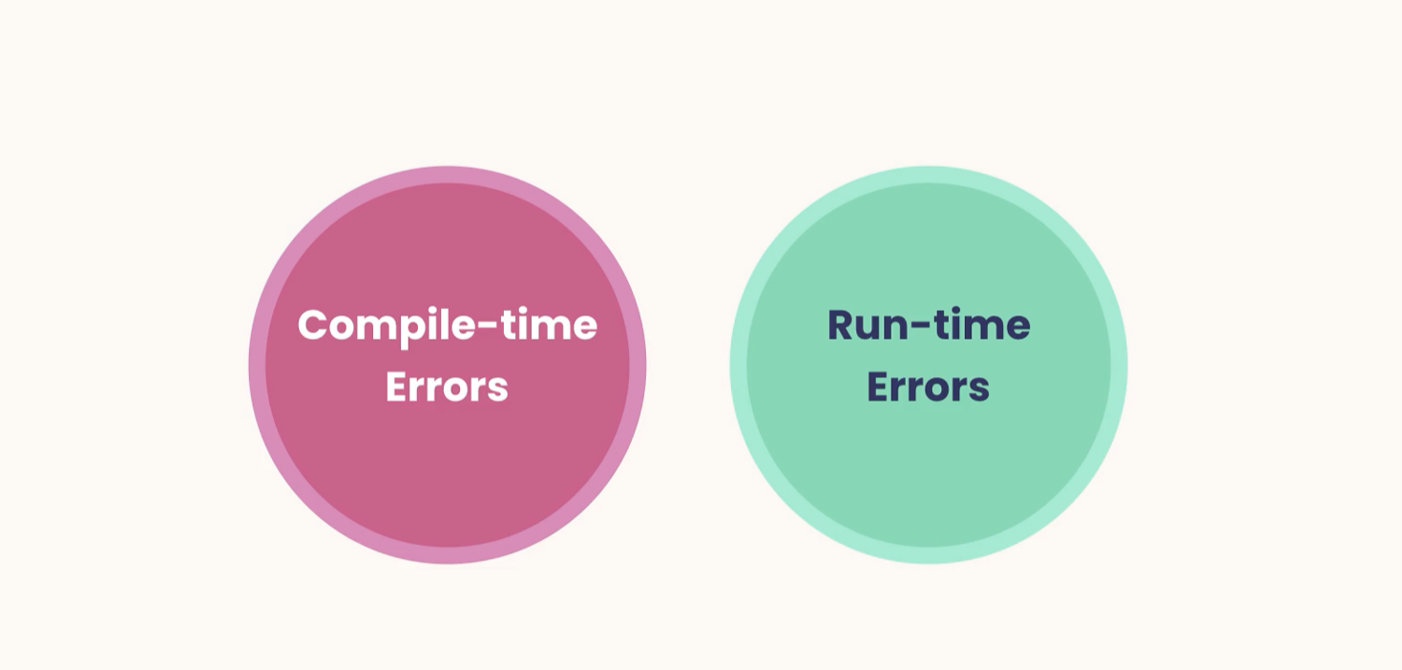

## Deploying console application

1. Package your file into JAR file
   1. Add artifact select Main class

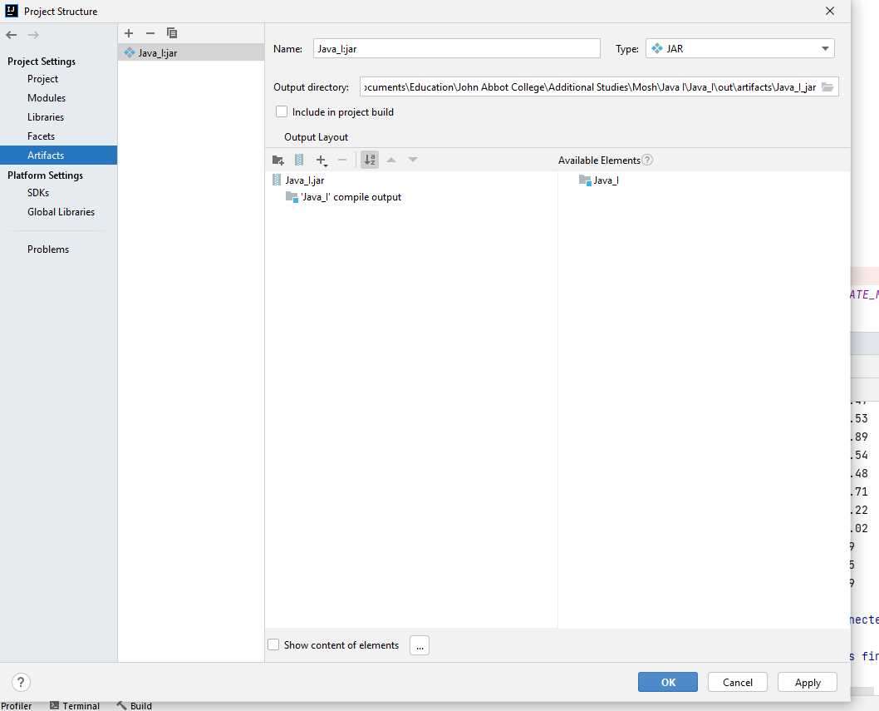

1. Build Artifact

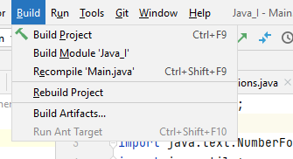

1. 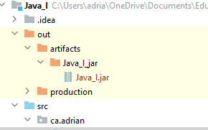

It can be run in terminal

Cmd => java -jar Java_I.jar

# GETTING STARTED

## Programming Paradigms

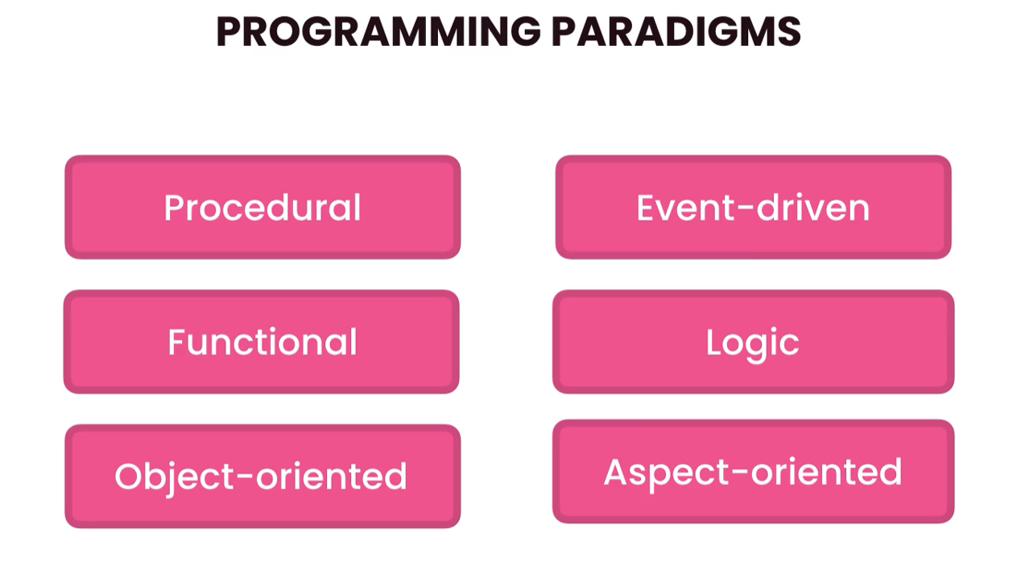

### Object Oriented Programming



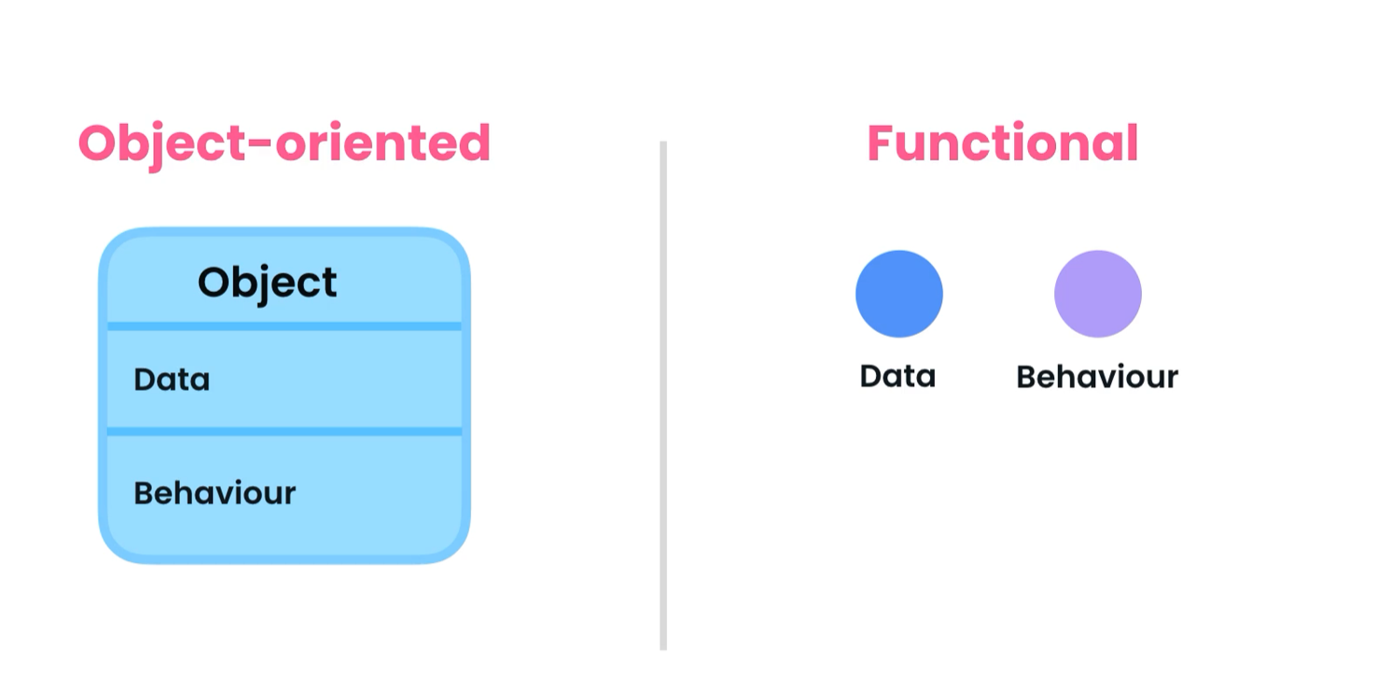

What is the best paradigm? | It depends on the problem.

Problem Solving: Process of **defining a problem**, identifying and comparing **different solutions**, and picking the one that best solves that problem with respect to the **context** and **constraints**.

## Benefits of Object-oriented Programming

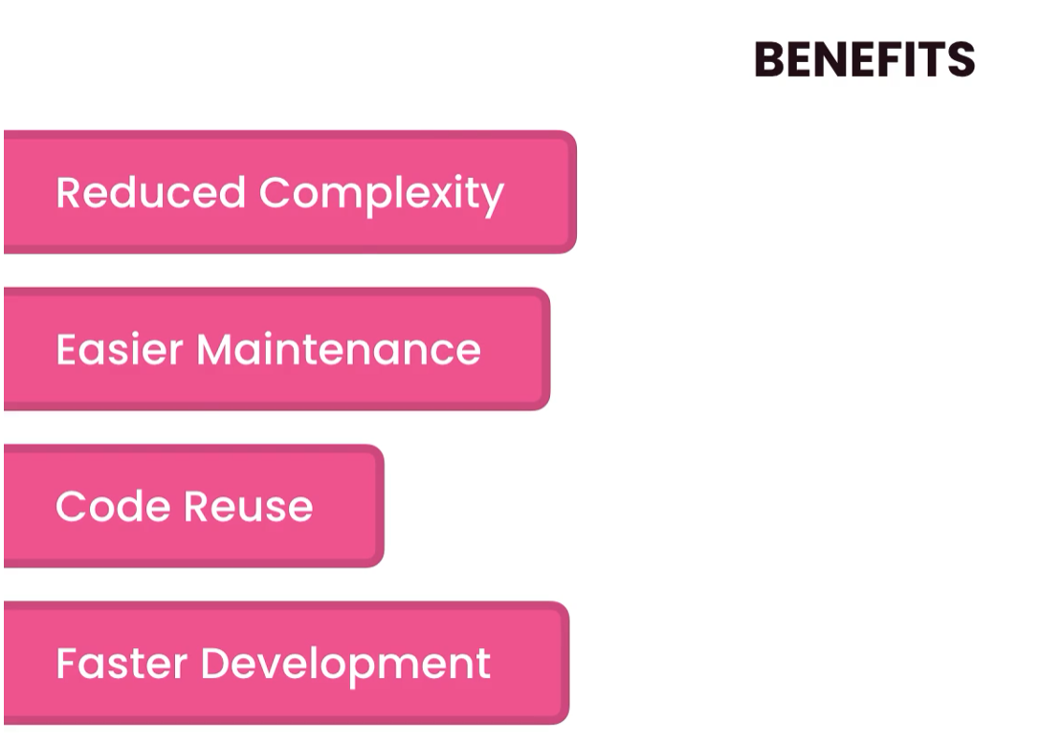

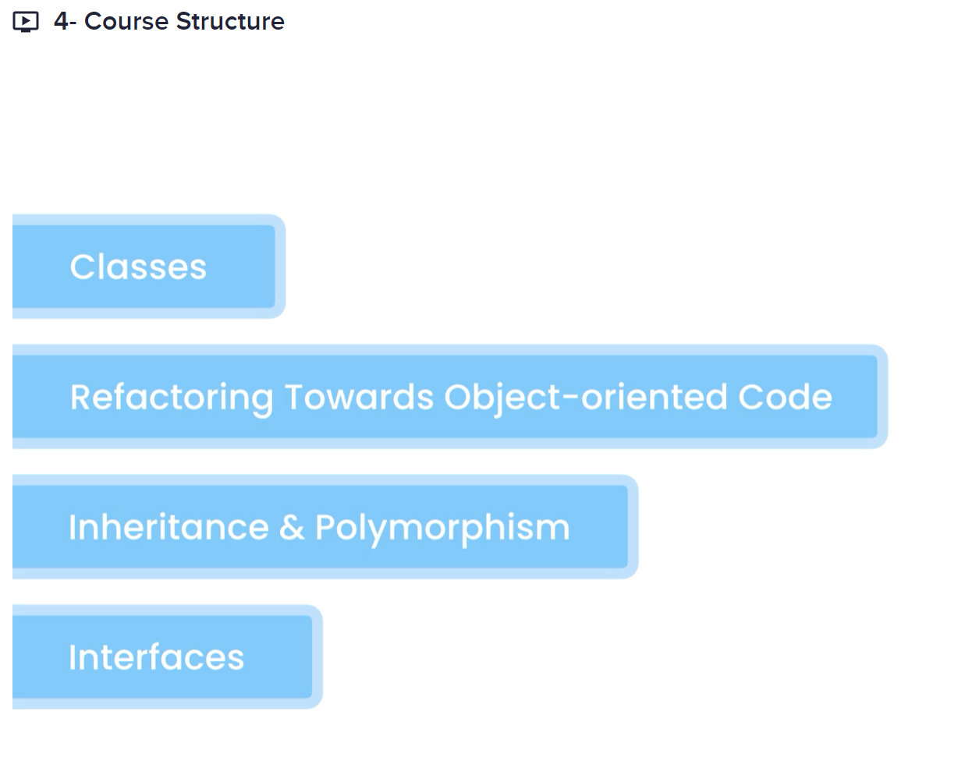

# CLASSES AND OBJECTS

Class: A blueprint for creating objects

Object: An instance of a class

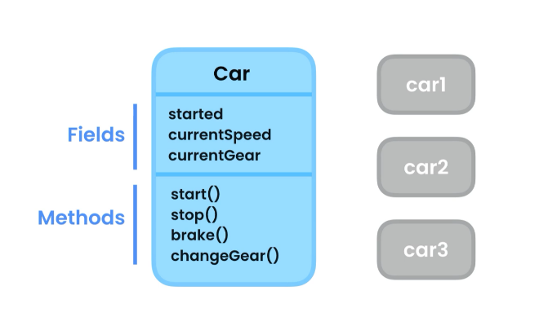 These objects *(car1, car2, car3)* are independent of

each other, each object has a different space in the

heap memory.

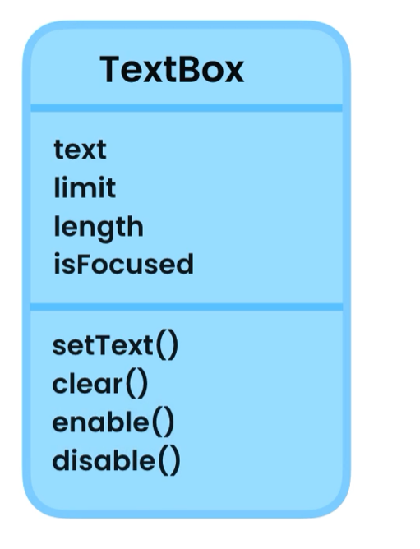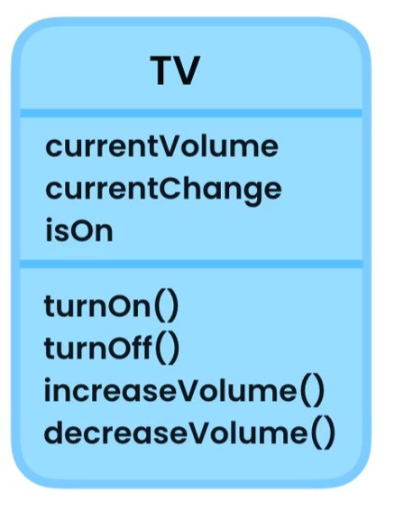

## Creating a class

Classes uses pascal naming convection **T**ext**B**ox, each letter of every word is capitalized

Syntax: public class TextBox{

}

Access modifier keyword class ClassName{}

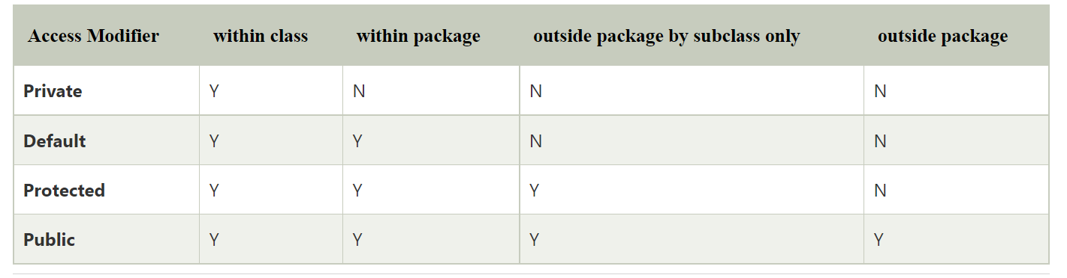

Inside the code block of the class

public class TextBox {  
 *// fields* public String text = "";  
  
 *// methods* public void setText(String text){  
 this.text = text; *// this -> this object* }  
  
 public void clear(){  
 text = "";  
 }  
}

## Initializing objects

var textBox1 = new TextBox();  
textBox1.setText("Box 1");  
System.*out*.println(textBox1.text.toUpperCase());  
  
var textBox2 = new TextBox();  
textBox2.setText("Box 2");  
System.*out*.println(textBox2.text);

OUTPUT:

BOX 1

Box 2

## Memory Allocation

Java manages two different area of the memory, the **HEAP** and **STACK** memory.

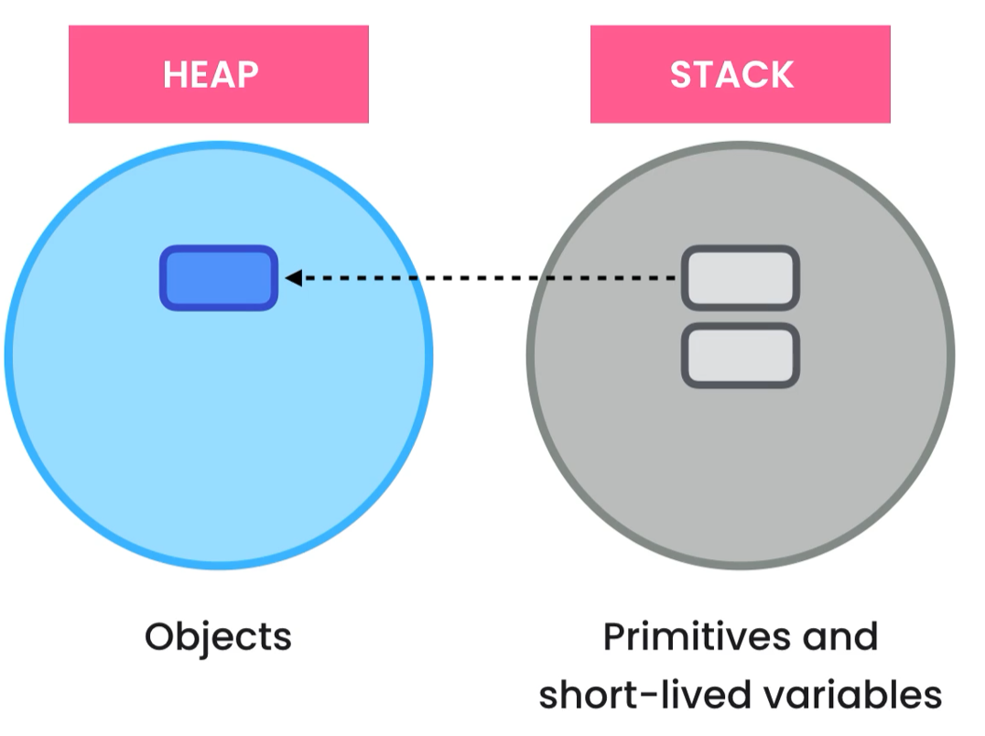

var textBox1 = new TextBox();  
textBox1.setText("Box 1");  
var textBox2 = textBox1;  
textBox2.setText("Hello World");  
System.*out*.println(textBox1.text);

Output: Hello World

Note: both variables are referring the same object in the heap, so changes will the object.

## Memory De-allocation

**Java runtime takes care of memory de-allocation**

**STACK:** Remove from the stack all variables and primitive types as soon as it reaches the end of the code block of the main method.

**HEAP:** Garbage collection will remove the object if the object is no used after a certain period.

## Encapsulation

Bundle the data and the methods that operate the data into a single unit called Class.

Use private modifier for fields so no access to them is possible, only through getters and setters

Example:

public class Employee {  
 *// fields* private int baseSalary;  
 private int hourlyRate;  
  
 *// methods* public int calculateWage(int extraHours){  
 return baseSalary + (extraHours * hourlyRate);  
 }  
  
 public void setBaseSalary(int baseSalary) throws IllegalArgumentException{  
  
 if (baseSalary <= 0)  
 throw new IllegalArgumentException("Salary must be greater than zero");  
 this.baseSalary = baseSalary;  
 }  
  
 public int getBaseSalary(){  
 return baseSalary;  
 }

## Abstraction

Reduce complexity by hiding unnecessary details in our classes.



With abstraction we hide the implementation of a class and treat it like a black box.

## Coupling

The level of dependency between classes

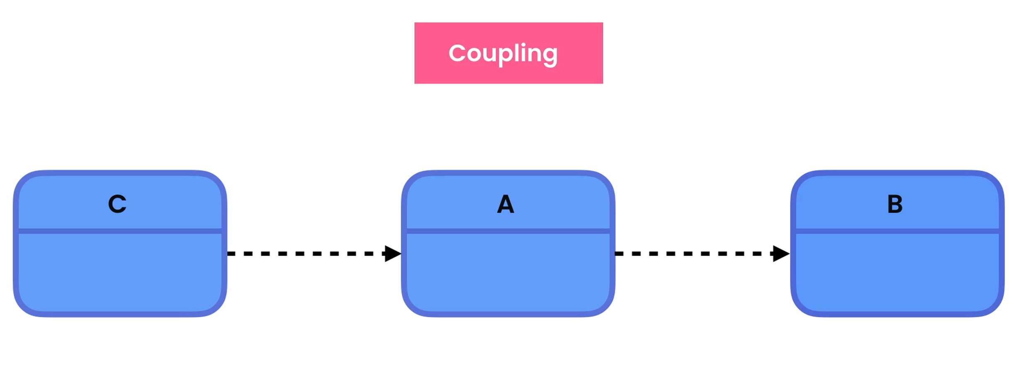

Reduction of coupling between classes whenever possible is good.

Reduce the number of methods in the class

## Reducing Coupling

A good approach to reduce coupling is to not expose methods that are only used in the class by other methods, so we declare private, and you wont access to it outside the class when making changes to the methods it won’t affect our application at all.

public class Browser {  
  
 public void navigate(String address){  
 String ip = findIpAddress(address);  
 String html = sendHttpRequest(ip);  
 System.*out*.println(html);  
 }  
  
 private String sendHttpRequest(String ip) {  
 return "<html>" +  
 "<h1>Hello Adrian</h1>" +  
 "</html>";  
 }  
  
 private String findIpAddress(String address) {  
 return "127.0.0.1";  
 }  
}

## Constructors

We use constructors to initialize our objects. If we do not create one, Java complier will create a default constructor and initialize our fields to default value:

* objects = null
* numbers = 0
* boolean = false

use abstraction as much as possible

*// constructors*public Employee(int baseSalary, int hourlyRate){  
 setBaseSalary(hourlyRate);  
 setHourlyRate(hourlyRate);  
}

We make our setter private, so no details are available outside this class.

## Method Overloading

It is when we need different implementation of the same methods with different parameters

Example:

public int calculateWage(int extraHours){  
 return baseSalary + (extraHours * hourlyRate);  
}  
  
public int calculateWage(){  
 return calculateWage(0);  
}

Constructor Overloading

*// constructors*public Employee(int baseSalary){  
 this(baseSalary, 0); *// calling the second constructor*}  
  
public Employee(int baseSalary, int hourlyRate){  
 setBaseSalary(baseSalary);  
 setHourlyRate(hourlyRate);  
}

To call a constructor from another constructor we use:

**this(arg1, arg2,…)**

Static Members

A class have two types of members:

* instance
  + belongs to instances of the class (objects)
    - employee.getName()
* static
  + belongs to the class not the object
    - Employee.numberOfEmployee;

We use static members when we want to represent a concept that will be in a single place (Class), a value is independent of objects

IMPORTANT: static methods can only call other static methods, the only way to have access is by creating an object to access it, since instance methods belongs to the object (instances of the class).

# REFRACTORING TO AN OBJECT-ORIENTED DESIGN

## The Problem

Analyse the problem and associated fields and methods, move them in classes separating the concern of each class, base on the concern separate classes.

Classes

* Console
* MortgageReport
* MortgageCalculator

# INHERITANCE

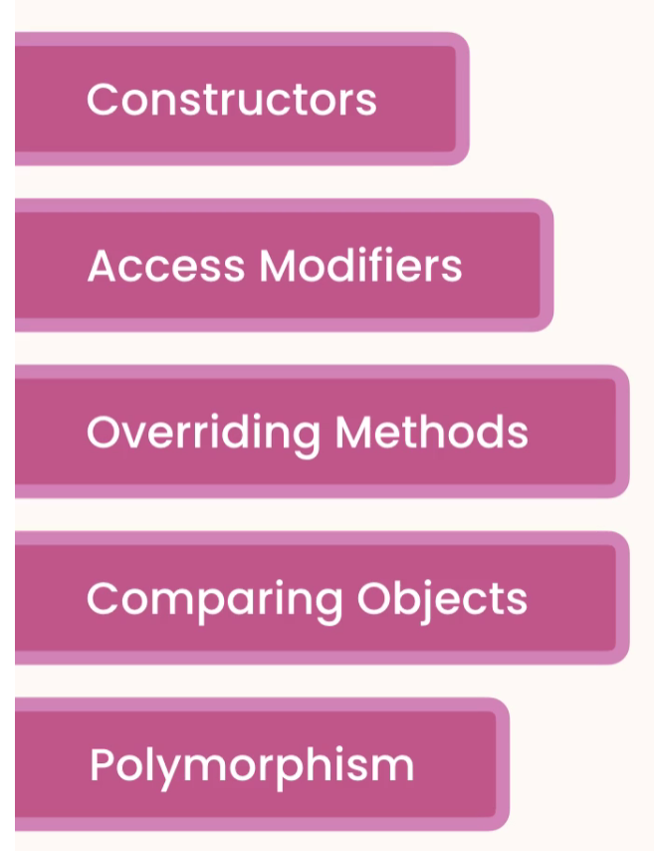

## Inheritance

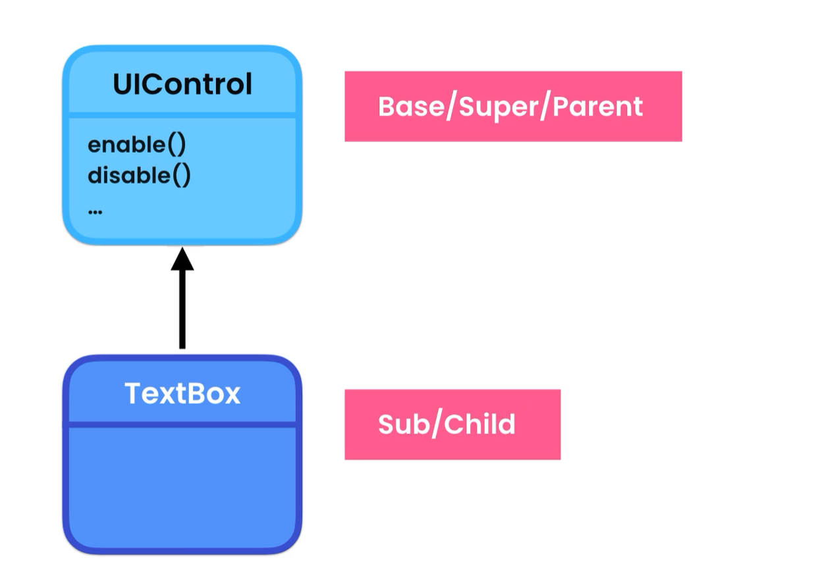

Inheritance is used for code reusability, when object share the same attributes, we declare de parent class and extend it in subclasses.

* We then have access to all data members of the parent class plus the subclass using extends

## The Object Class

Every class that we declare in Java directly or indirectly inherits from the Object Class, the java compiler does it automatically for us.

hashCode() -> integer calculated based on the address of the object in the heap memory

the equals() compare objects by hashCode

var box1 = new TextBox();  
System.*out*.println("box1 hashCode: " + box1.hashCode());  
var box2 = box1;  
System.*out*.println("box2 hashCode: " + box2.hashCode());  
System.*out*.println(box1.equals(box2)); //

--------------------------------------------------

Output:

box1 hashCode: 455659002

box2 hashCode: 455659002

true

--------------------------------------------------

Sometimes we want to compare the objects based on the attribute’s values and NOT the hashCode

### toString()

### -> string representation of an object which has two parts

[ca.adrian.TextBox@1b28cdfa](mailto:ca.adrian.TextBox@1b28cdfa)

1. ca.adrian.TextBox: fully qualify name of the object
2. @1b28cdfa: hashCode in hexadecimal

## Constructors and Inheritance

When creating a constructor in a subclass, we must call the parent constructor and pass the required arguments if any, the super() must be the first line in the subclass constructor.

public UIControl(boolean isEnabled) {  
 this.isEnabled = isEnabled;  
 System.*out*.println("UIControl");  
}

…

public class TextBox extends UIControl{  
 *// fields* private String text = "";  
  
 public TextBox() {  
 super(true);  
 System.*out*.println("TextBox");  
 }

## Access Modifiers

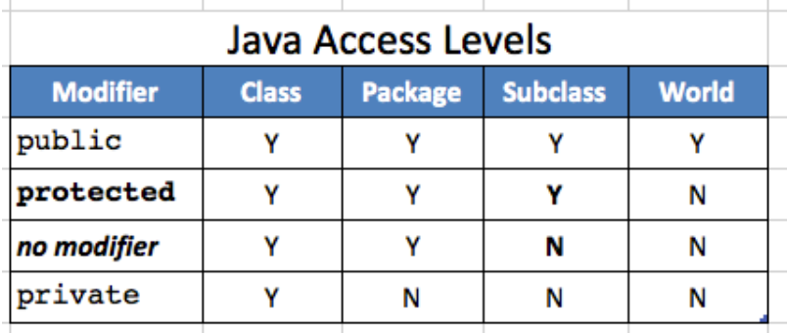

Protected and default is a bit of a code smell, not good practice to use it, better to stick to private and public access modifiers.

## Overriding Methods

When we change the implementation of a method. Example toString() we use the @Overrride annotation to give extra info to the compiler this way we will print the value of our object and not the string representation of the object -> ca.adrian.TextBox@1b28cdfa.

@Override *// annotation that gives the java compiler extra information*public String toString() {  
 return “Hola”;  
}

## Upcasting and Downcasting

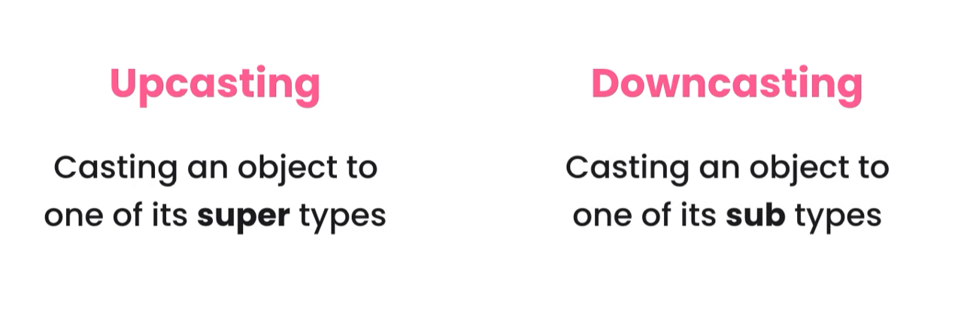

**Upcasting** -> (parent) child

**Downcasting** -> (child) parent

Inheritance represent - IS A RELATIONSHIP

public static void show(UIControl control){  
 if (control instanceof TextBox){  
 *// cast in order to have access to textBox members* var textBox = (TextBox) control;  
 textBox.setText("Hello from TextBox");  
 System.*out*.println(textBox);  
 }  
 else  
 System.*out*.println(control);  
}

## Comparing Objects

We can compare objects using the equals(), but this will compare the objects by hashCode.

To compare objects based on their data values, we can override the equals() like this:

public class Point {  
 private int x;  
 private int y;  
  
 public Point(int x, int y) {  
 this.x = x;  
 this.y = y;  
 }  
  
@Override  
public boolean equals(Object o) {  
 if (this == o) return true;  
 if (o == null || getClass() != o.getClass())  
 return false;  
 Point point = (Point) o;  
 return x == point.x && y == point.y;  
}  
  
@Override  
public int hashCode() {  
 return Objects.*hash*(x, y);  
}

}

## Polymorphism

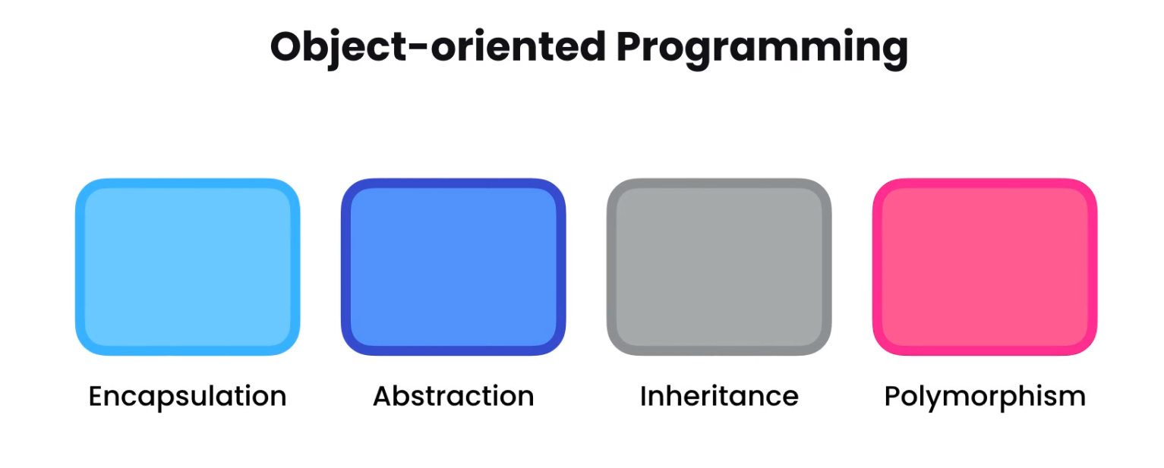



It allows an object to take many forms

Example:

// Parent Class

public class UIControl {  
 public void render(){} // declare default method no implementation

}

//Subclass-1

public class CheckBox extends UIControl{  
 @Override  
 public void render() {  
 System.*out*.println("Render CheckBox");  
 }  
}

//Subclass-2

public class TextBox extends UIControl{  
  
 @Override  
 public void render() {  
 System.*out*.println("Render TextBox");  
 }

}

MAIN:

public static void main(String[] args) {  
 UIControl[] controls = { new TextBox(), new CheckBox()};  
 for(UIControl control: controls)  
 control.render();  
}

**OUTPUT:**

**Render TextBox**

**Render CheckBox**

## Abstract Classes and Methods

**Abstract Class:** We use abstract classes when we don’t want to instantiate it but only extended.

**Abstract method:** it will force classes that extend the abstract class to implement it. The class must be abstract to have an abstract method.

Example: public abstract void render();

## Final Classes and Methods

**Final Class:** When we declare a class as final we cannot extended anymore.

**Final Method:** When a method is declared as final, we cannot override it.

Deep Inheritance Hierarchies



Inheritance is good but up to 3 level.

## Multiple Inheritance

Java does not support multiple inheritance.

**The diamond problem**

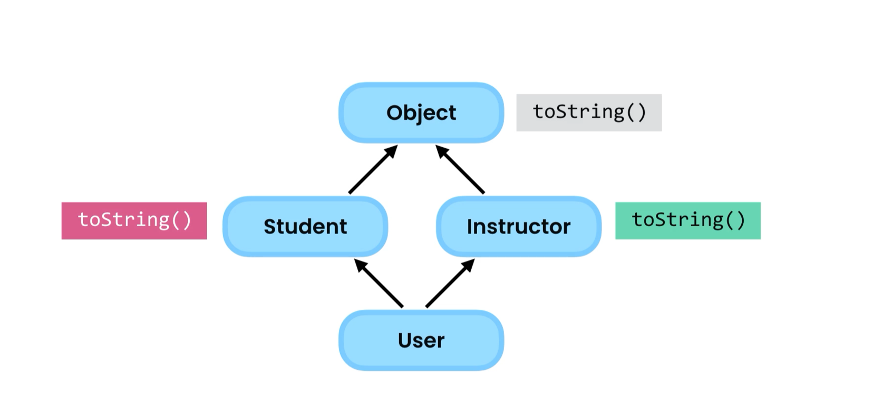

# INTERFACES

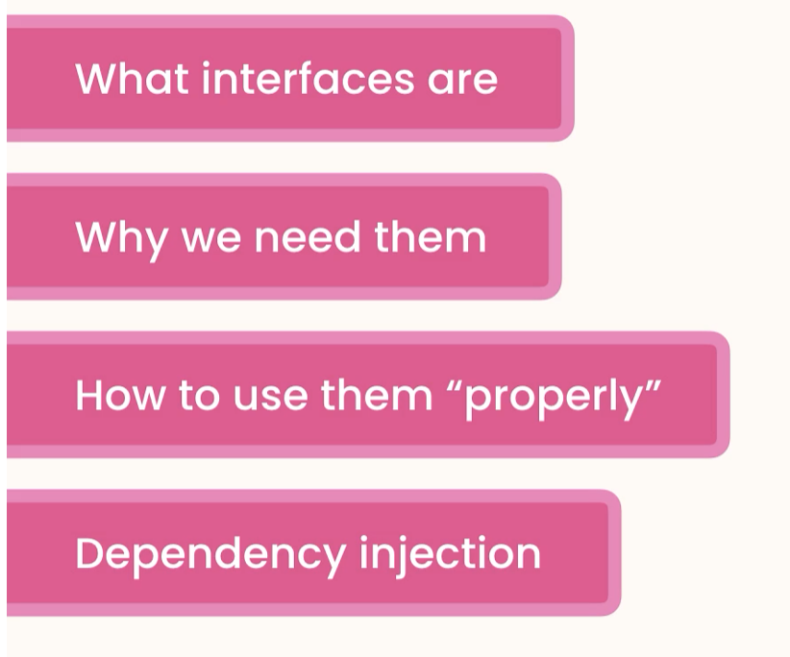

## What are interfaces?

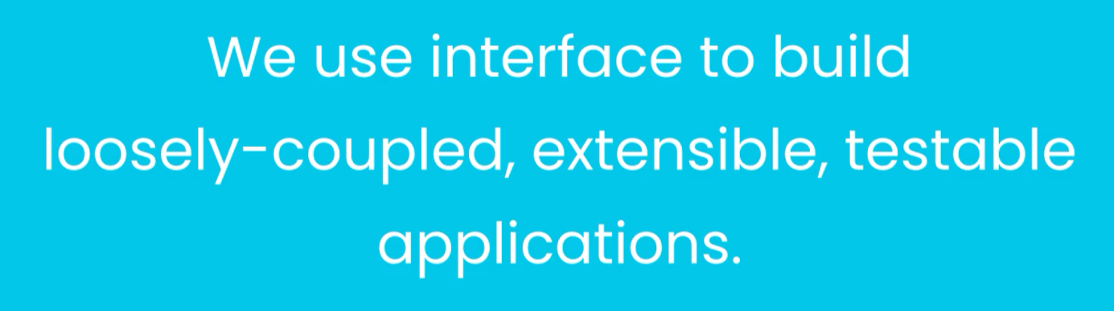

If class A used B

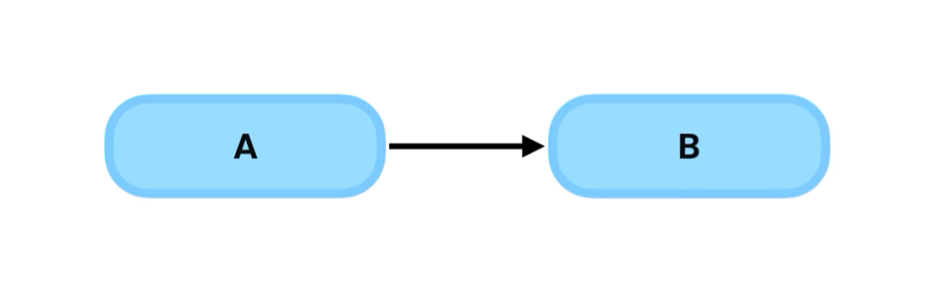

We say class A is dependent or coupled to B, if we change B we might have to change A and all the classes that depends of A.

------------------------------------------------------------------------------------------------------------------------------------------

To decouple A from B we put and interface between them, interface defines the capabilities of a class.

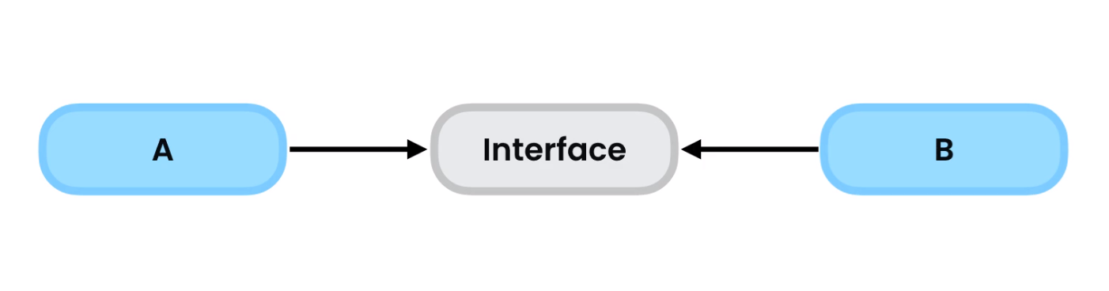

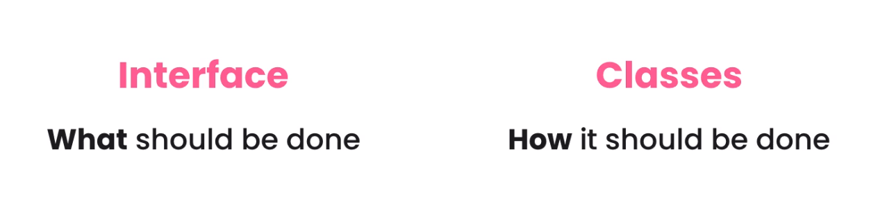

Example of tightly coupled classes:

public class TaxCalculator {  
 private double taxableIncome;  
  
 public TaxCalculator(double taxableIncome) {  
 this.taxableIncome = taxableIncome;  
 }  
  
 public double calculateTax(){  
 return taxableIncome * 0.3;  
 }  
}

public class TaxReport {  
 private TaxCalculator calculator;  
  
 *// constructor* public TaxReport(){  
 this.calculator = new TaxCalculator(100_000);  
 }  
  
 public void show(){  
 var tax = calculator.calculateTax();  
 System.*out*.println(tax);  
 }  
}

TaxReport is tightly coupled with TaxCalculator class. BAD PRACTICE, any changes made to TaxCalculator will affect TaxReport

## Creating an Interface

public interface TaxCalculator {  
 double calculateTax();  
}

---------------------------------------------------------------------------------------------------

public class TaxCalculator2018 implements TaxCalculator{  
 private double taxableIncome;  
  
 public TaxCalculator2018(double taxableIncome) {  
 this.taxableIncome = taxableIncome;  
 }  
  
 @Override  
 public double calculateTax(){  
 return taxableIncome * 0.3;  
 }  
}

## Dependency Injection



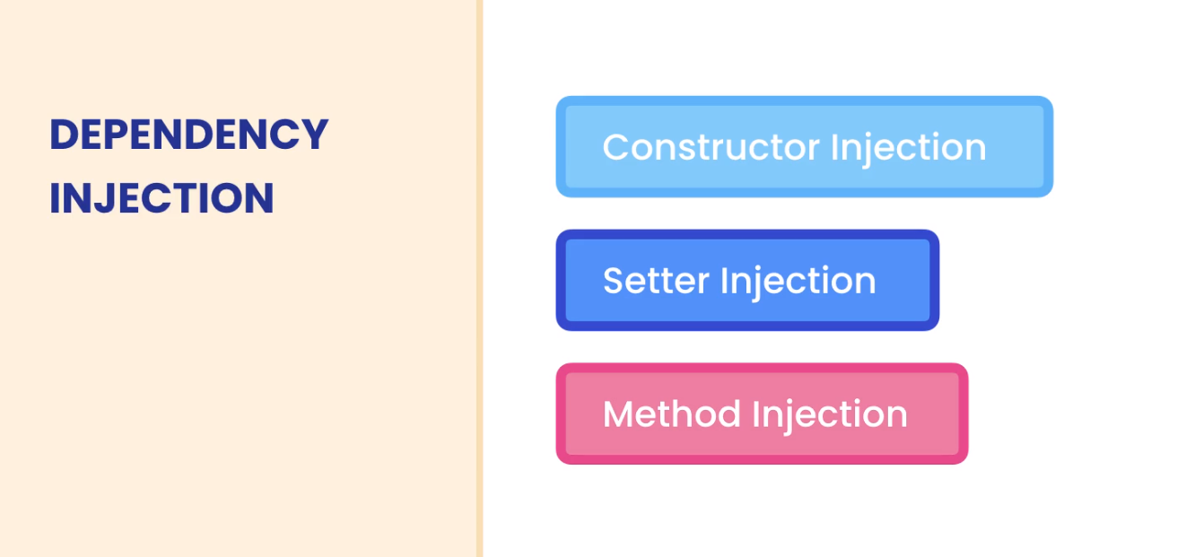



1. We create interface that defines what the class that implements it must do.

public interface TaxCalculator {  
 double calculateTax();  
}

-----------------------------------------------------------------------------

1. Make the class to implement the interface and override its methods

public class TaxCalculator2018 implements TaxCalculator{  
 private double taxableIncome;  
  
 public TaxCalculator2018(double taxableIncome) {  
 this.taxableIncome = taxableIncome;  
 }  
  
 @Override  
 public double calculateTax(){  
 return taxableIncome * 0.3;  
 }  
 }

-----------------------------------------------------------------------------

1. Inject the dependency to the class via constructor using the interface and not the class that implements it.

package ca.adrian;  
  
 public class TaxReport {  
 private TaxCalculator calculator; *// interface  
  
 // constructor, dependency injection by the constructor* public TaxReport(TaxCalculator calculator){  
 this.calculator = calculator;  
 }  
  
 public void show(){  
 var tax = calculator.calculateTax();  
 System.*out*.println(tax);  
 }  
}

-----------------------------------------------------------------------------

1. Pass the class as argument to the constructor.

public static void main(String[] args) {  
 var report = new TaxReport(new TaxCalculator2018(100_000));  
 report.show();  
}

-----------------------------------------------------------------------------



By using setter injection, we change the dependency of a class throughout the lifetime of our application.

Any other class that implements the same interface can be used for dependency

Example:

public class TaxCalculator2019 implements TaxCalculator{  
  
 @Override  
 public double calculateTax() {  
 return 0;  
 }  
 }

-----------------------------------------------------------------------------

public static void main(String[] args) {  
 var calculator2018 = new TaxCalculator2018(100_000);  
 var report = new TaxReport(calculator2018);  
 report.show();  
  
 report.setCalculator(new TaxCalculator2019());  
 report.show();  
}

Here both classes implements the same interface declared in TaxReport that has a dependency in both classes.

## Method Injection

We pass the dependency by the method as an argument

**Parameter:** Interface

**Argument:** Class that implements it

------------------------------------------------------------------------------------------------------------------------------------------

public class TaxReport {  
   
 public void show(TaxCalculator taxCalculator){  
 var tax = taxCalculator.calculateTax();  
 System.*out*.println(tax);  
 }  
   
}

TaxCalculator is an Interface

------------------------------------------------------------------------------------------------------------------------------------------

public static void main(String[] args) {  
 var calculator2018 = new TaxCalculator2018(100_000);  
 var calculator2019 = new TaxCalculator2019();  
 var report = new TaxReport();  
 report.show(calculator2018);  
 report.show(calculator2019);  
}

------------------------------------------------------------------------------------------------------------------------------------------

Must of the time we pass the dependency injection in the constructor cause we can quickly see the dependencies of a class.

## Interface Segregation Principle



By doing so we can reduce the impact of changes

Interfaces can extend multiple interfaces

Project -MyTube Video Platform

My Solution: <https://github.com/adrian3914/Mosh-Java-II/tree/main/MyTube>

------------------------------------------------------------------------------------------------------------------------------------------

## New feature of Interfaces **BAD TO USE**

## Fields

Fields declared in an interface are a constant and static, these fields will be public so no abstraction accomplished.

## Static Methods

The problem with static methods is that contains implementation -LOGIC this can change in the future and break classes that implement it.

Interfaces are about **WHAT** and no **HOW.**

We can reuse some logic if required using abstract classes and defining the access modifier as protected so the children that inherited the members can have access to it.

------------------------------------------------------------------------------------------------------------------------------------------

## Interfaces and Abstract Classes

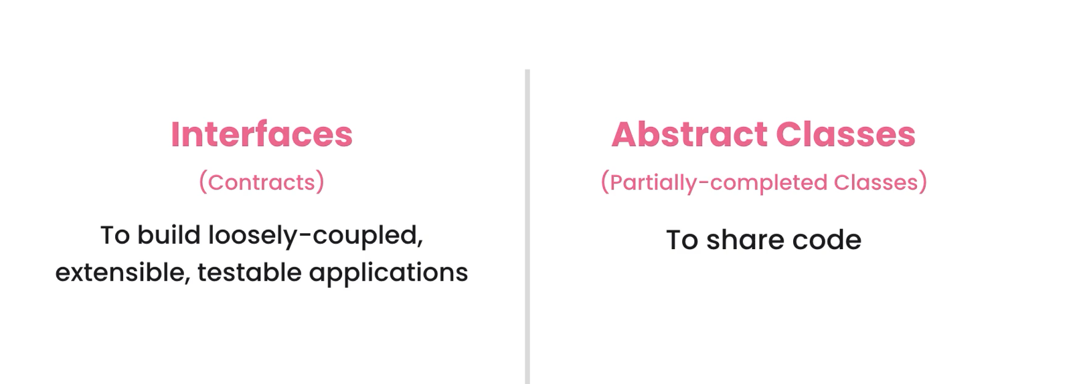

## When to use interfaces

We use interfaces when we want to de-couple class dependency

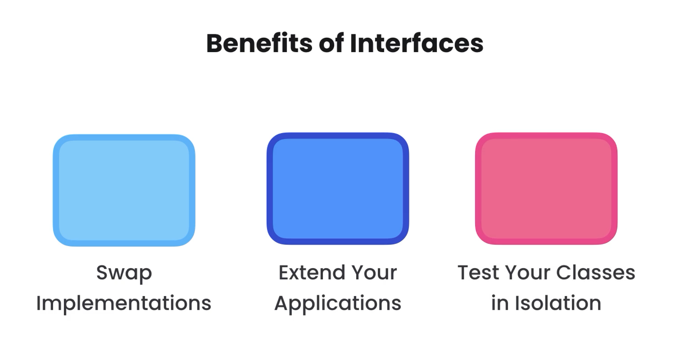

**Tightly coupled**

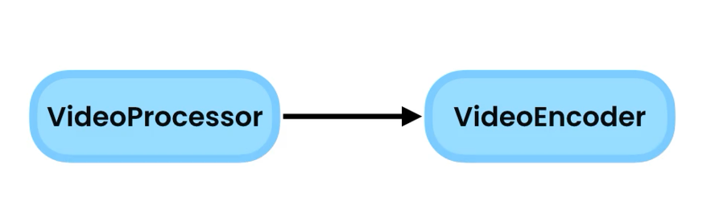

**Decoupled using an interface**

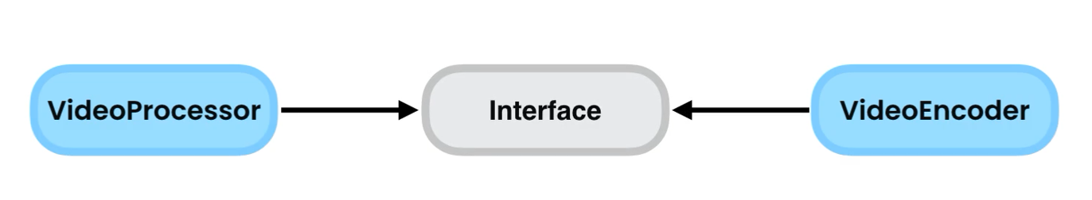

**------------------------------------------------------------------------------------------------------------------------------------------**

**Testing in isolation**

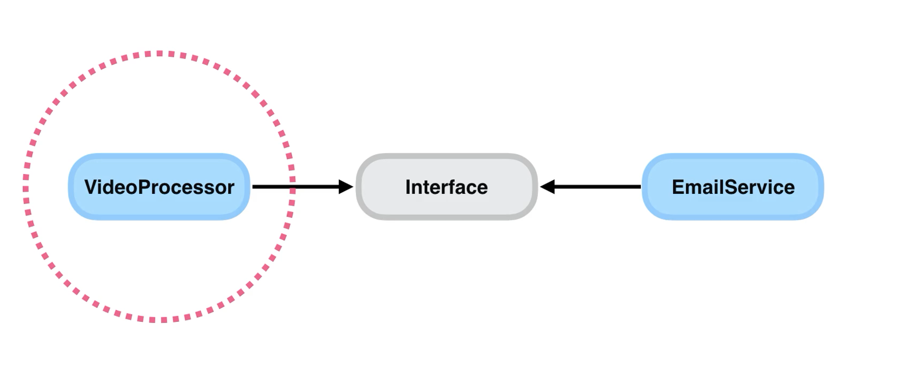

**------------------------------------------------------------------------------------------------------------------------------------------**

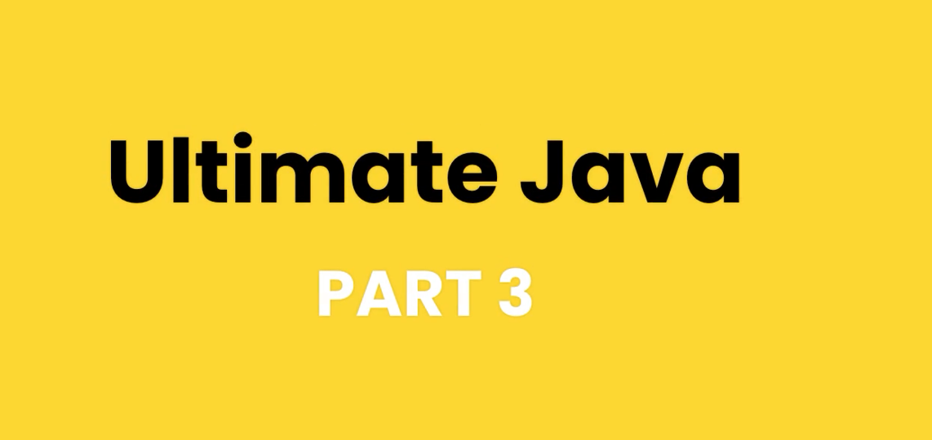

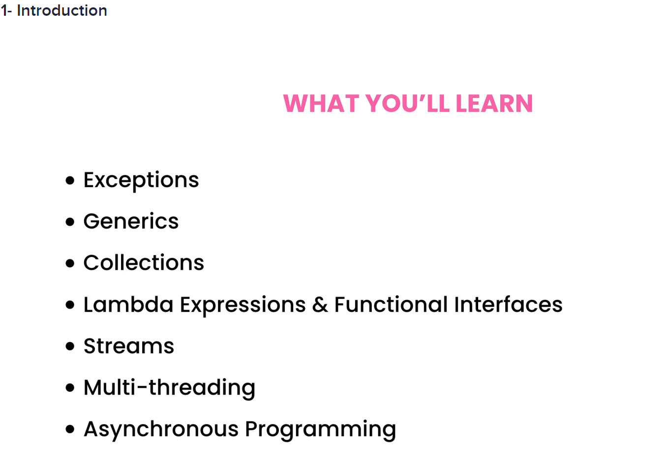



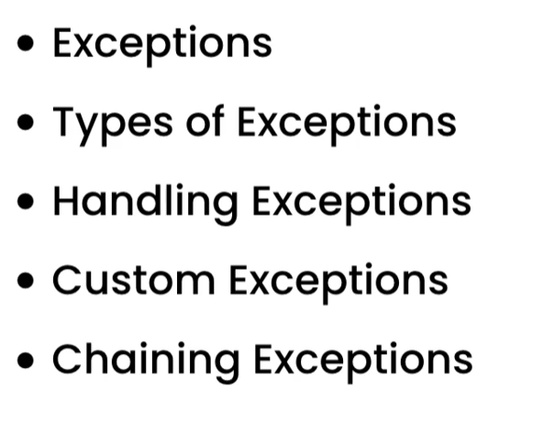

## What are Exceptions?

An exception is an object that contains information about an error.

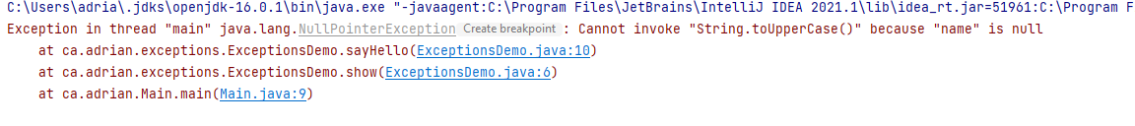

In the above example NullPointerException is the object, and below we can see the **stack trace**, methods calls.

When an exception happens in a method we say, the method threw an exception. When this happen the java runtime looks of a block of code that handles the exception. If it does not find it, it goes to the previous method.

## Types Of Exceptions

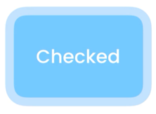

**Checked Exceptions ->** Developer should anticipate them. Java compiler checks them at compile time and advise you.

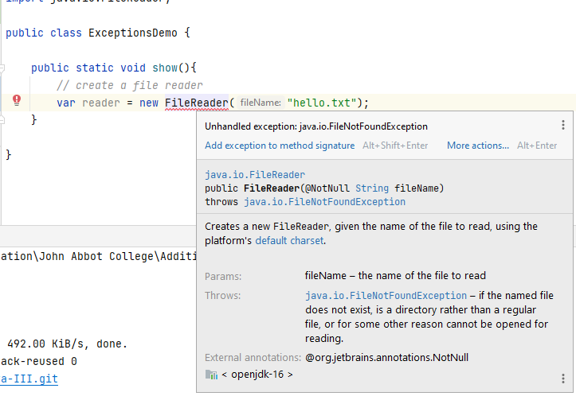

------------------------------------------------------------------------------------------------------------------------------------------



Unchecked Exceptions || Runtime exceptions -> not checked at compile time.

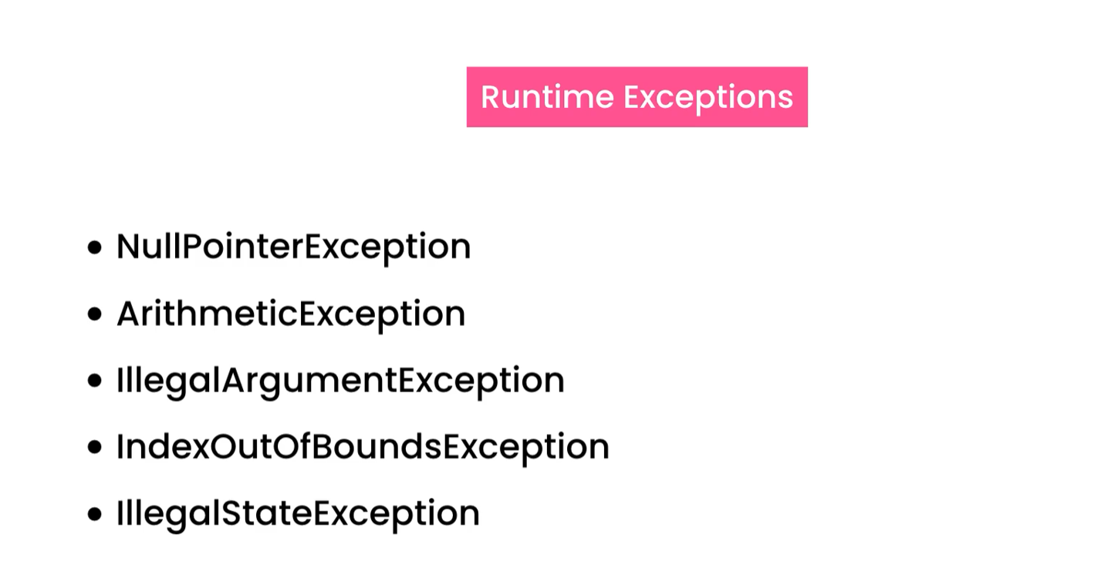

------------------------------------------------------------------------------------------------------------------------------------------

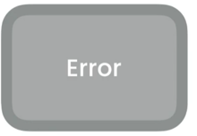

External error

* Stack overflow error
* Out of memory error

------------------------------------------------------------------------------------------------------------------------------------------

## Exceptions Hierarchy

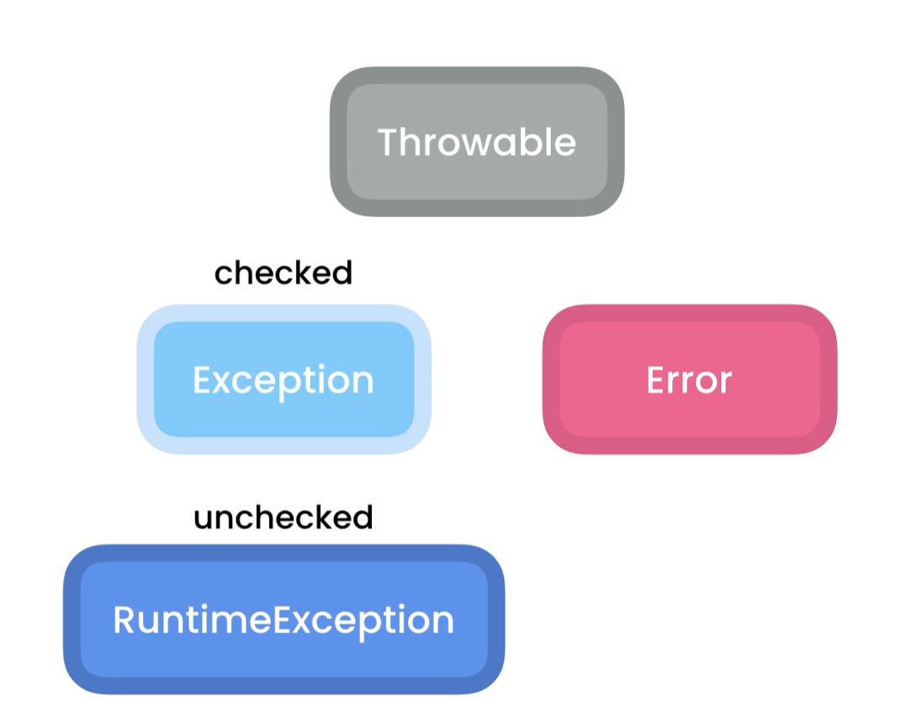

**NullPointerException hierarchy**

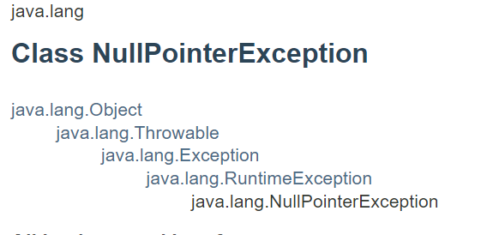

## Catching Exceptions

We use try and catch blocks

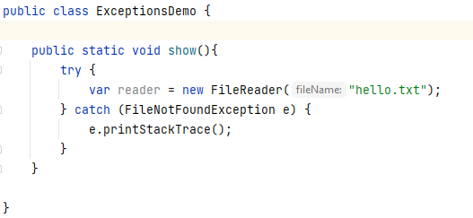

## Catching Multiple Types of Exceptions

We can:

Add multiple catch exception

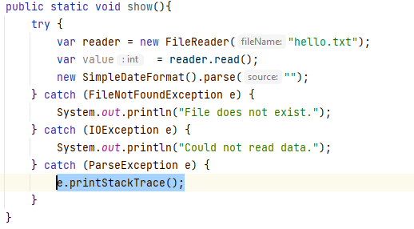

Add multiple exceptions using |

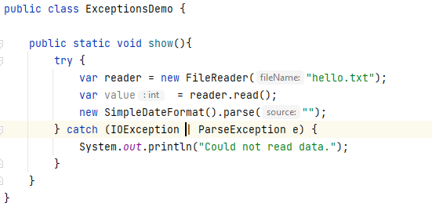

## The Finally Block

try{}

catch{}

finally{} -> this will always get executed, exception or not

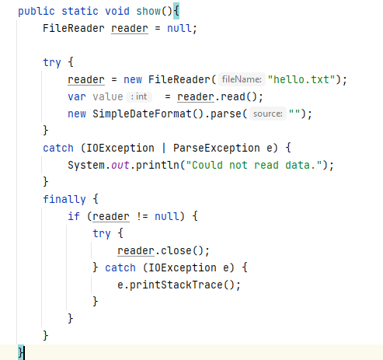

## The try-with-resources Statement

try( FileReader reader = new FileReader(“hello.txt”))

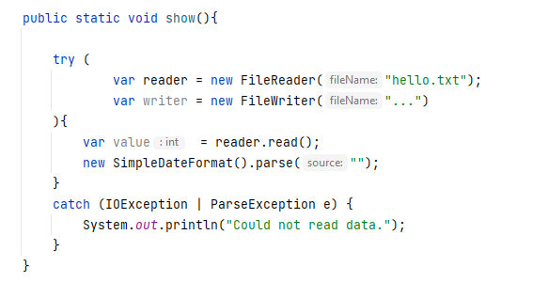

## Throwing Exceptions

Technique of throwing exceptions are called defensive programming.

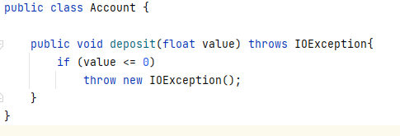

By adding throws keyword to the method signature will tell whoever calls it that this method throws an exception.

## Re-throwing Exceptions

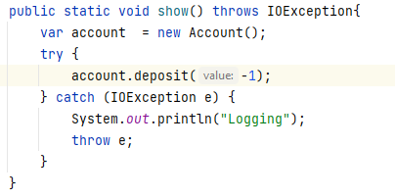

In this case we are handling an exception and re-throwing it to whoever calls this method

So we throw e and add throws to method signature

## Customs Exceptions

Sometimes we need to create customs exceptions specific to our application domain.

1. We create a class that extends Exception or RunTimeException depending on the exception type.

* Check -> Exception
* Unchecked (Runtime) -> RunTimeException

1. Create a constructor and call the parent constructor using keyword.

Example: **creating the custom exception**

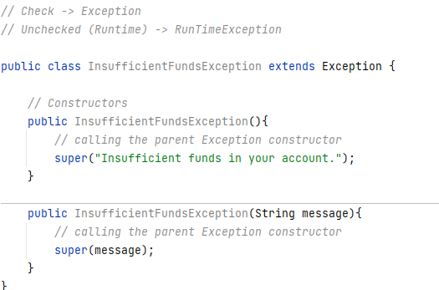

**Using our Custom Exception**

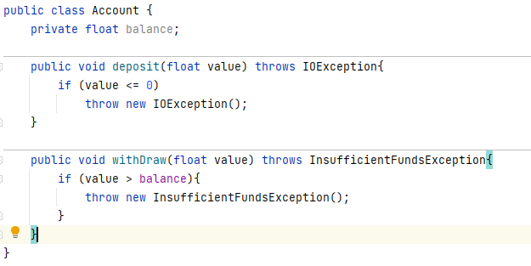

Handling the exception

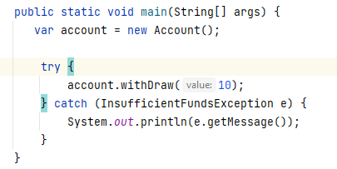

## Chaining Exceptions

We wrap an exception on another

Example:

**More Generic Exception**

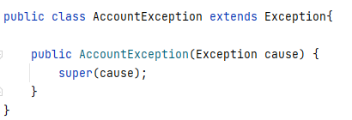

**Exception that causes it**

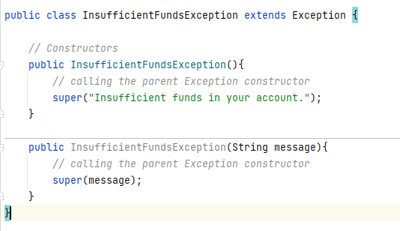

**Where Exception is thrown**

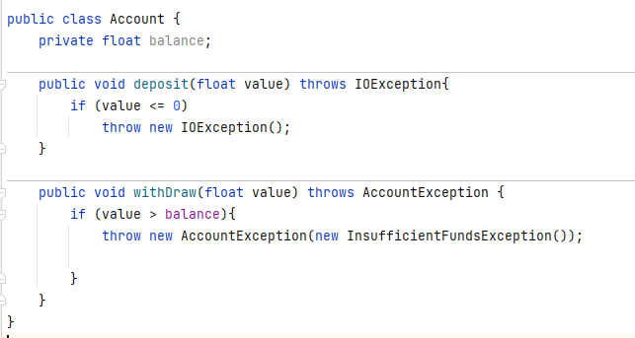

**Handling Exception**

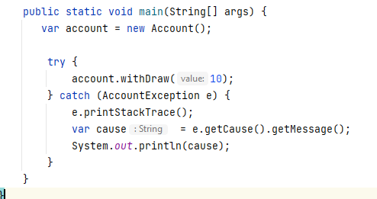

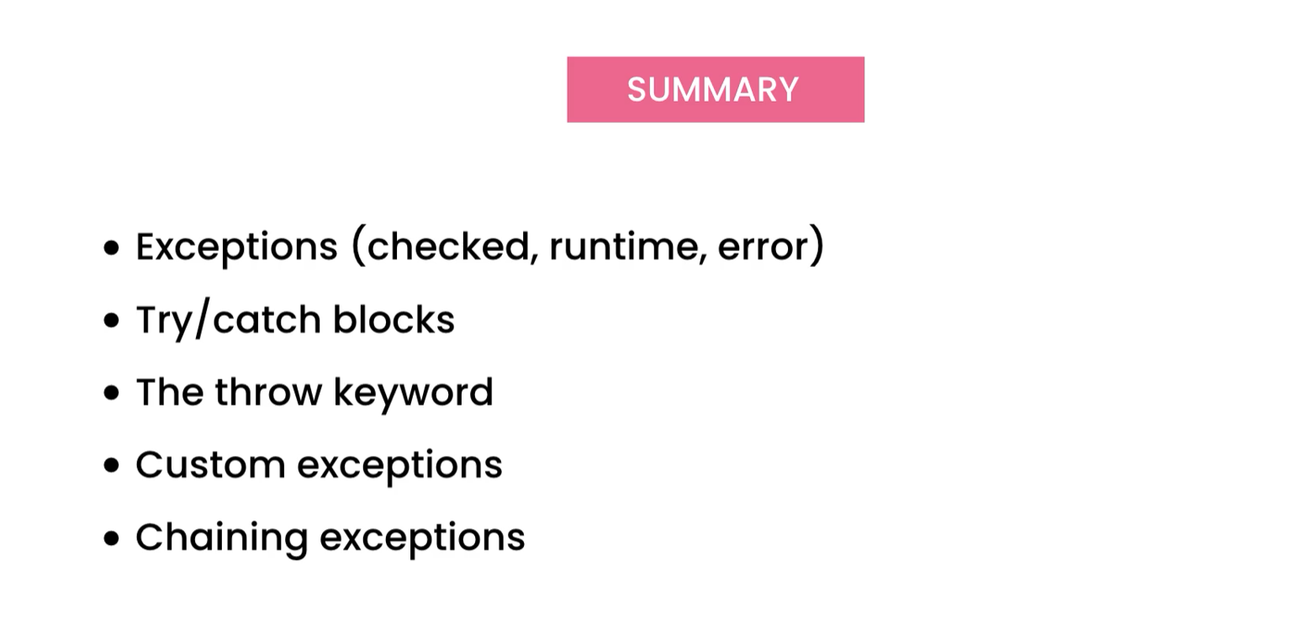



**The List Class accepts items only of type int. We want to be able to add different items type, we use generics**

------------------------------------------------------------------------------------------------------------------------------------------

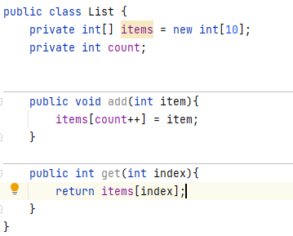

------------------------------------------------------------------------------------------------------------------------------------------

## Poor Solution

We can use Object[] since all the reference type derives from object so we can pass any data type, we can even pass primitive type and the compiler will implicit cast it to its wrapper class which is a reference type, int -> Integer, float -> Float, etc.

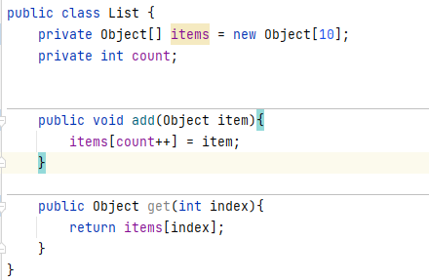

------------------------------------------------------------------------------------------------------------------------------------------

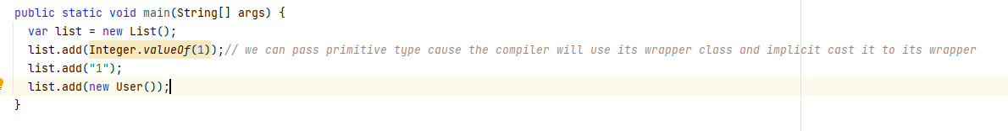

------------------------------------------------------------------------------------------------------------------------------------------

### Problems with this implementation



Exception





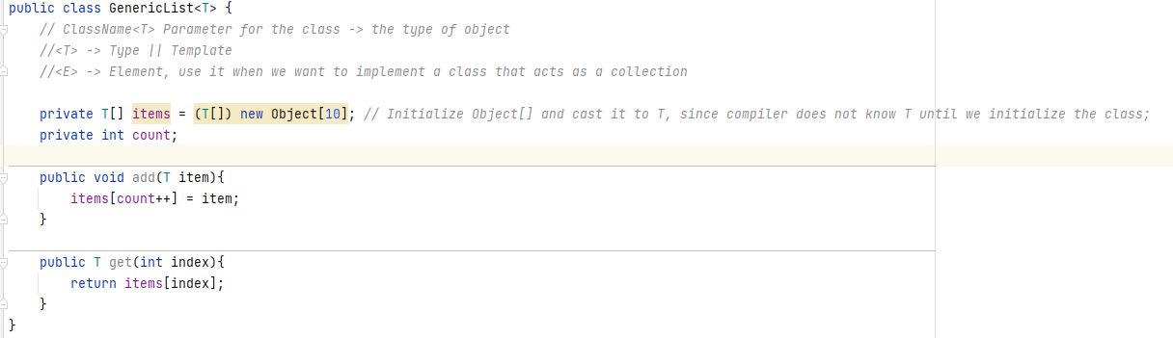

When initializing the class we pass the T-> Type

**Integer**

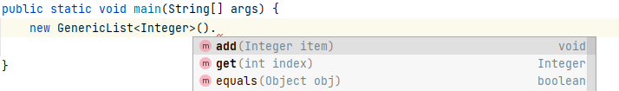

------------------------------------------------------------------------------------------------------------------------------------------

**Float**

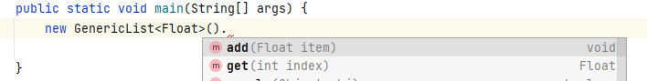

By the use of generics, we will get compile type error

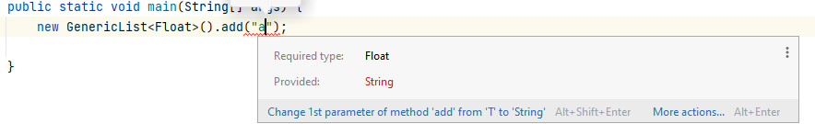

We can instantiate the class with any type

**Integer**

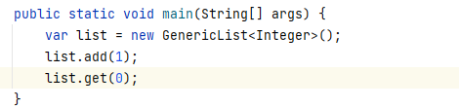

**User**

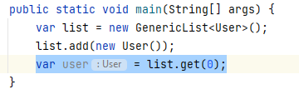



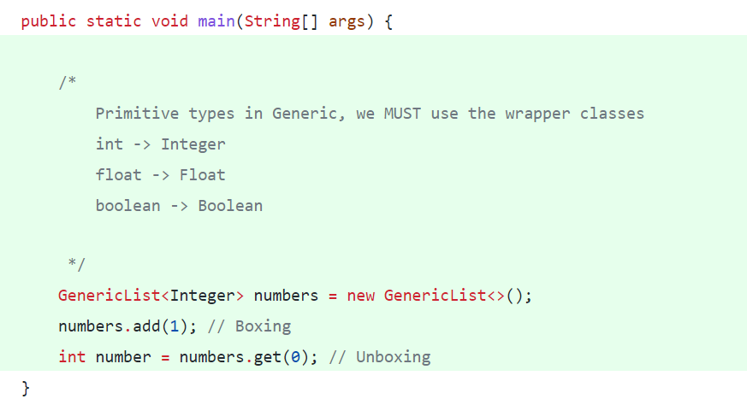



**There are times we want to add a constraint or restriction to a Type parameter**

If want to use only number, we use inheritance from Number

Example:



T can be only of Number type

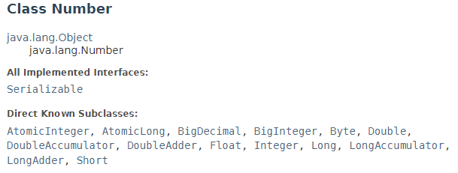

Subclasses of Byte, Double, Float, Short, etc. are children of Number.

We can only pass its subclasses or itself

Example:

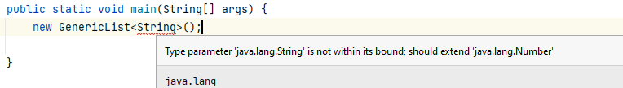

**Float**

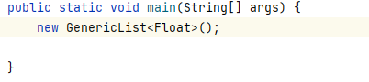

**The constraint can be also an interface, now we can pass only classes that implement the Comparable interface.**



**>>>>>>>>>>>>>>>>>>>>>>>>>>>>>>>>>>>>>>>>>>>>>>>>>>>>>>>>>>>>>>>>>>>>>>>>>>>**

**We can pass User**

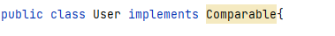

------------------------------------------------------------------------------------------------------------------------------------------

**We can extend multiple interfaces; we can pass only classes that implement the interfaces.**



**>>>>>>>>>>>>>>>>>>>>>>>>>>>>>>>>>>>>>>>>>>>>>>>>>>>>>>>>>>>>>>>>>>>>>>>>>>>**

**We cannot pass User anymore in this case since extends two interface and user implements only one**

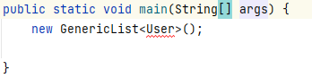



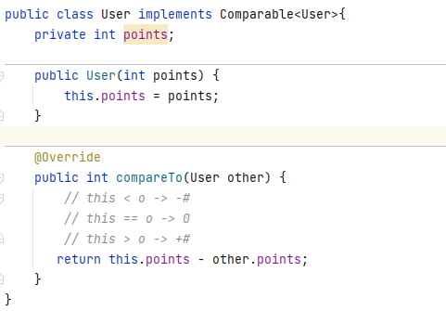

**Comparing in Main**

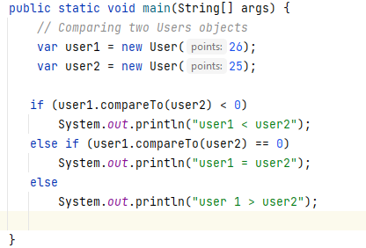



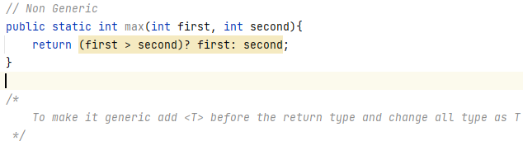

---------------------------------------------------------------------------------------------------------------------------------------

Example:

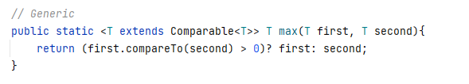

We add the constraint of Comparable Interface to be able to pass classes that implement the interface and compare objects.

---------------------------------------------------------------------------------------------------------------------------------------

**Using the Generic method**

**Passing User**

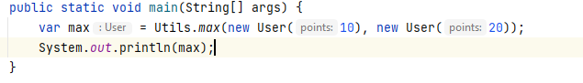

**Passing an integer**

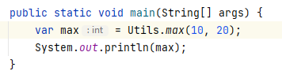



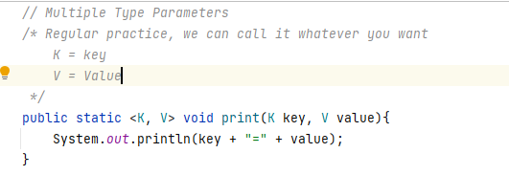

**Main**

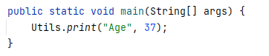

**Multiple Type Parameters in a Class**

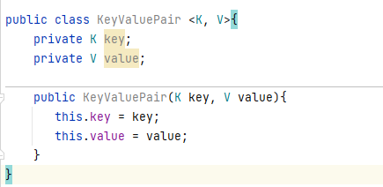



? -> Wild character, Unknown type. When use we can pass anything

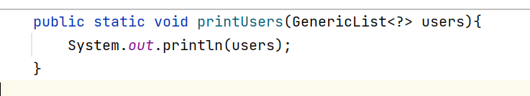

Int this case we can pass a GenericList of any type.

When we use a wild char the java compiler will create an anonymous class type under the hood

 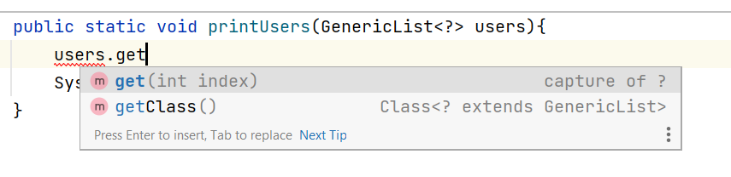

get() returns an instance of capture class (anonymous)

------------------------------------------------------------------------------------------------------------------------------------------

In order to limited we add a constraint either extends class || interface, this way all of sub-types classes and all classes that implement such interface can be passed.



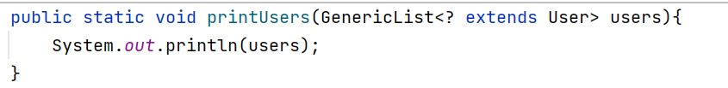

When the compile see the constraint makes the anonymous class one of User subtypes

extends **: YOU CAN READ**

**makes the capture anonymous class extend the class**

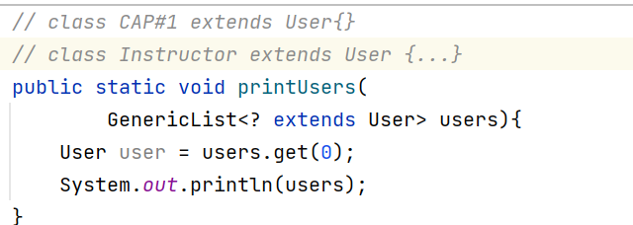

super**: YOU CAN ADD**

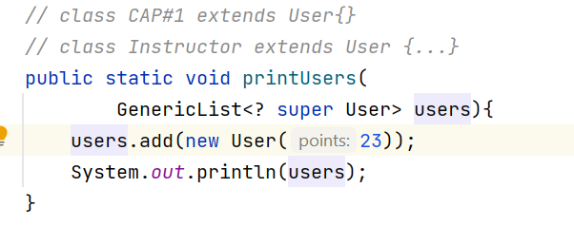

**When the compiler see expression **

**It will treat it as the parent of the User -> Obj**

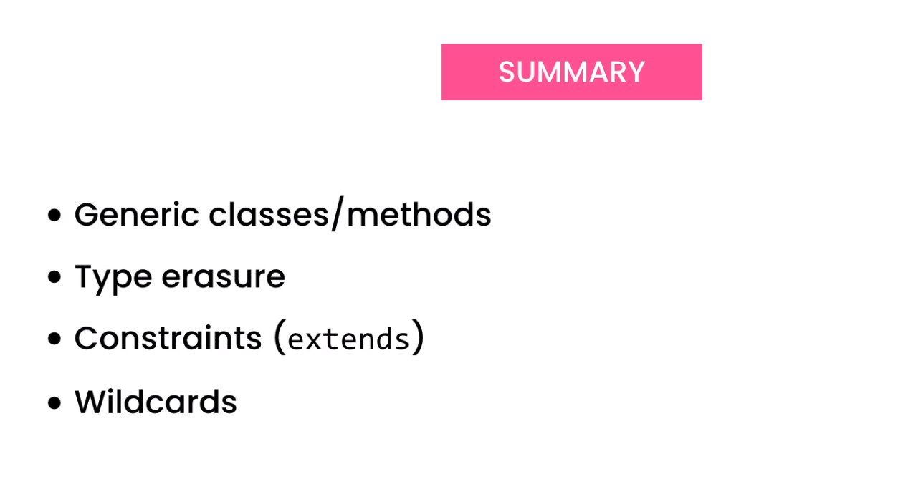





Green Interfaces

Blue classes that implement them

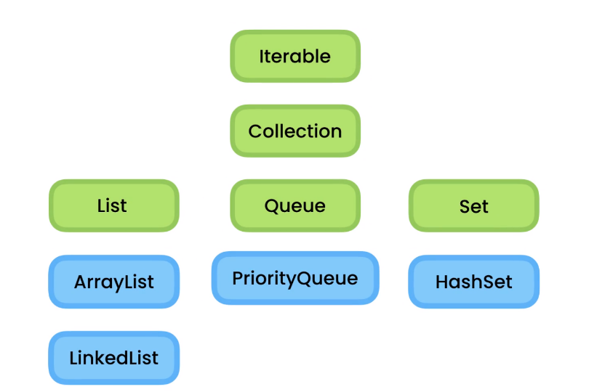



…



The Iterable interface represents an object that is Iterable, it means we can iterate or loop over it without knowing anything about its implementation details.

We implement the iterable interface in the class.



We declare a nested class, so when changes are made to the data structure like [] instead of ArrayList, only the nested class will be affected.

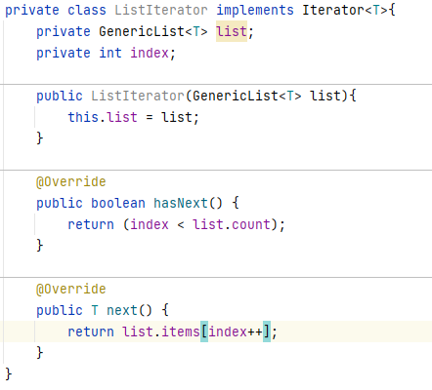

Override method of Iterable interface

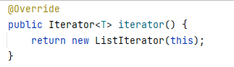



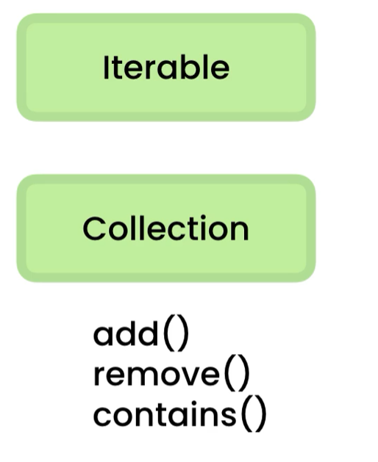

The collection interface represent a container for an object that is a collection or container for other objects.

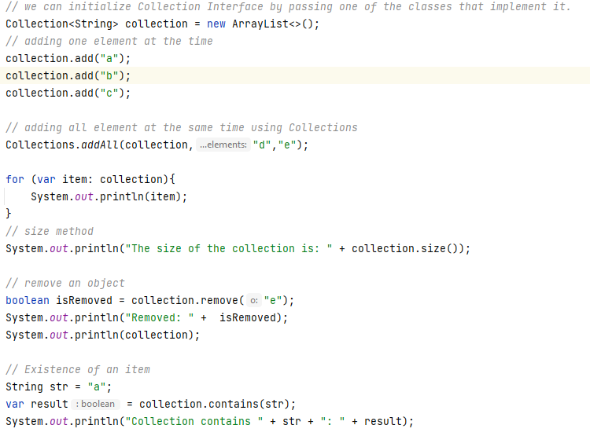

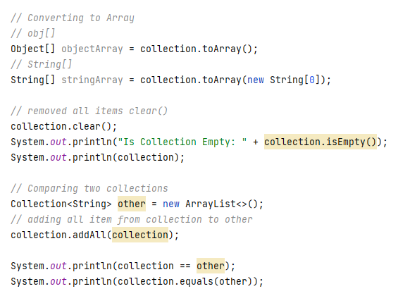



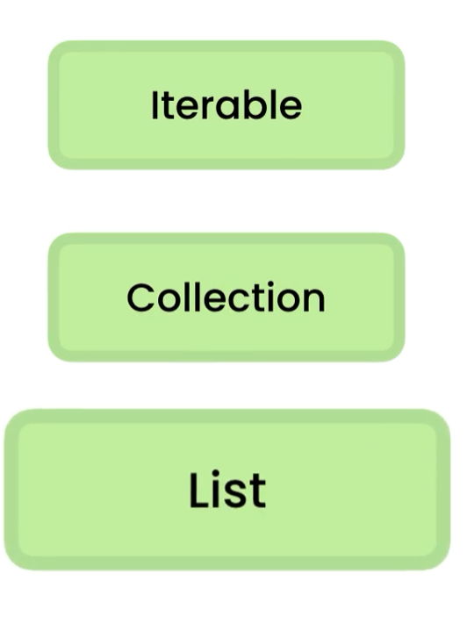

The List interface represent an order collection also called a sequence, so we have access by its index, here we have access to all methods, in collection and iterable interfaces as well.

We Initialize the List<> as follow: 

Here we pass ArrayList<>() class since implements List<> interface Dependency Injection in action.

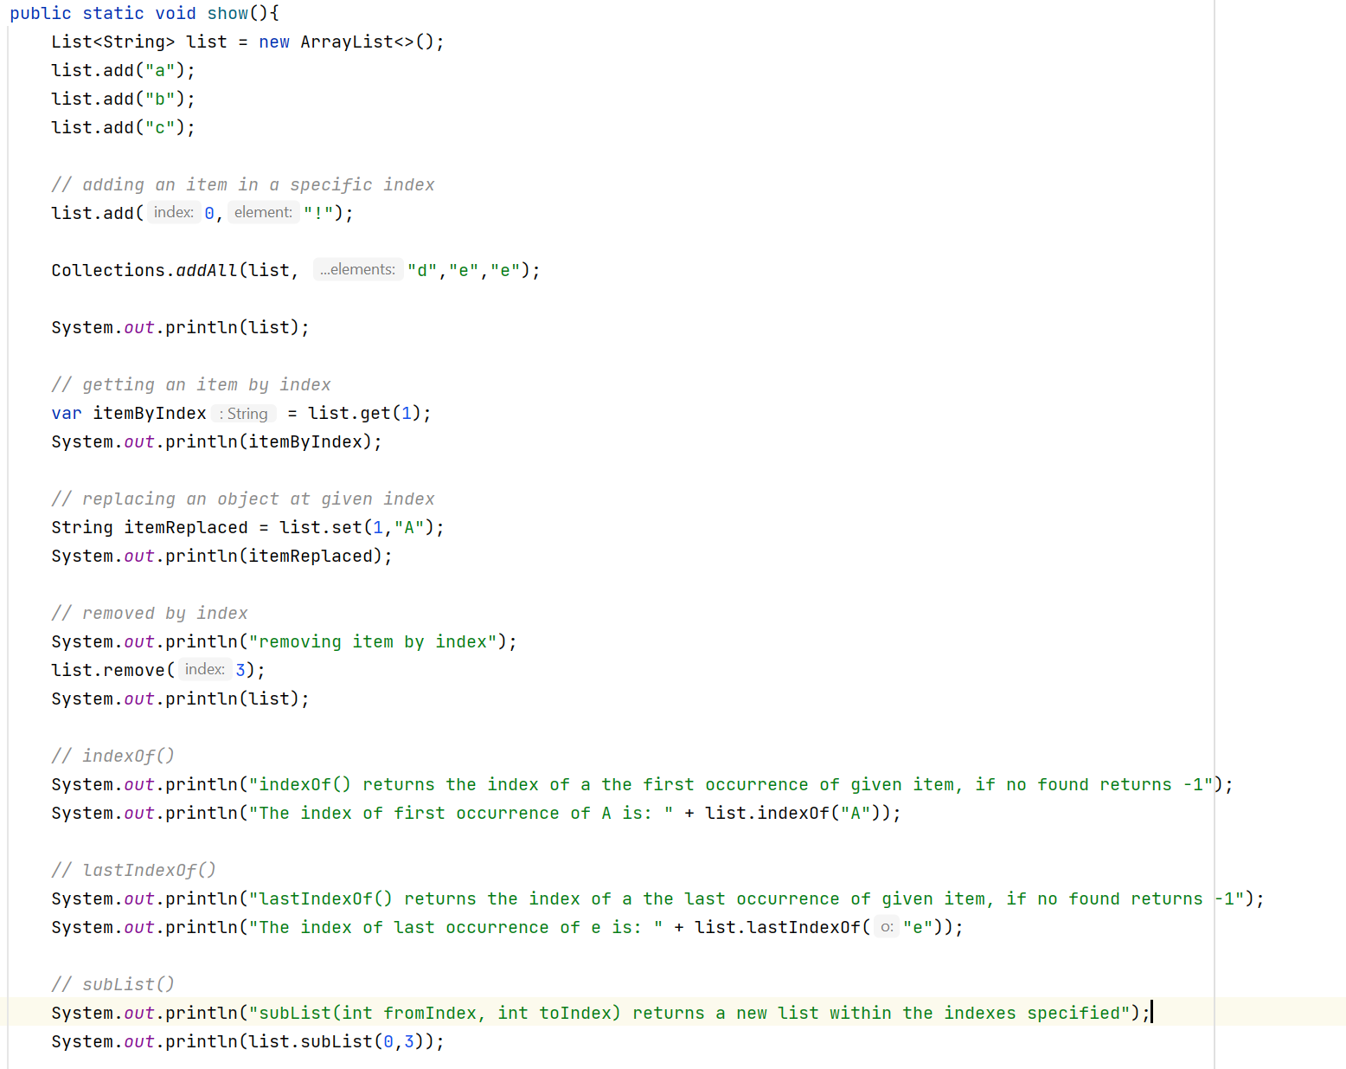



Sorting Data using the comparable Interface.

To sort data using the comparable interface, the class must implement the comparable interface, override the method compareTo().

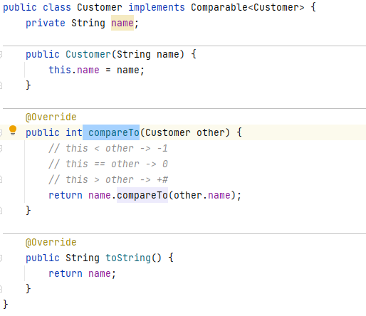

Main:

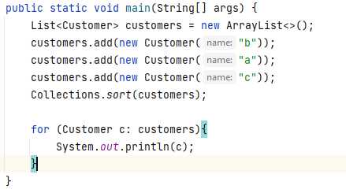

OUTPUT:

a

b

c



To compare objects using the Comparator Interface

We make a new class that implements Comparator<> interface and override the method

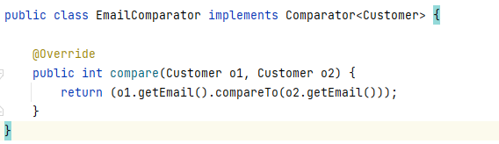

Now we can call Collections.sort()



We pass list and Comparator

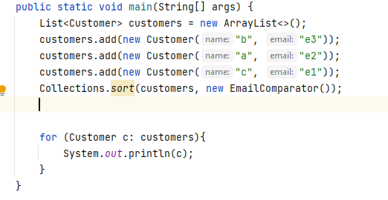

OUTPUT

c

a

b



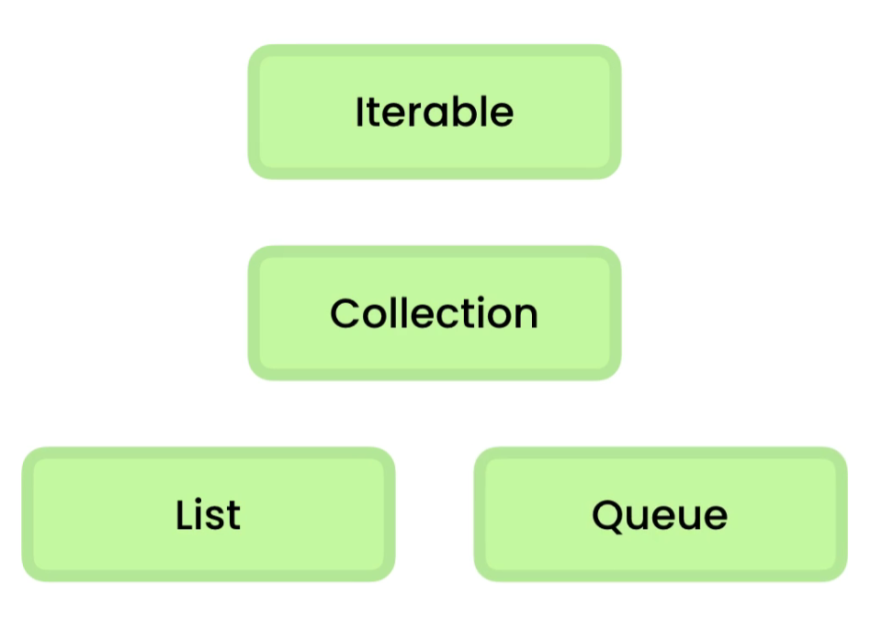

We use queues when we want to process jobs based on the order, we received them. Think like a printer.

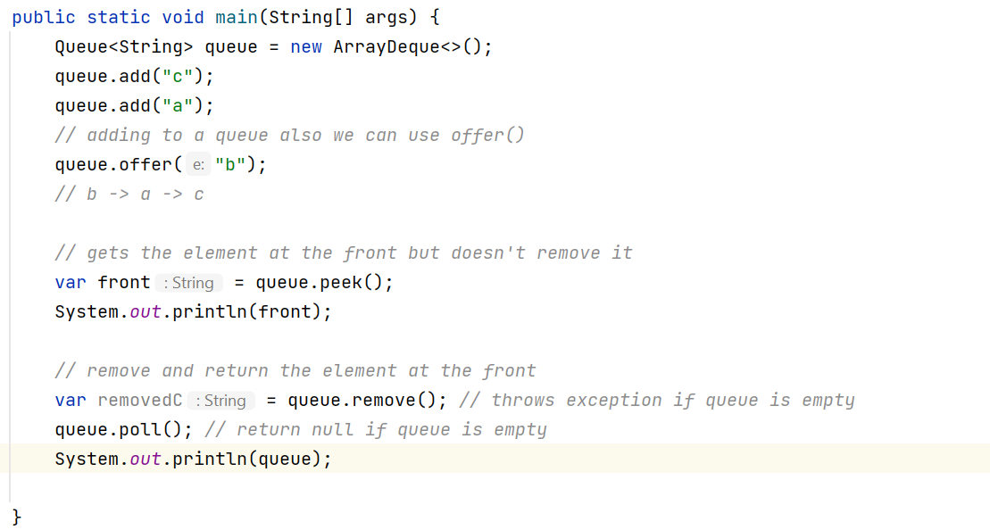



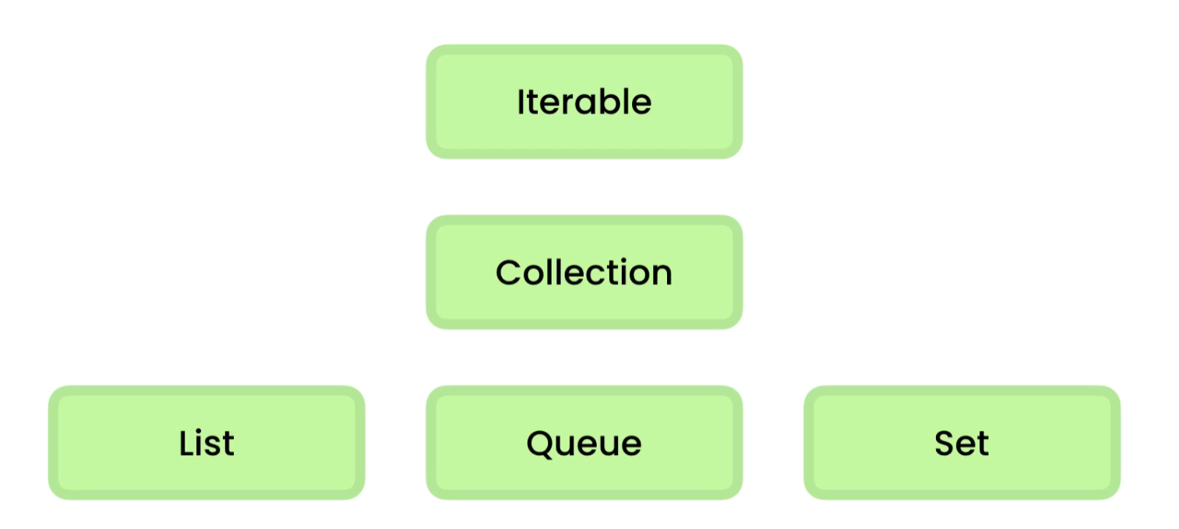

The set interface contains a collection with no duplicates. Great to store a set of unique values

A set does not guarantee the order of items, only that contains unique values.

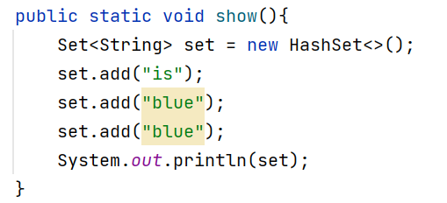

OUTPUT: [blue, is]

There 4 operations in a set that we need to remember.

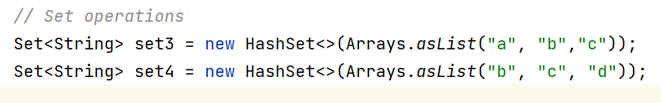

UNION

Add both sets only values that are not repeated

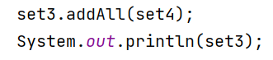

**OUTPUT: [a, b, c, d]**

**---------------------------------------------------------------------------------------------**

INTERSECTION

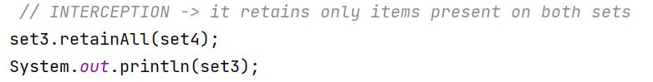

**OUTPUT: [b, c, ]**

DIFFERENCE

To know what items, we have in the first set that we do not have in second.

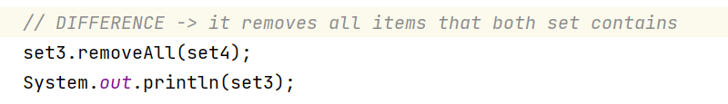

OUTPUT: [a]

REMOVING DUPLICATES

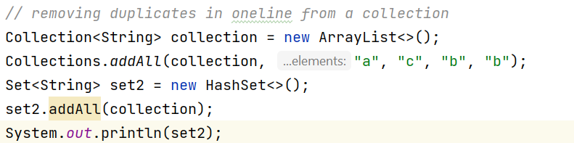

OUTPUT: [a, b, c]



A hash table is a special data structure, so we can use it to store data, the way it stores the data is different from how a list of array stores data. We can quickly look for an object no matter how many objects we have stored. We can find the customer using only one comparison -> O(1)

**In Java we call hash tables Maps**



The map represents a set of key value pairs.

**Key : value pair**

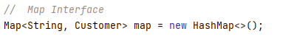

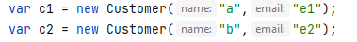

**Methods:**

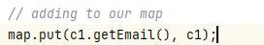

**------------------------------------------------------**



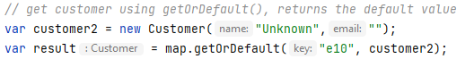

**------------------------------------------------------**

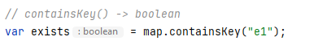

**------------------------------------------------------**



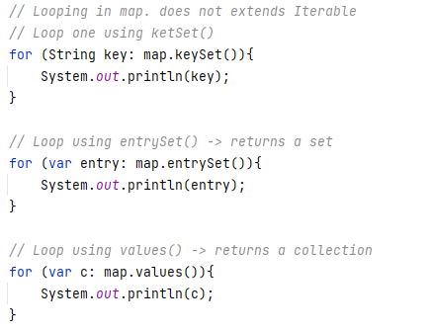

**------------------------------------------------------**

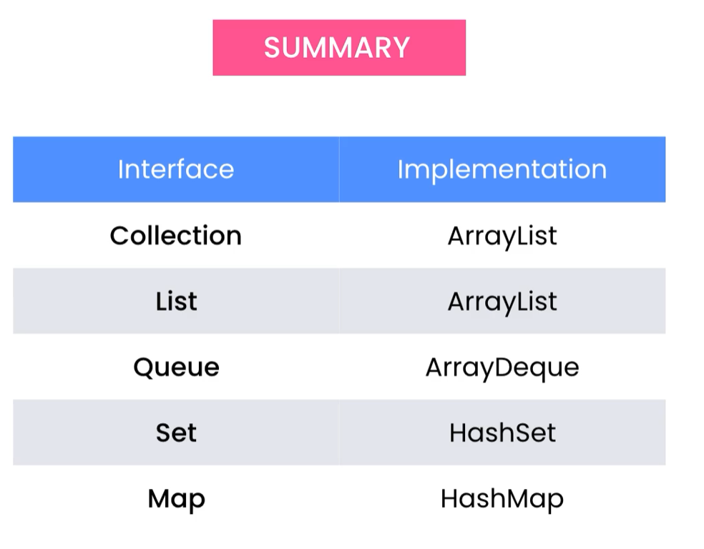



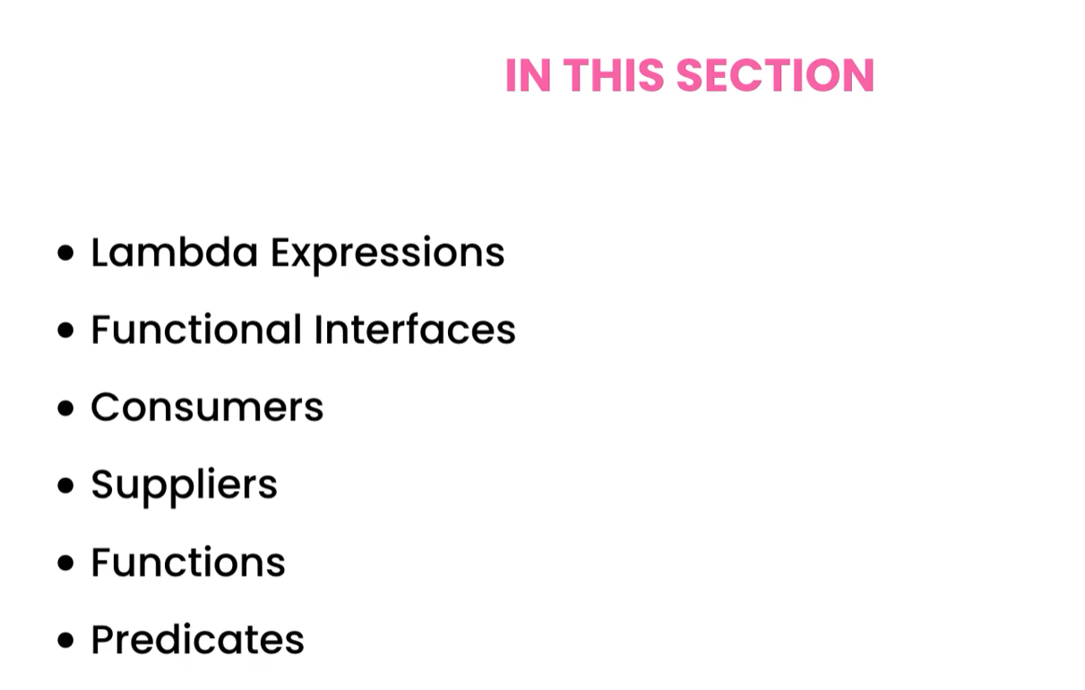



**Functional Interface:** It is an interface with a single abstract method.

Comparable Interface

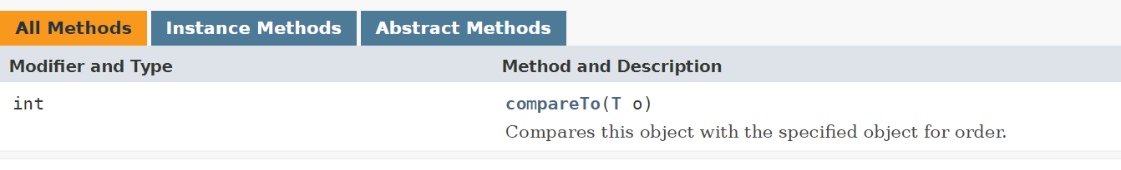

Comparable Interface

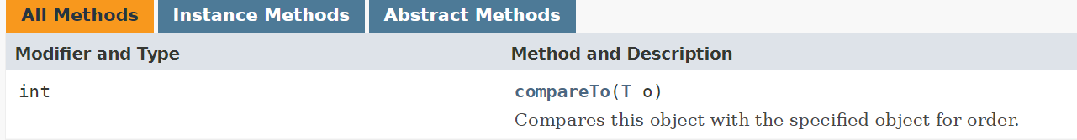

**Functional Interface**

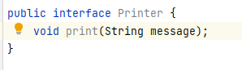

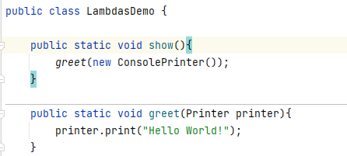

Sometimes we do not want to create a class that implements the interface. So we use anonymous inner classes.



We can use anonymous inner class instead of creating a class that implements the interface.

**Anonymous Class:** Because **the class has NO NAME**

**Inner Class:** Because it is used inside a method

Example:

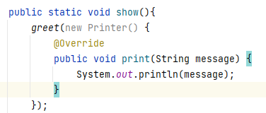

Java introduced a better way to the same called Lambda expression.



Lambda expression is an anonymous function that we can pass around in our code. A function that stands alone without belonging to a class.

We can implement functional interfaces using lambda expression.

**Syntax:** (Parameters) -> { implementation}

Example:

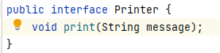

-----------------------------------------------------------

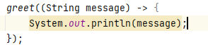

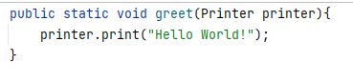

-----------------------------------------------------------

We can remove the type of parameter String since the compiler knows the signature of the method in the interface

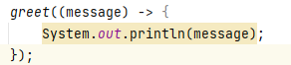

If we have a single parameter, we can remove the parenthesis enclosing the parameters.

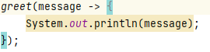2

We use () only if we have no parameters or multiple parameters.

* () -> {…}
* (a, b, c) -> {…}

If the body of the lambda expression has only one line of code, we do not need the {}



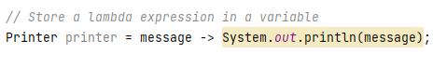

**Lambda expression are objects that we can use to represent anonymous function.**



We can access variables declared

**In the method**

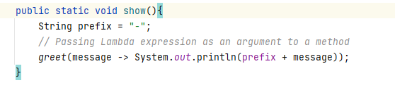

**Static fields declared in the class.**

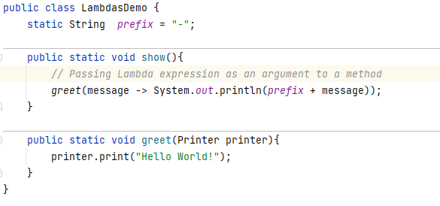

**Instance fields in the class in a non static method**

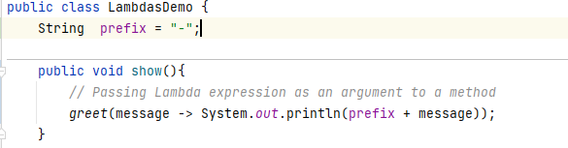

**this**

In a lambda expression **this** -> refers to the current object LamdasDemo, in a inner class this refers to the instance of the anonymous class.

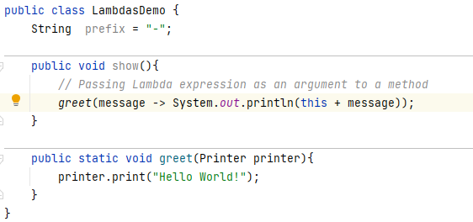

Anonymous inner classes can have fields but not lambda expression.



**Method References:** we write compact and easier to read lambda expressions.

// Class/Object::method

Example:

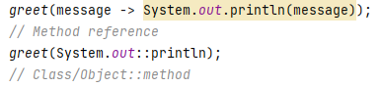

Theses two lines are the same, one using lambda expression and the other using method references

In IntelliJ we can convert lambda expression to method refencing by clicking on lambda body and then ALT + ENTER

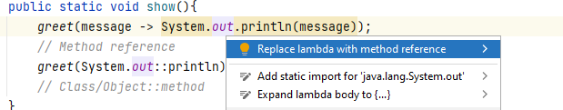

**Method Reference:**  We can reference static or instance methods in a class as well as constructors.

Methods

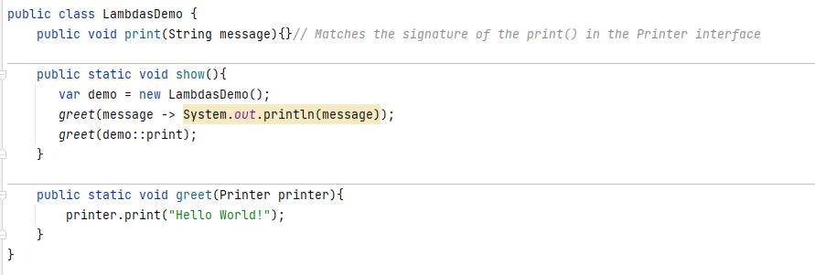

**Constructor**

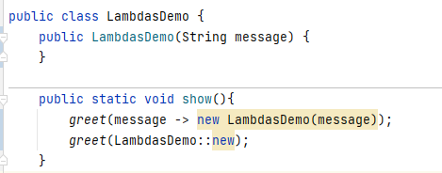



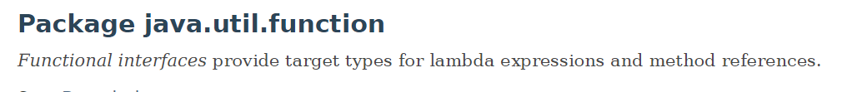

Java API <https://docs.oracle.com/javase/8/docs/api/java/util/function/package-summary.html>

**We have 4 types of built-in functional interfaces in Java**

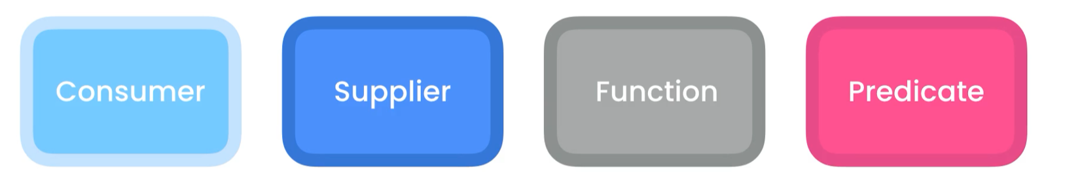

void consume(obj) obj supply() obj map(obj) bool test(condition)

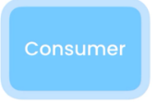------------------------------------------------------------------------------------------------------------------------------------------

It takes a single argument and returns no value, that is why is called a consumer, it consumes its value.

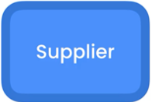------------------------------------------------------------------------------------------------------------------------------------------

It takes no argument and returns a value; it supplies a value.

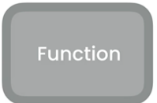------------------------------------------------------------------------------------------------------------------------------------------

It is a function that can map a value to a different value.

------------------------------------------------------------------------------------------------------------------------------------------

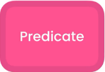It takes an object and checks if the object satisfies some criteria, we use it for filtering data.

------------------------------------------------------------------------------------------------------------------------------------------



The Consumer Interface takes a single argument and returns no value.

Some methods expects a Consumer object

Example:



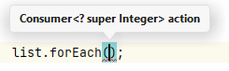

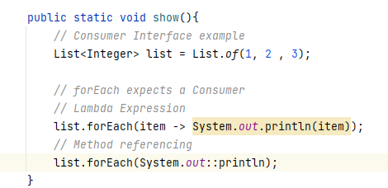



The consumer interface has a default method called andThen(Consumer<? super T> after);

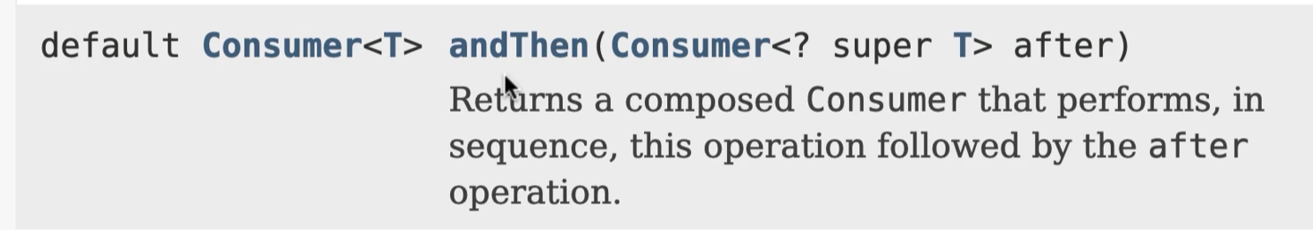

With this method we can change consumers in sequence

Example:

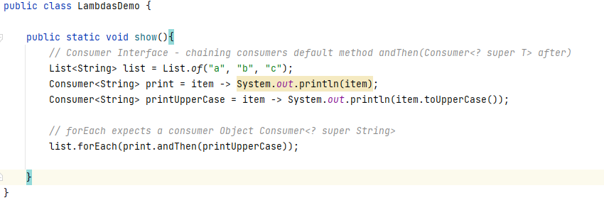

OUPUT: a A b B c C

We can continue calling andThen(Consumer obj)

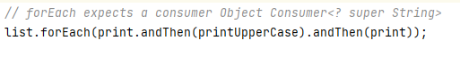



The Supplier interface supplies a value and take no argument

**Doc Ref**: <https://docs.oracle.com/javase/8/docs/api/java/util/function/Supplier.html>

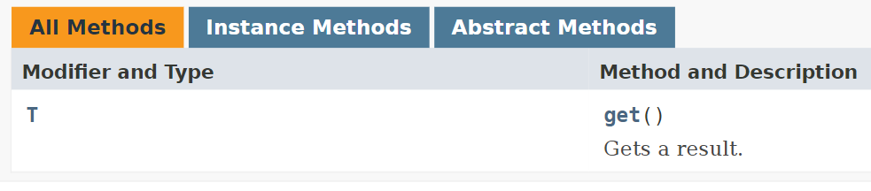

We can represent this functional interface by using a lambda expression, the method must have the same signature as get() no parameter and returns a value of T



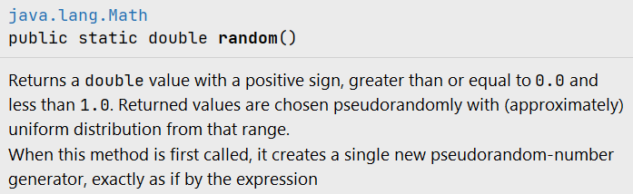

Like the consumer interface , the supplier interface has few specialisations to work with primitive type.

Example:

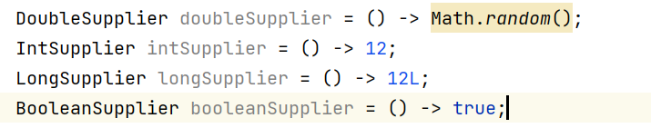

**If we are working with primitive values, it is better to use these interfaces, we do need to box it to reference type and unboxing.**



**Doc Ref:** <https://docs.oracle.com/javase/8/docs/api/java/util/function/Function.html>

Function Interface: it represents a function that takes an argument and returns a value.

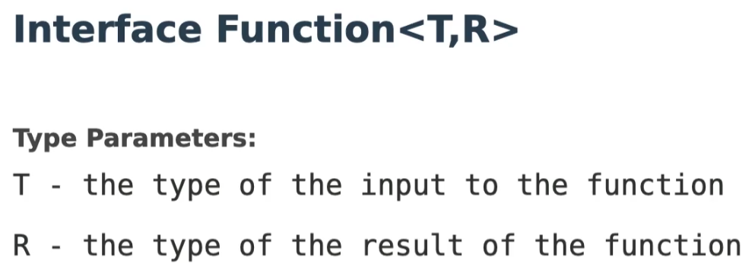

----------------------------------------------------------------------

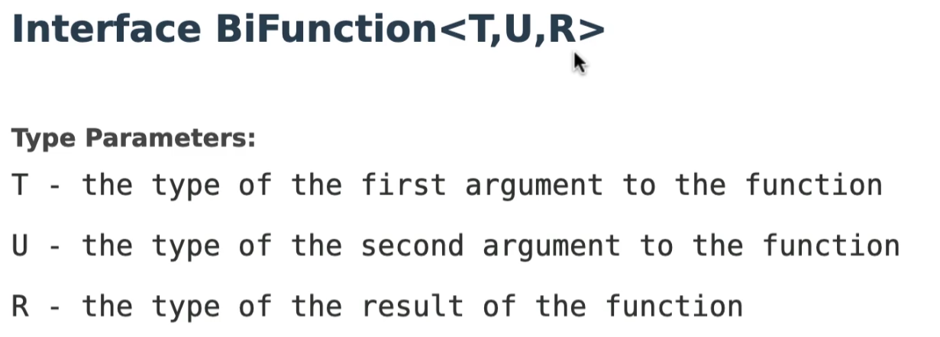

----------------------------------------------------------------------

Primitive Specialization

**First - Category**

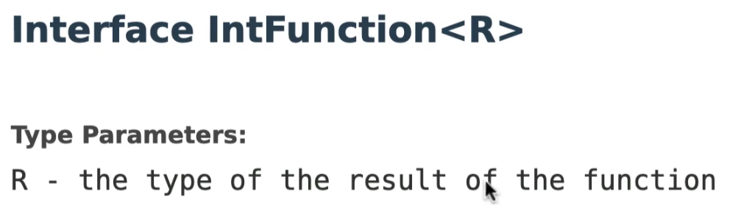

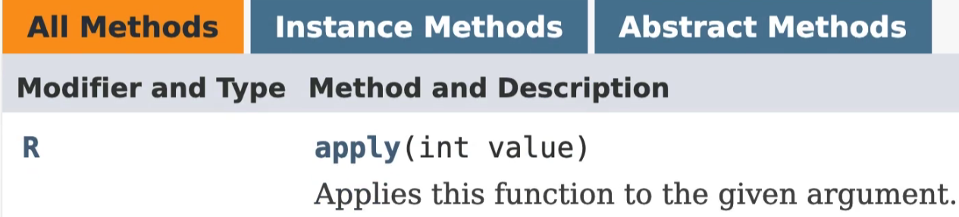

We also have

* LongFunction
* DoubleFunction

-------------------------------------

**Second – Category**

Argument is parameterized

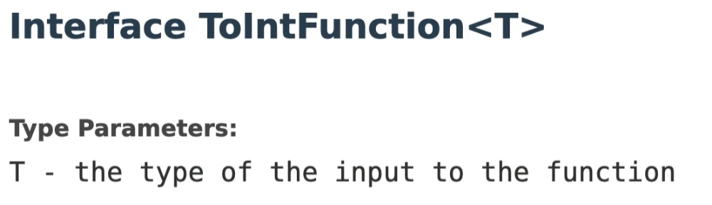

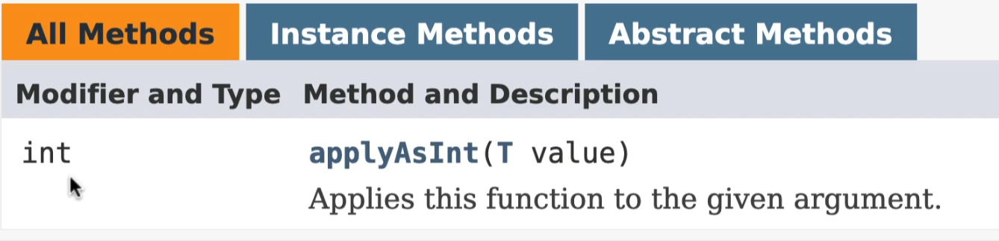

We also have

* ToLongFunction
* ToDoubleFunction

-------------------------------------

**Third – Category**

Both the argument and return are specialization of the Function Interface.

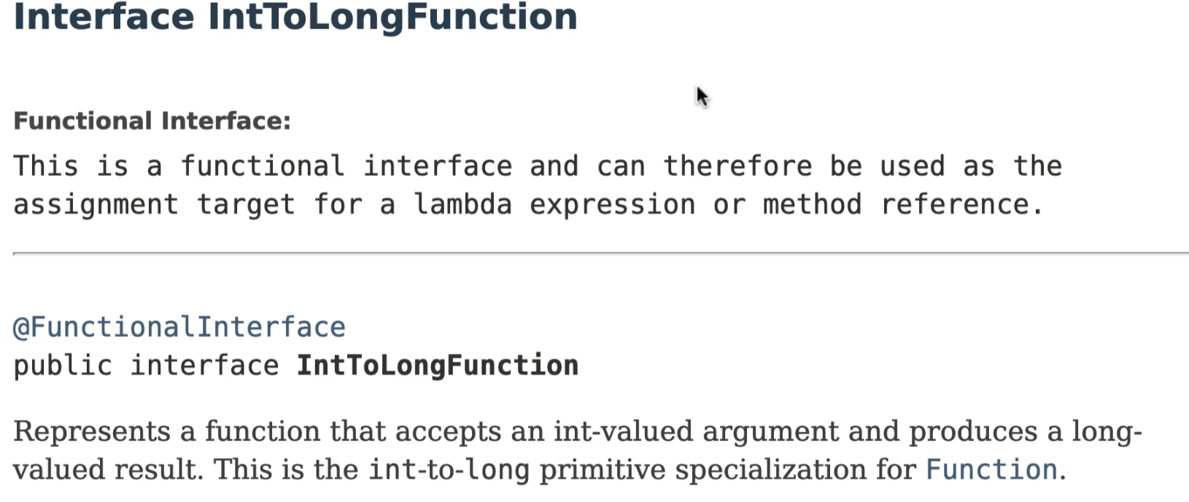

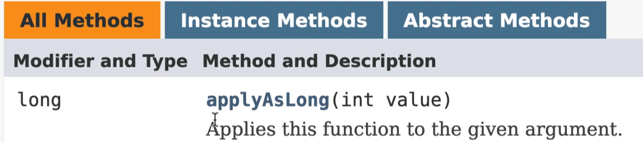

**Code Sample using Function interface**

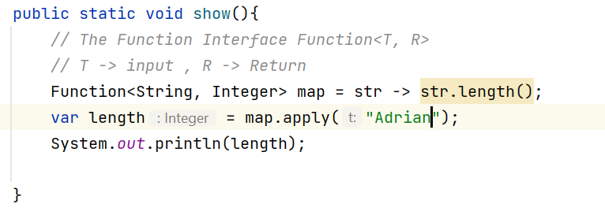

OUTPUT: 6



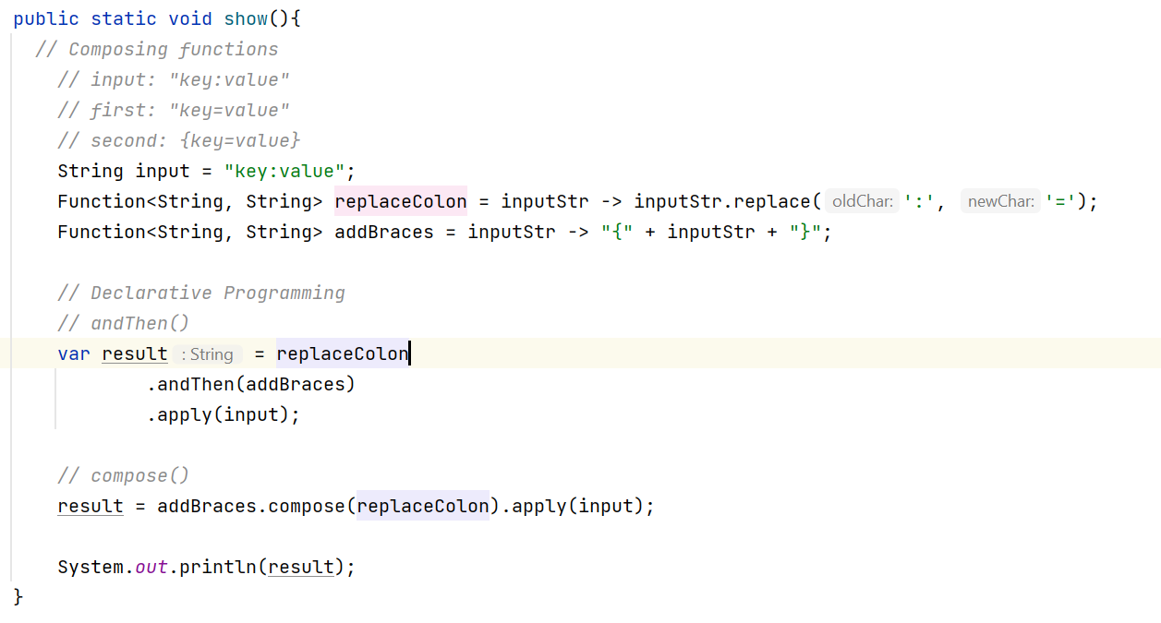



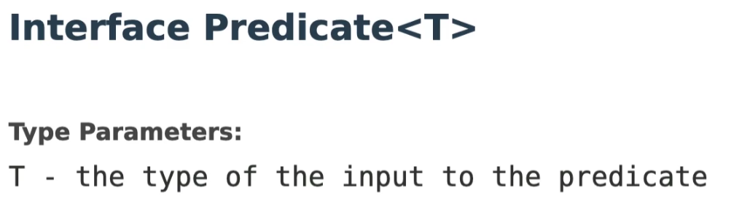

Used to filter data, tons of applications in the real world.



Specializations

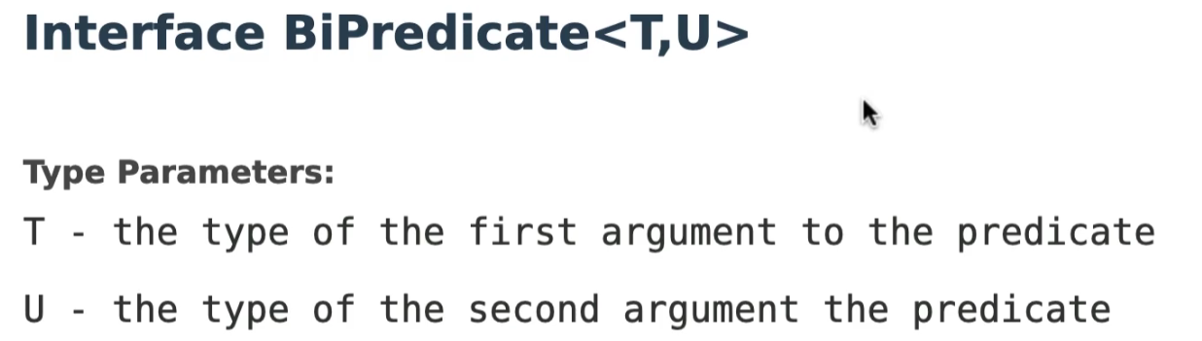

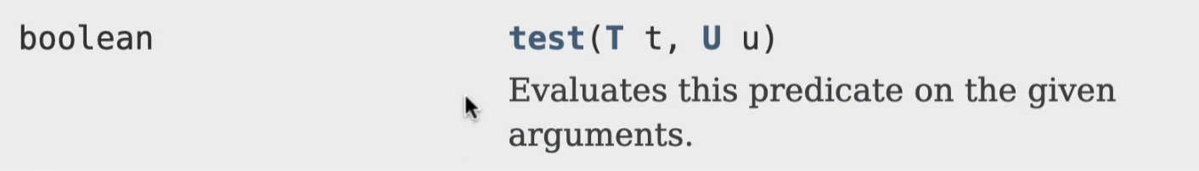

------------------------------------------------------------------------------------------------------------------------------------------

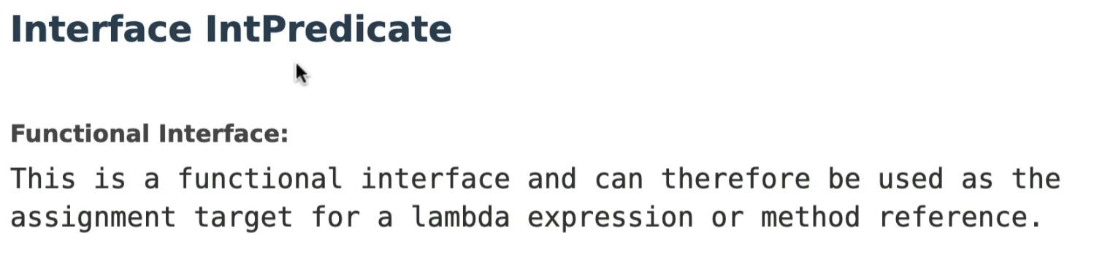

Example:

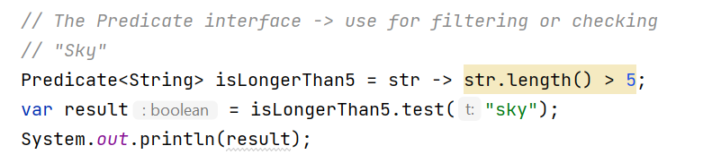

Combining Predicates to build more complex functions or predicates.

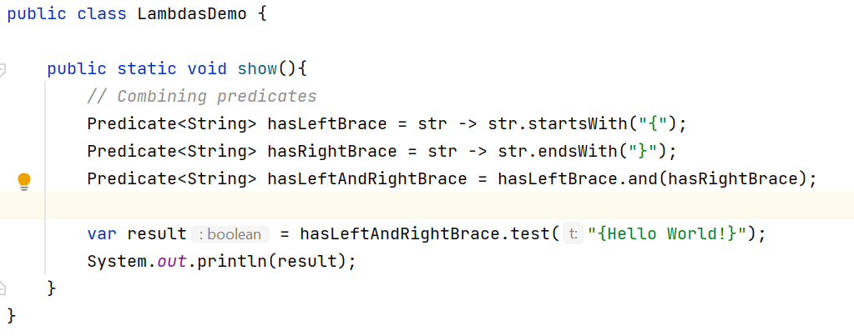



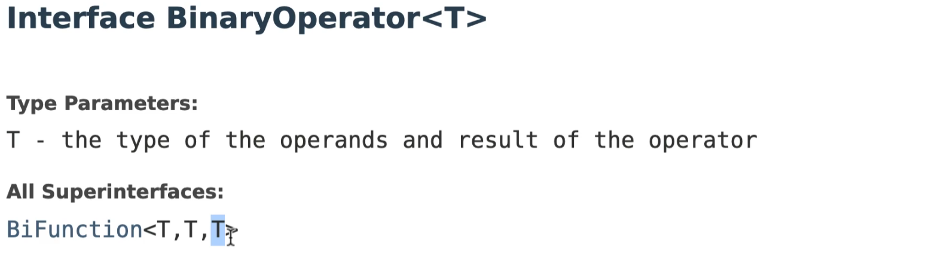

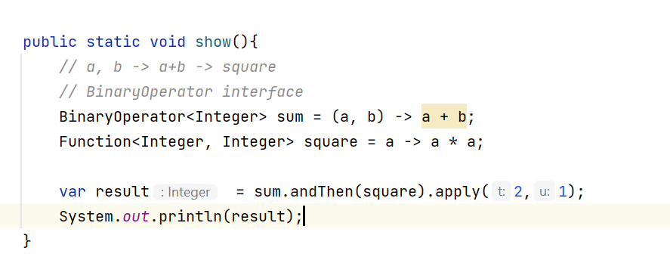



UnaryOperator extends Function <T, T>, UnaryOperator is a Function

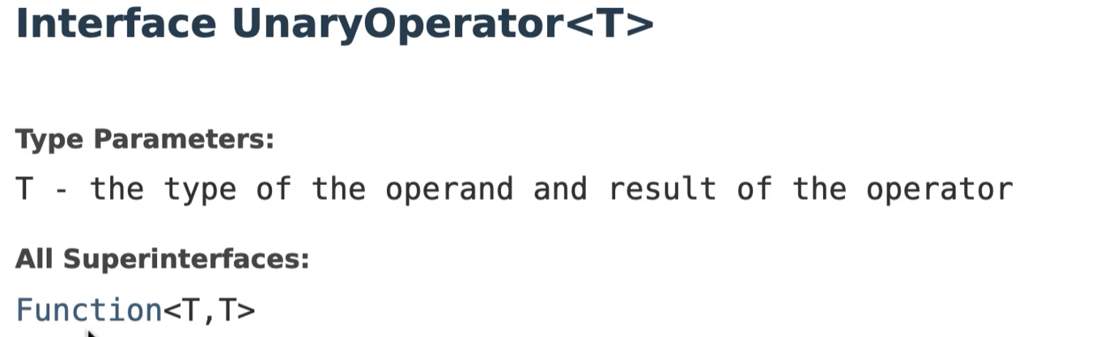

Example:

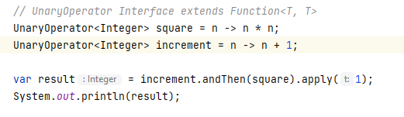

Output: 4

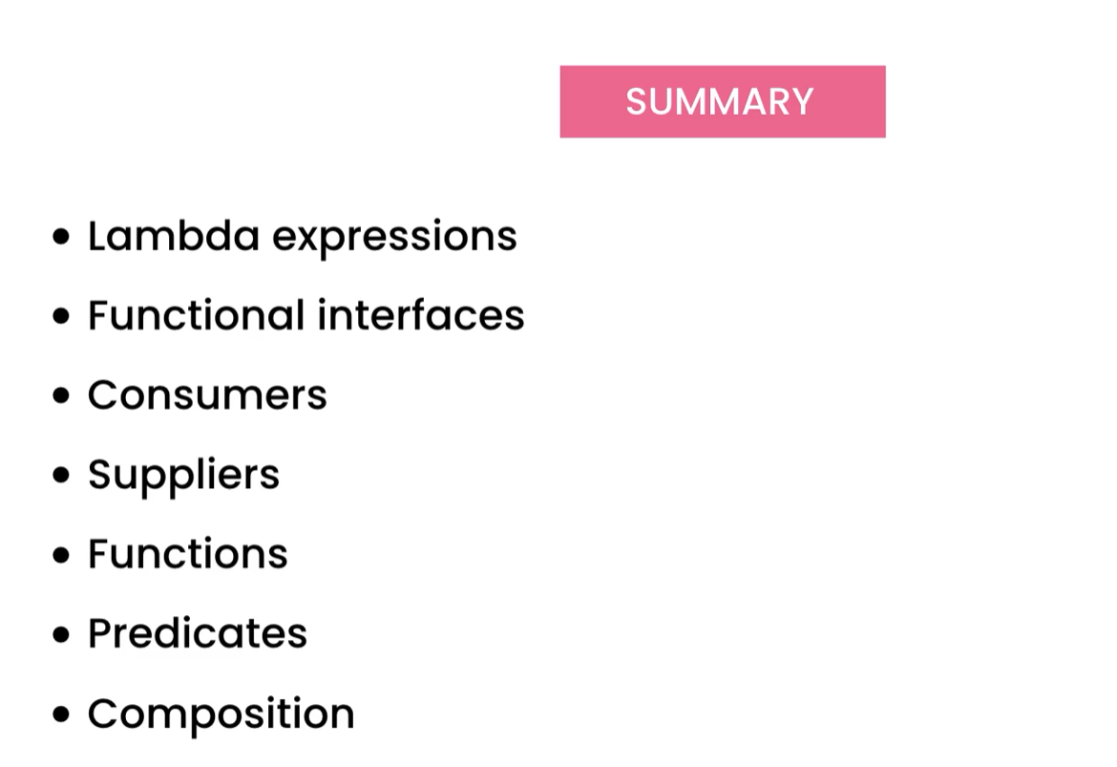



Streams allow us to process a collection of data in a declarative way ( kind of writing sequel queries).

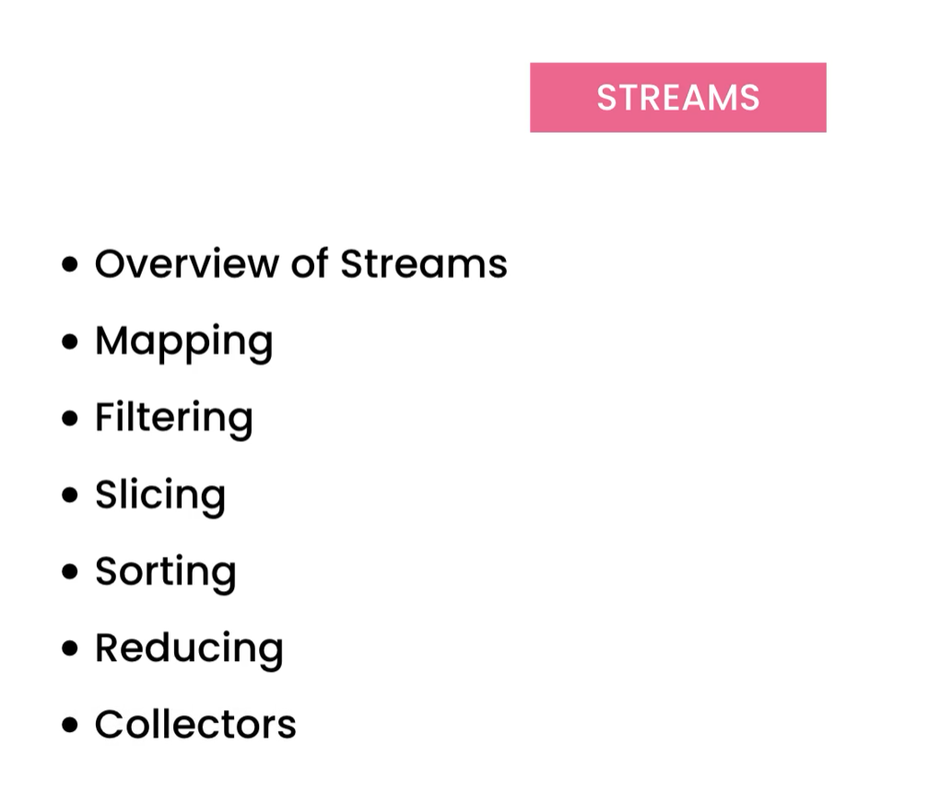



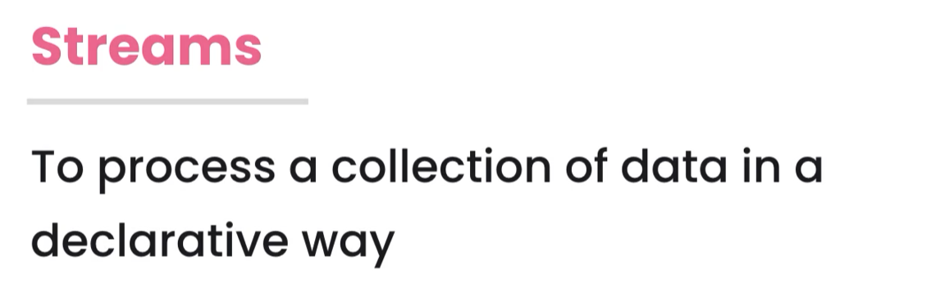

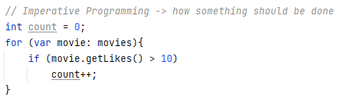

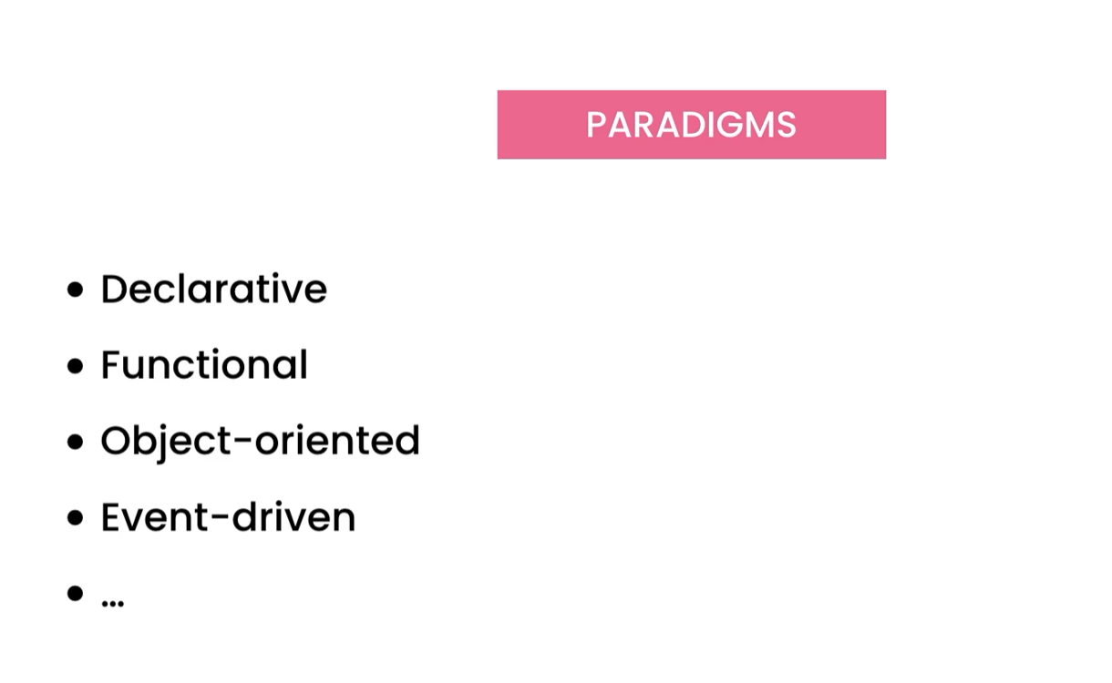

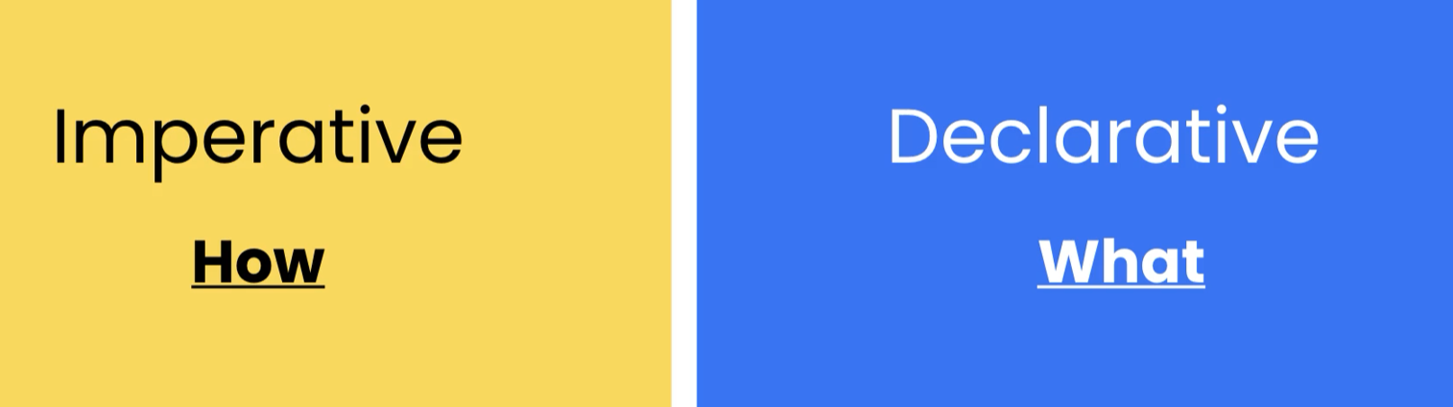

Every Collection in Java has stream().



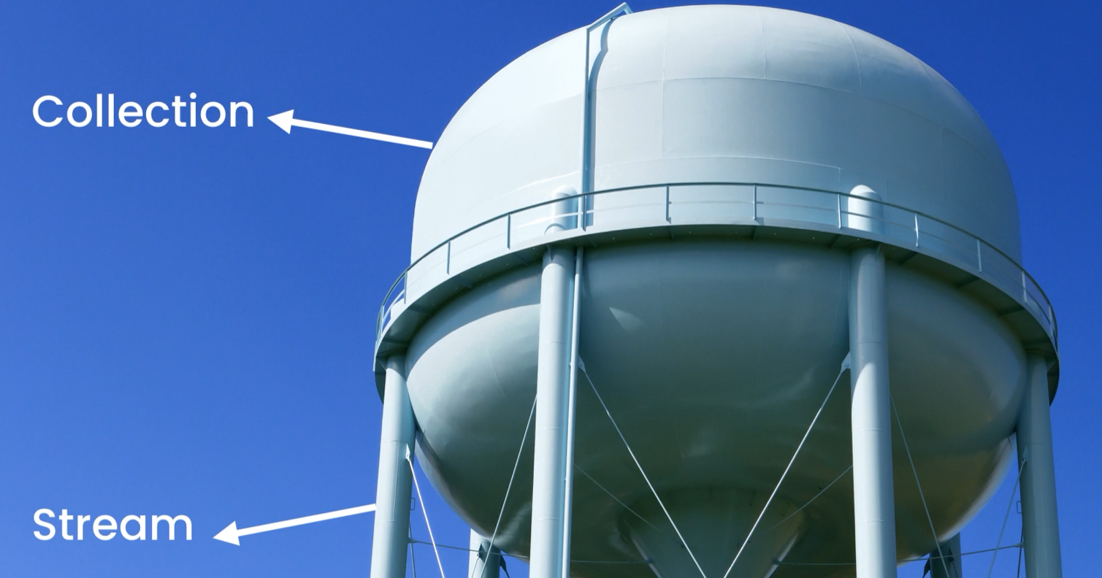

Stream is like a pipe

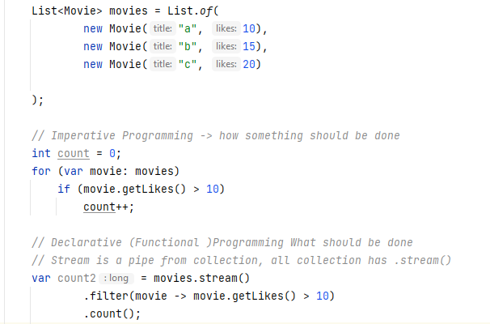



We can create streams from:

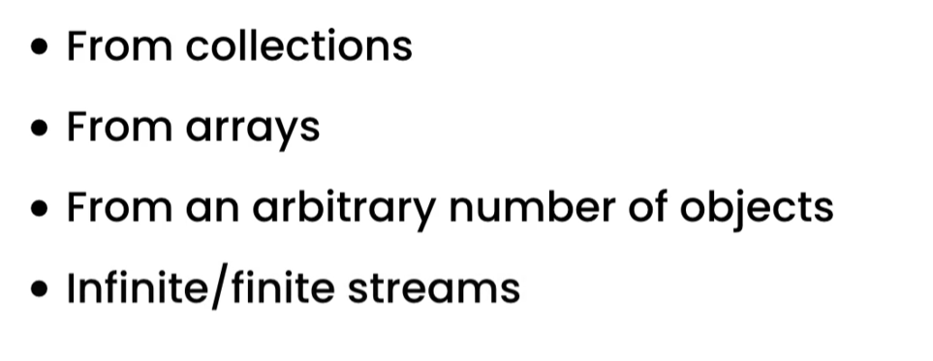

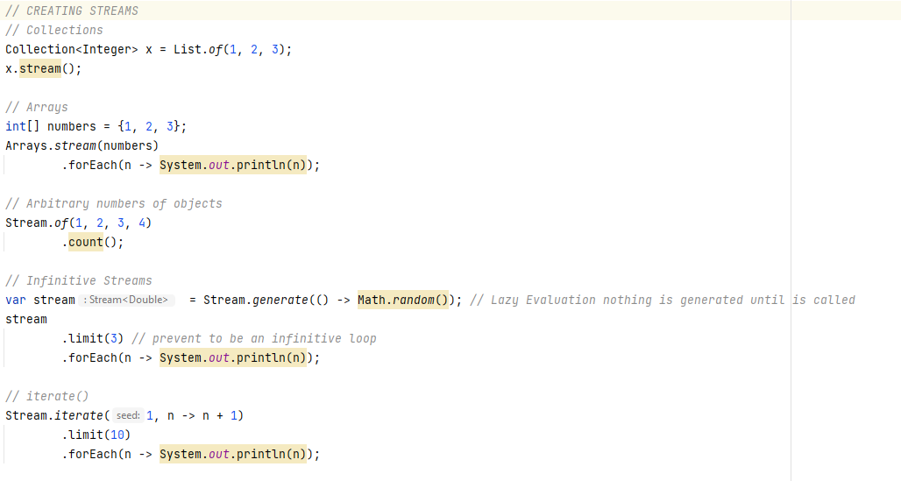



Mapping is transforming the values from one to another

We can use in the streams:

* map()
* flatMap()

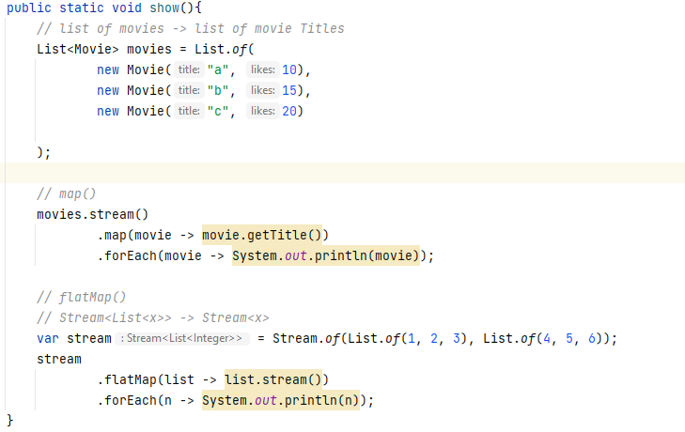

Output: 1 2 3 4 5 6 7



Stream methods follow under two categories

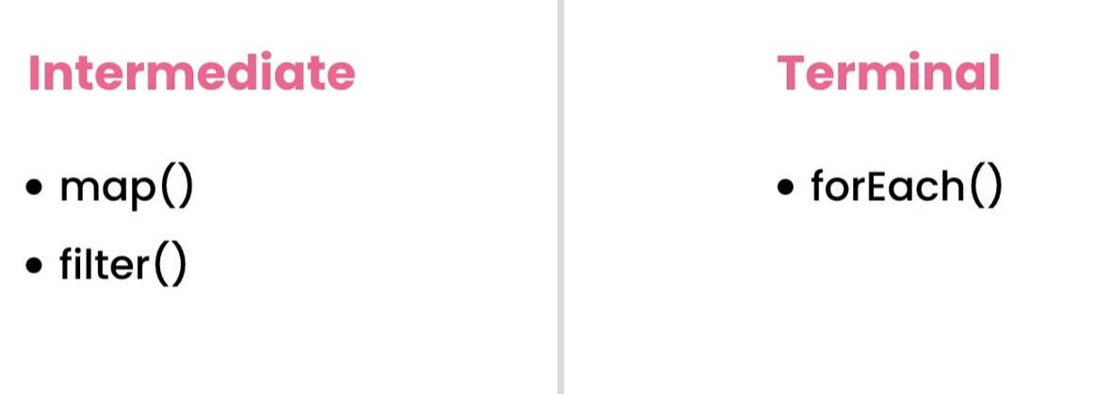

Code Sample:

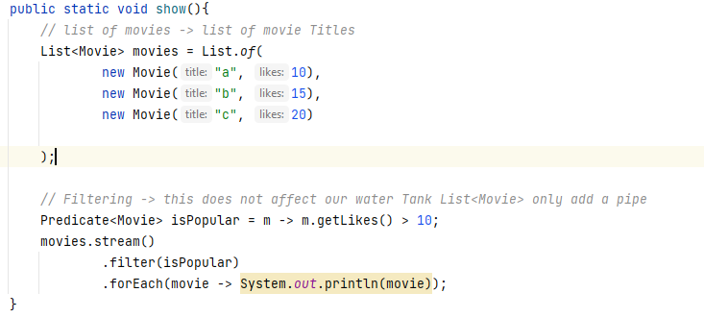



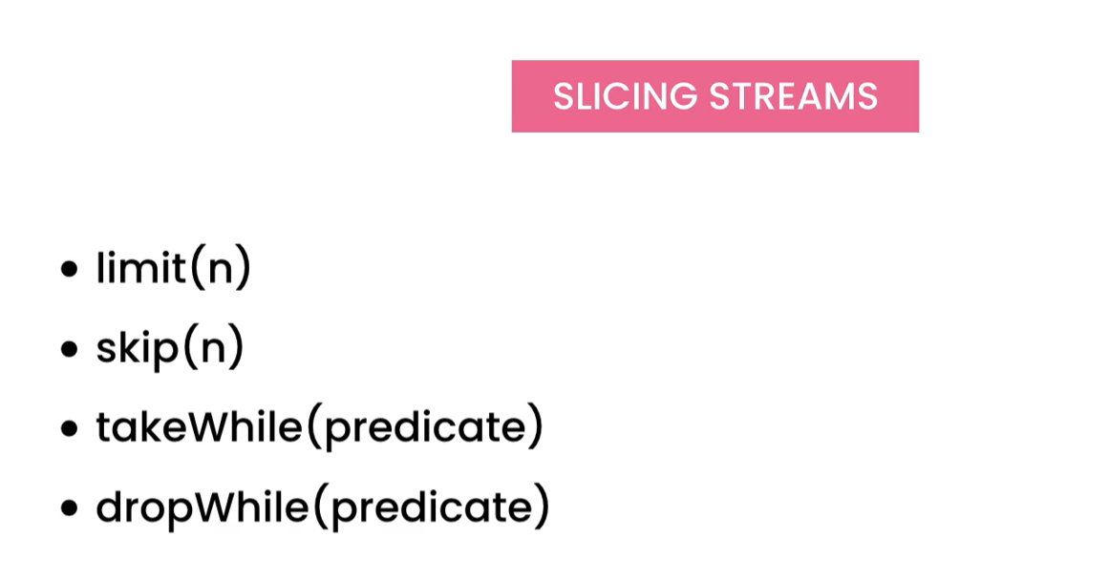

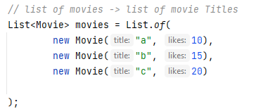

**Adding a pipe**



**Limiting**

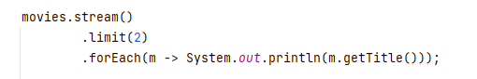

**OUTPUT**

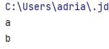

**Skipping**

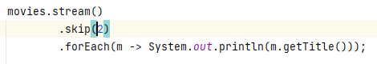

**OUTPUT**

c

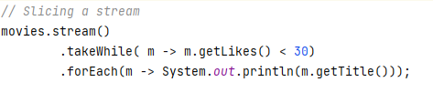

**takeWhile() & dropWhile() will stop the moment it returns false. Filter will check the whole collection.**



One way of sorting is by implementing the Comparable interface in the Class Movie

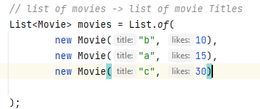

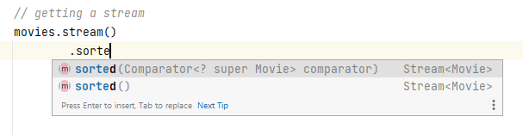

If call the sorted() with no argument it will rely on the implementation in the class.

We can call:

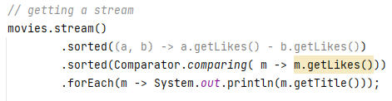

Reversing order -> Using method references

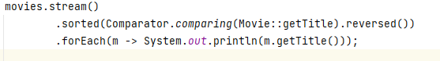



.distinct()

To get distinct elements in Stream we use .distinct()

First map it to a value then call distinct() for unique values

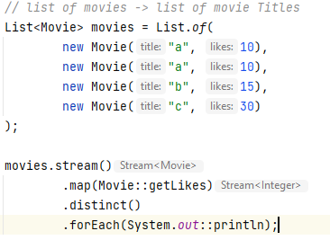

OUTPUT:

10

15

30



We can peek after certain operations to see if the output is correct, peek() is very useful for troubleshooting.

Sample Code:

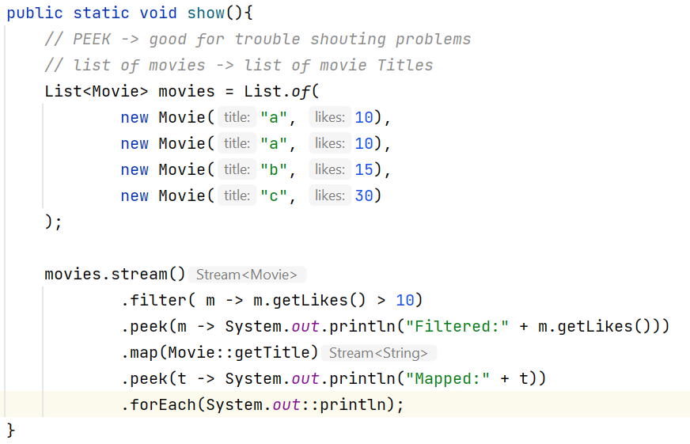



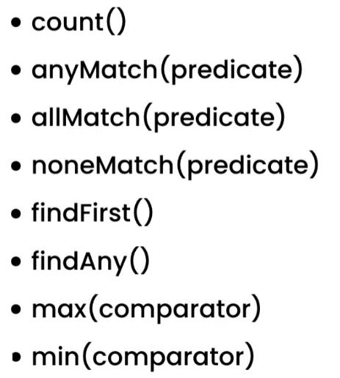

Reducers reduce a stream of objects to a single object.

All these operations are terminal operations, so we cannot call anything after.

Sample Code:

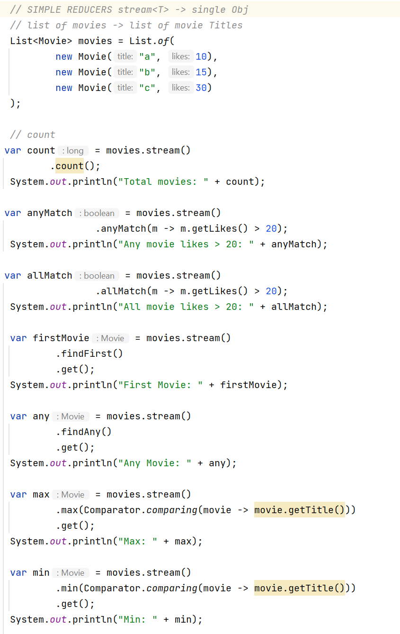

OUTPUT:

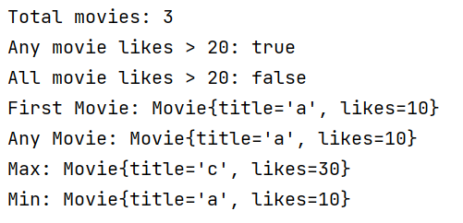



reduce()

It gives us more control of reducing stream to a single value. (General purpose reductions)

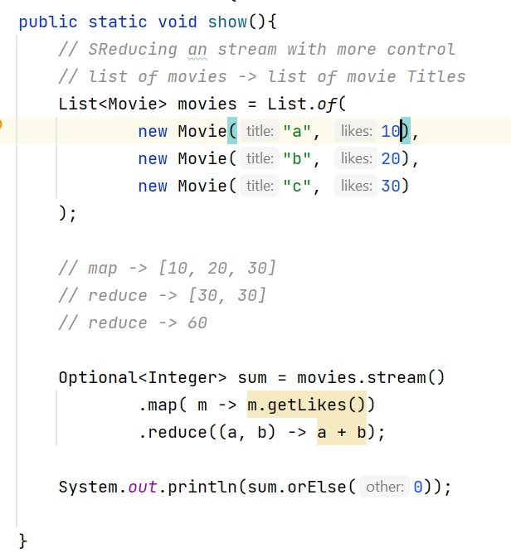

Optional<T> means we might or might not have a value.

To avoid an Exception, we can use orElse()

We can use the overload reduce Method

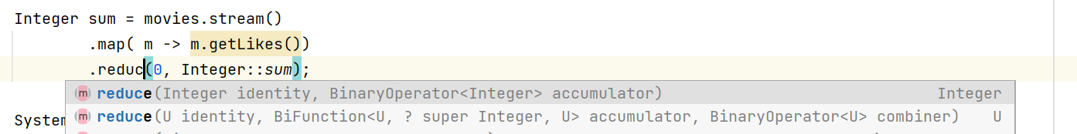

So it returns an integer object

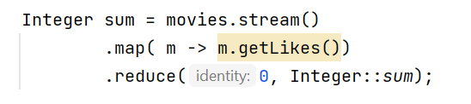



To collect the stream result to a Set, Map, List, etc.

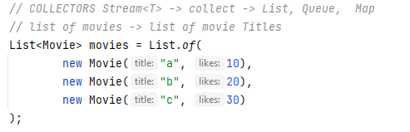

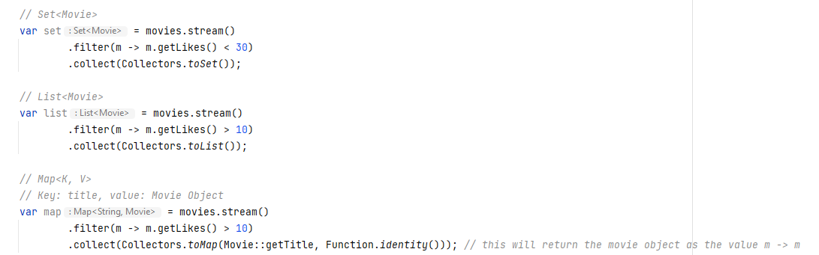

**Sum & Statistic**

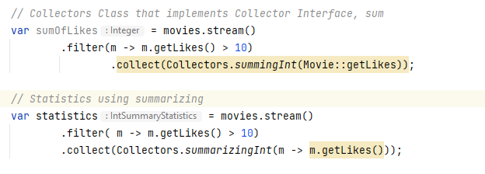



**OUTPUT:**



JOINING

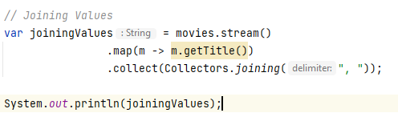

**OUTPUT:** a, b, c



We can group objects based on a field value, using **groupingBy()**

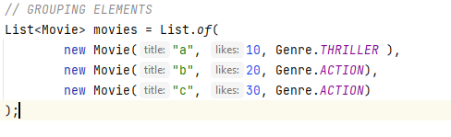

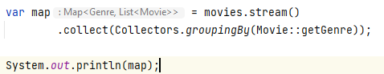

**OUTPUT:**



// Grouped by Genre, mapping by titles and joining the result

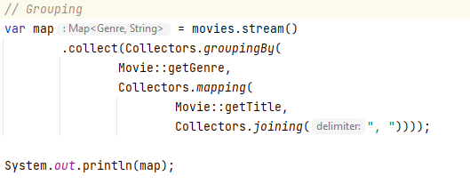

**OUTPUT:**





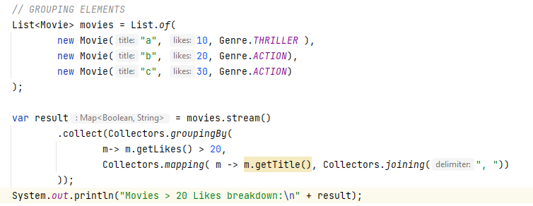

OUTPUT:

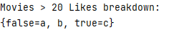



If we are working with Streams of primitive values is better to use primitive specialization

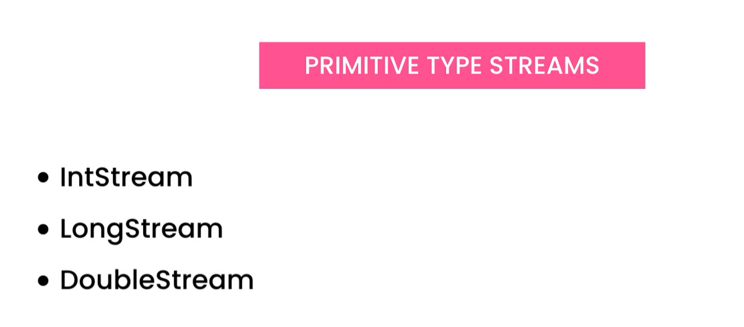



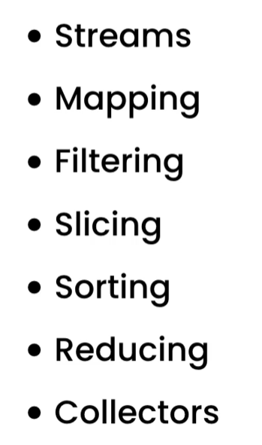



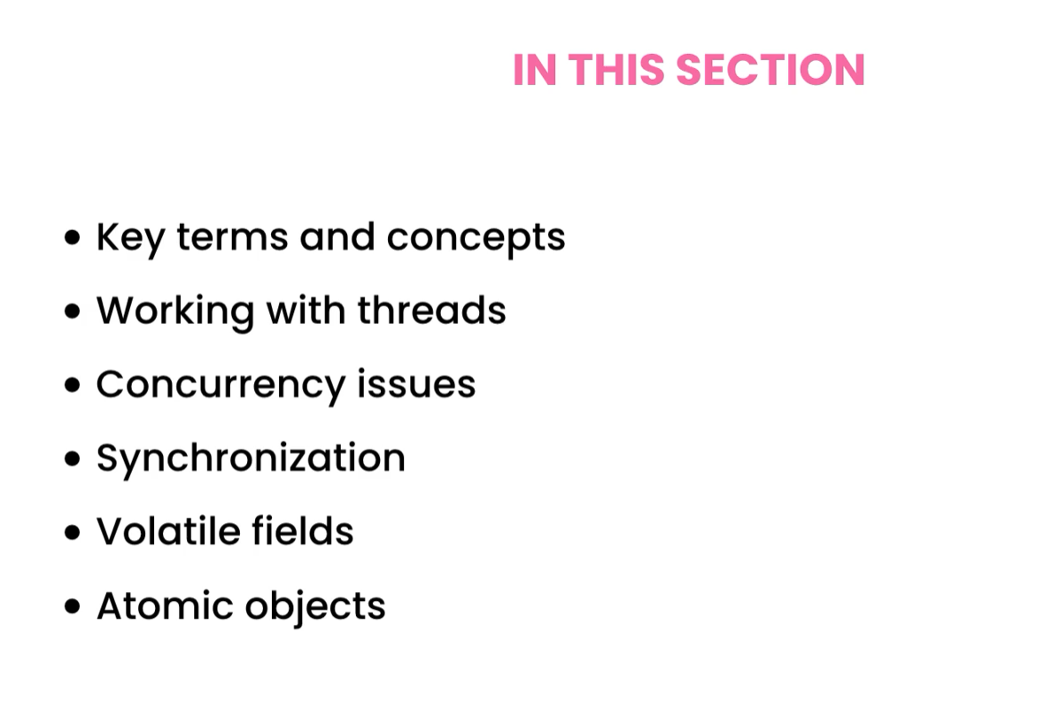



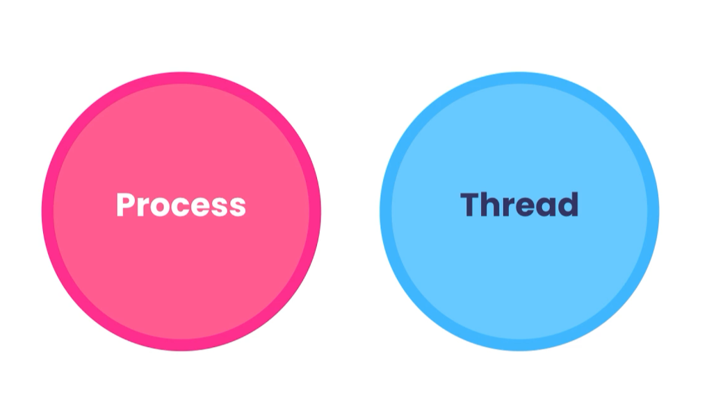

**Process:** it is an instance of a program or an application, when we start our application, the operating system loads an image of it (process).

**Concurrency at the process level:** Operating system can process many processes at the same time as running the antivirus while playing music.

We can also have concurrency withing the process or within the application using **threads**

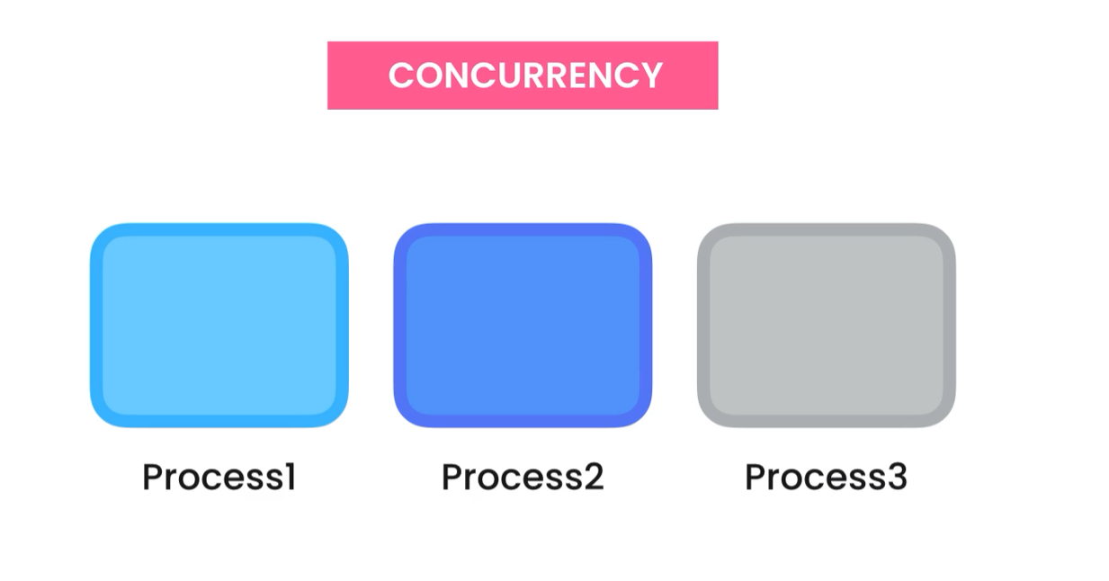

**THREAD:** It is a sequence of instructions

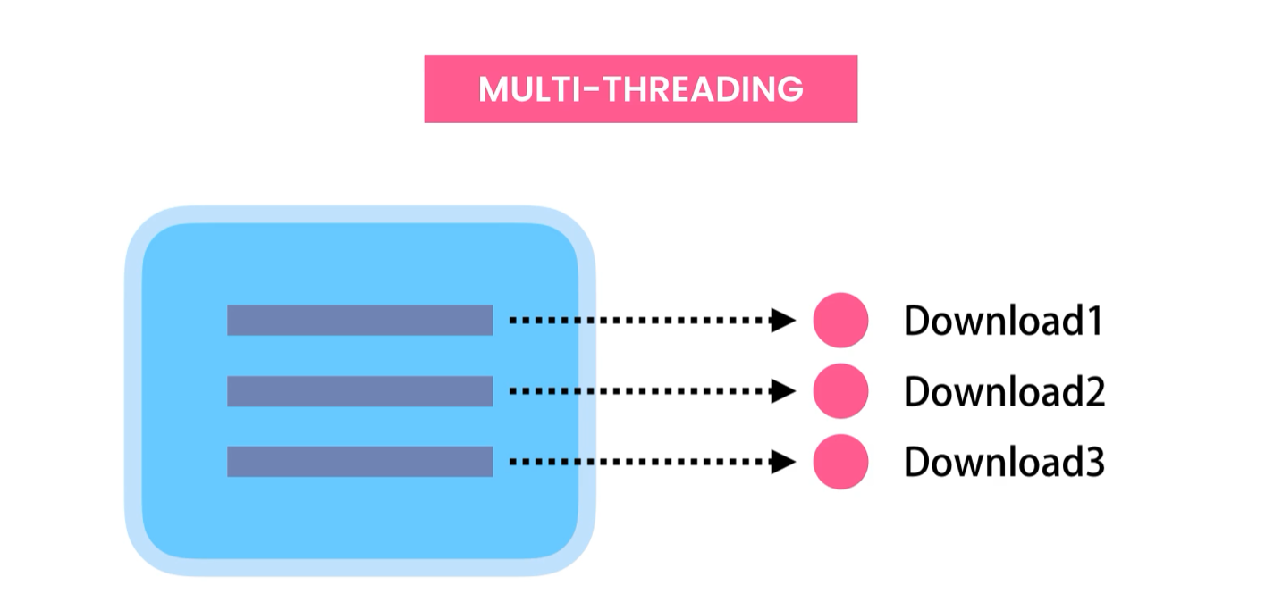

// Checking used and available Threads to JVM, each core can process 2 threads



OUTPUT:

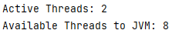



We need to create a class that implements the interface Runnable.

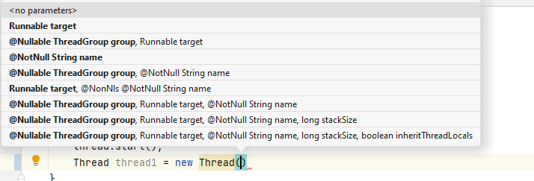

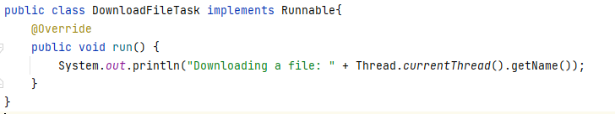

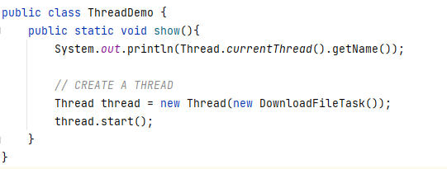

OUTPUT:

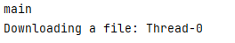

**Each thread:** starts -> execute a task -> dies

STARTING 10 THREADS

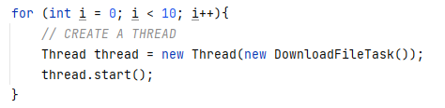

Threads runs in parallel

OUTPUT:

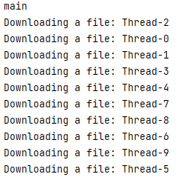



thread.sleep(long millis)

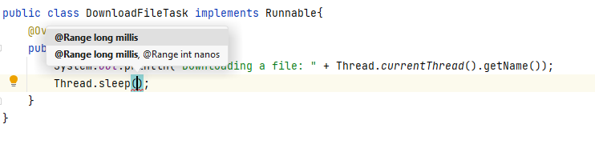



**joint()**

Let’s say, we want to scan a file after download, we do not know how long the download it will take ,we join the threads.

scanning could take a long time, so we should run it in a different thread.

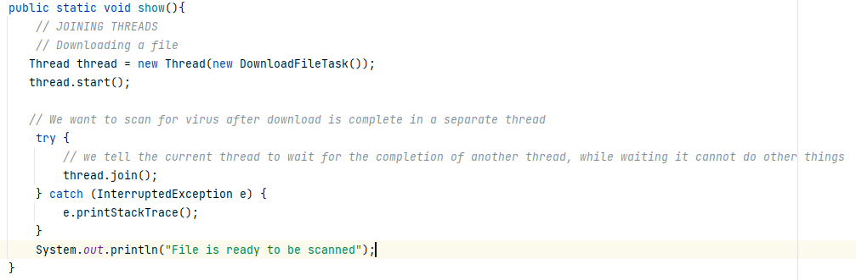



While dealing with long big task, we want to give the ability to the user to cancel.

Interrupt() does not force a thread to stop, it sends an interruption request



To check



If the thread is sleeping and we send an interruption request, it throws an exception. That is why we handle the following Exception.

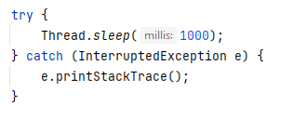



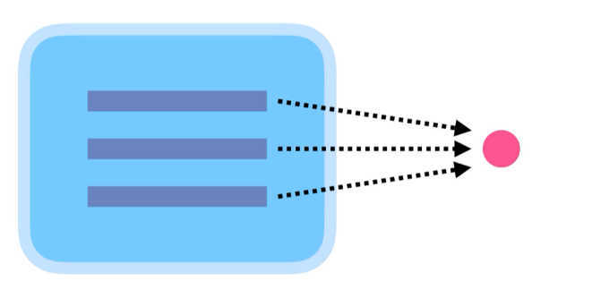In Real World, our threads may need to access and modify shared resources

Example:

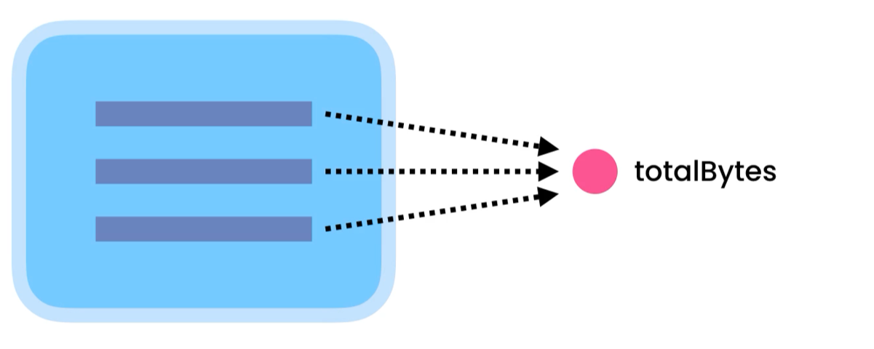

If multiple threads access the object and change it, we will have multiple issues.

1. Multiple threads changing the object at the same time

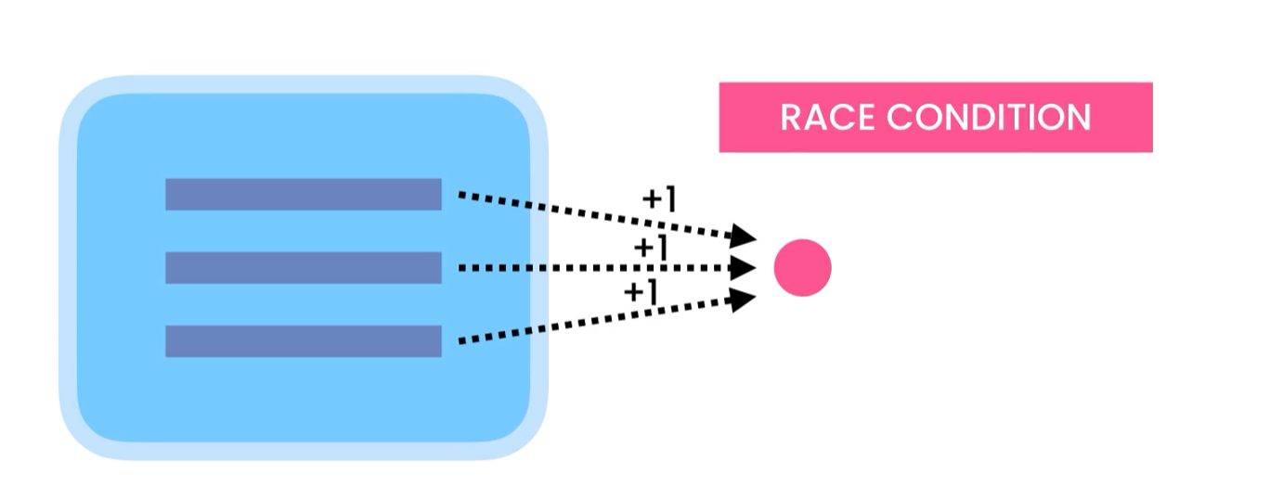

1. One thread changes the shared data, but the changes are no visible to other threads.

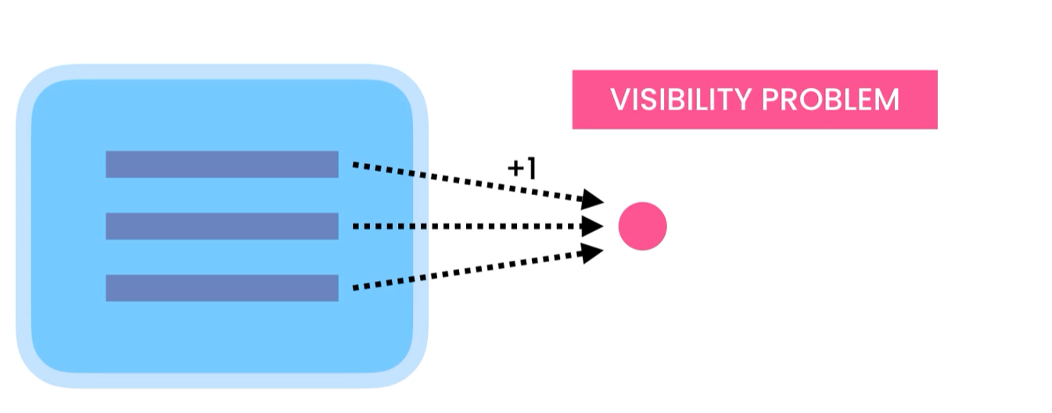



In the below code multiple threads are trying to access the same share obj -> status

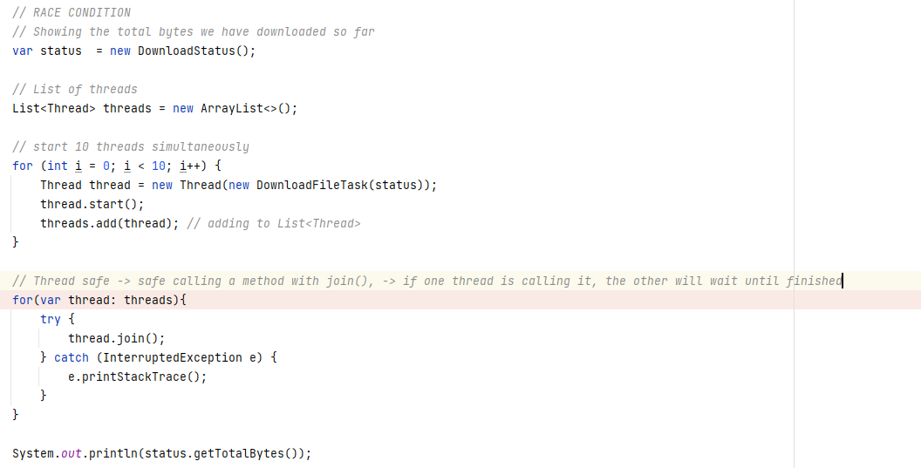

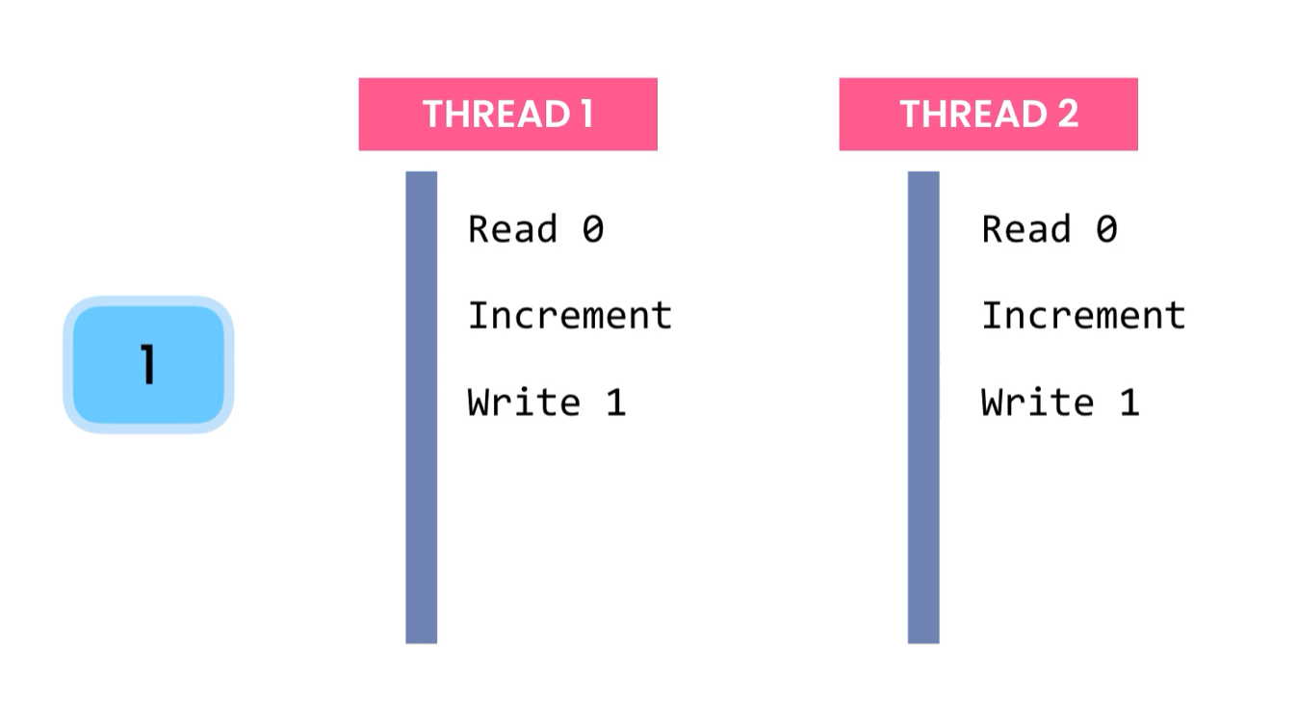



* **Confinement**
  + - Restrict each thread to have its own data

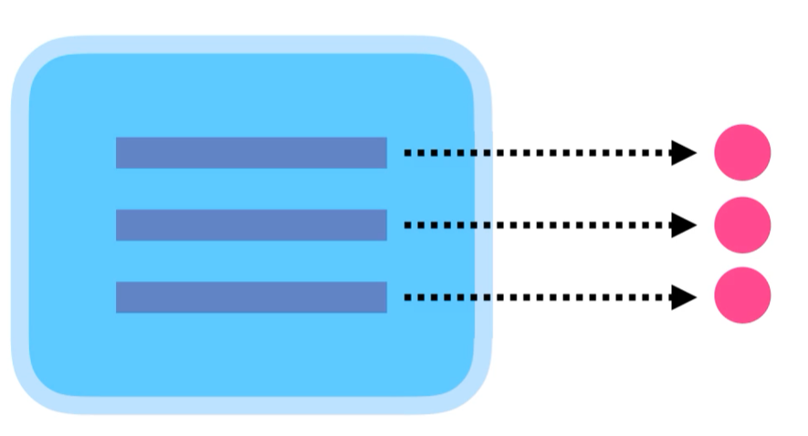

* **Immutability**
  + - Using immutable objects -> String
  + **Synchronization**
    - Synchronize or coordinate the access to an object using **LOCKS**

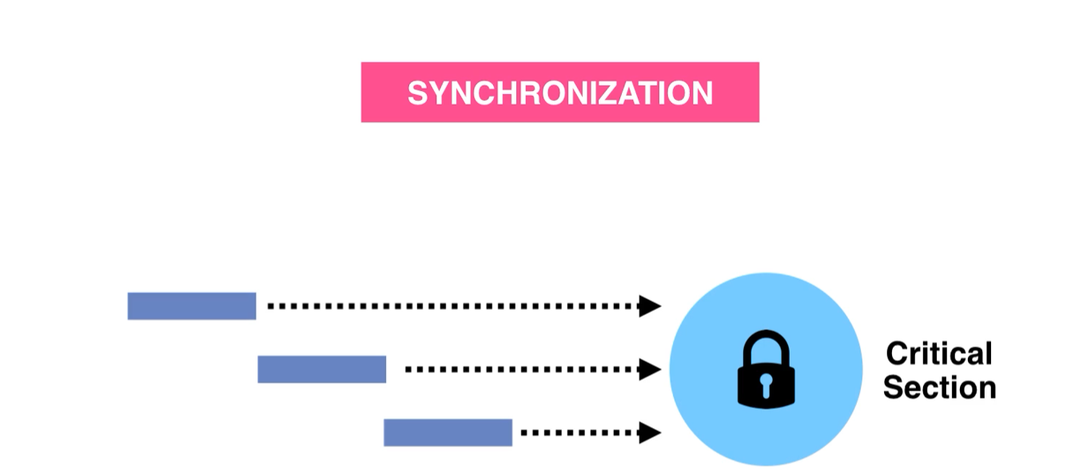

**SYNCHRONIZATION IS CHALLENGING AND ERROR PROMPT**

One of the errors: One thread waits for another indefinitely.

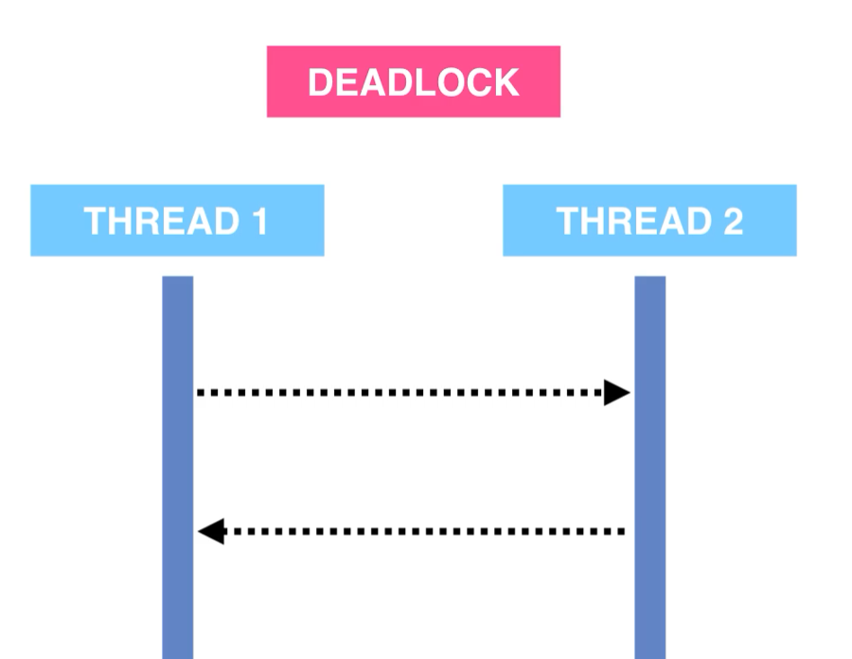

AVOID SYNCHRONIZATION

* **Atomic Objects**
  + Use Atomic Classes, we can have thread safety without using locks
* **Partitioning**
  + Partitioning data into segments, Java provides several collection classes that support concurrency

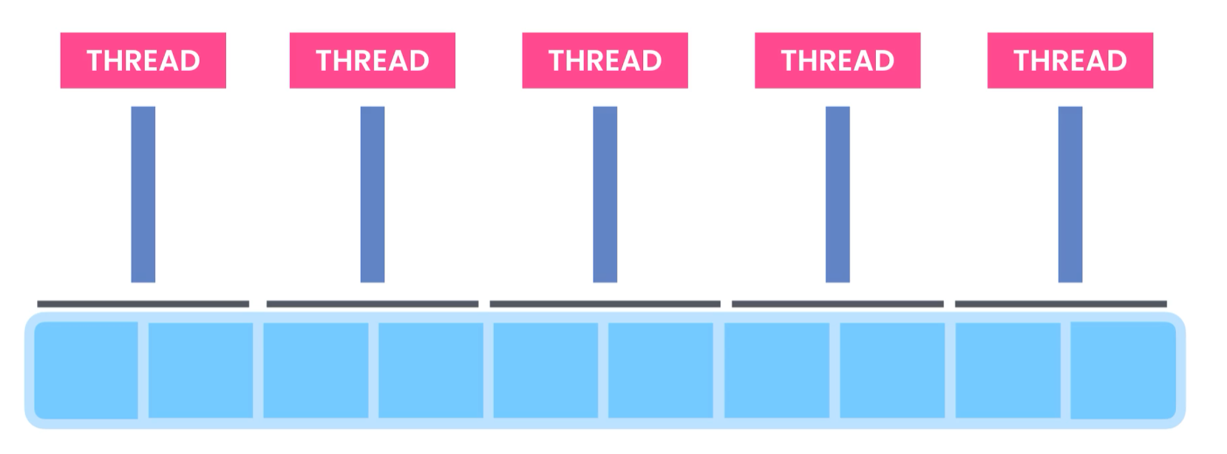



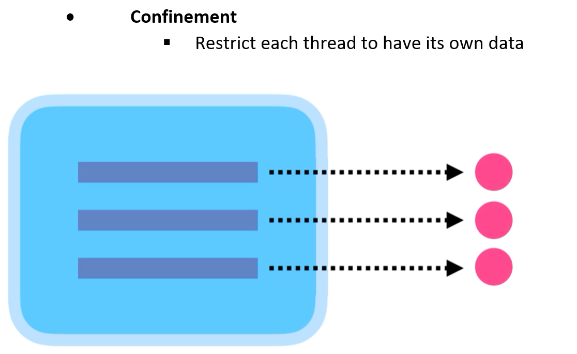

See source code: [**https://github.com/adrian3914/Mosh-Java-III/commit/67d58b1ee6e159428fa4d88b996a54d963253b5d**](https://github.com/adrian3914/Mosh-Java-III/commit/67d58b1ee6e159428fa4d88b996a54d963253b5d)

**Threads do not modify the same object, by returning a new DownloadStatus, we have a new obj for each thread.**

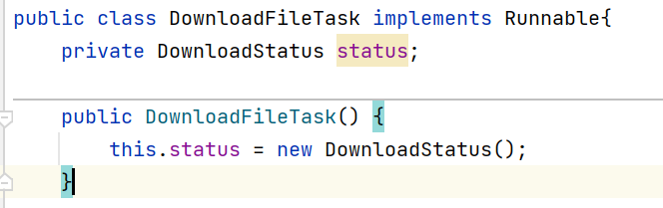



**We lock to the action that will modify our shared resource, this way only one Thread at the time will have access to it.**

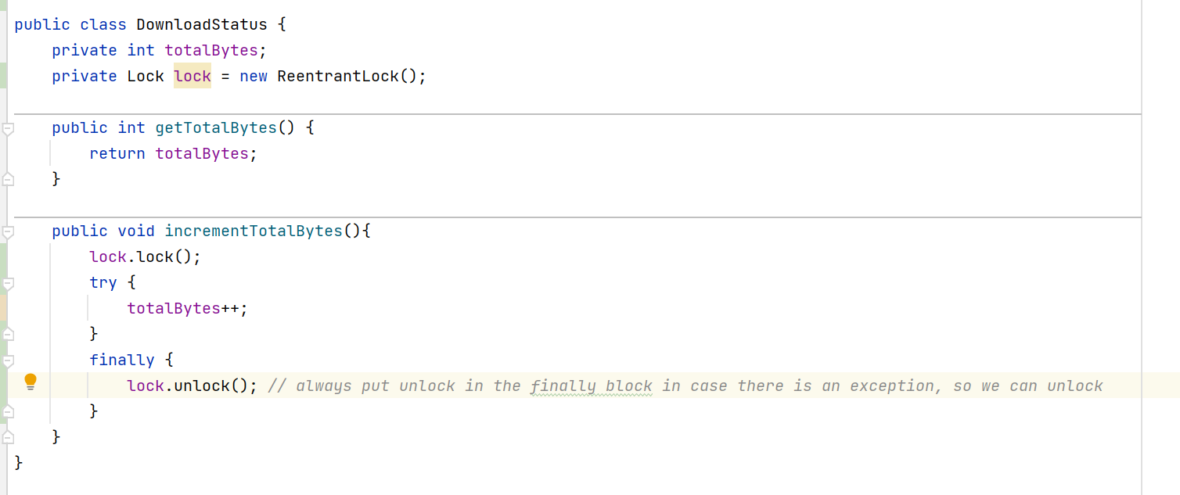

**ALWAYS PUT unlock () in a finally clause. So in case an exception is thrown we can unlock it.**



**Every object in java has a built-in lock**

**We can surround the code where the object field will be access with:**

**synchronized(monitorObj) {…}**

**example:**

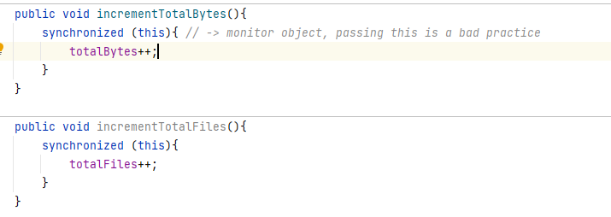

Using the **this** as the monitor object, if one thread is calling one of the methods, another thread cannot call the other since we are using the same monitor object.

We should use dedicated monitor objects for each synchronous method.

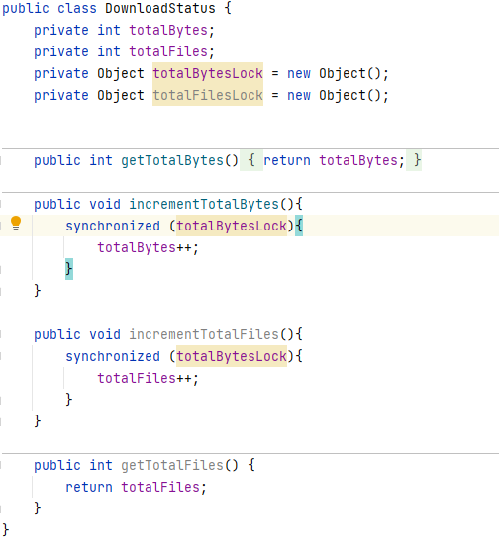

Another way of using the synchronized keyword. -> monitor object = **this (current object)**

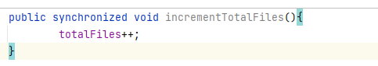



The volatile keyword solves the visibility problem but not the race condition. It ensures if one thread changes some data others can see the changes

**Volatile** -> unstable, we tell the JVM this field might change, so don’t rely on the value stored in the cache. Always read it from the main memory

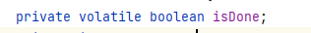

**Two threads read the value**

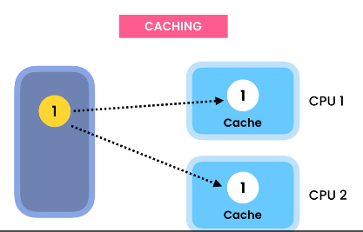

**One changes its value**

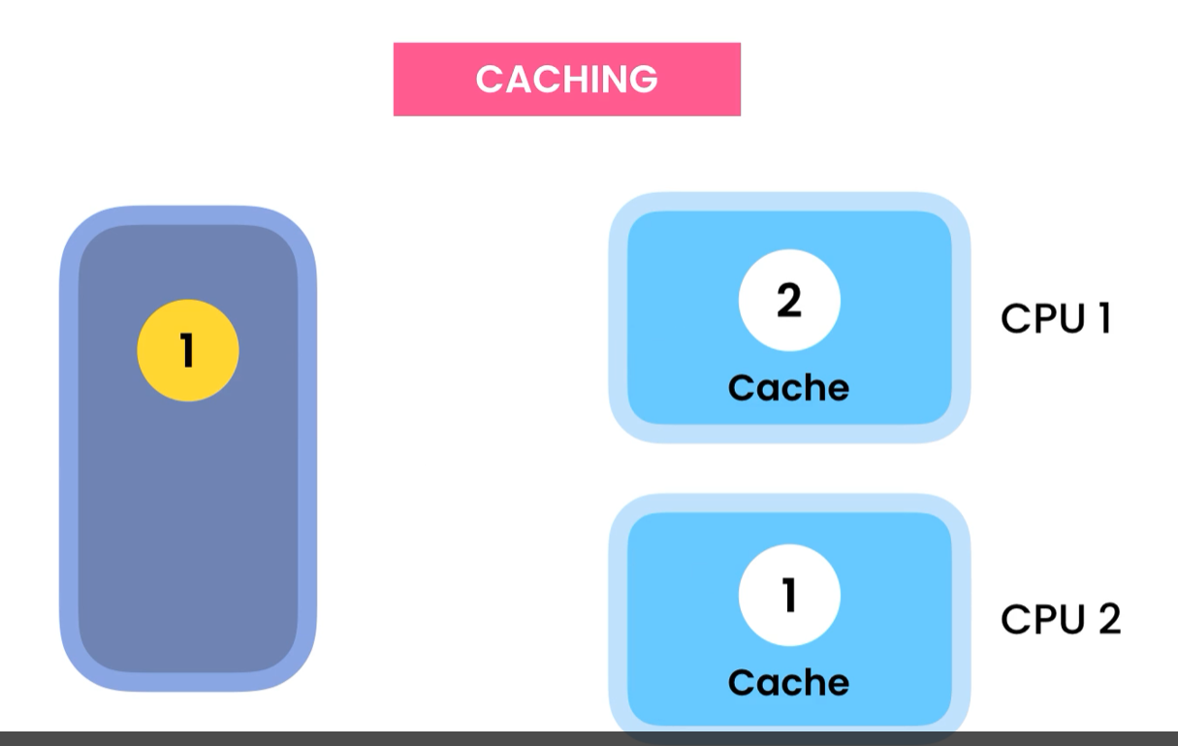

**The other doesn’t see the change. Since the change is in the main memory**

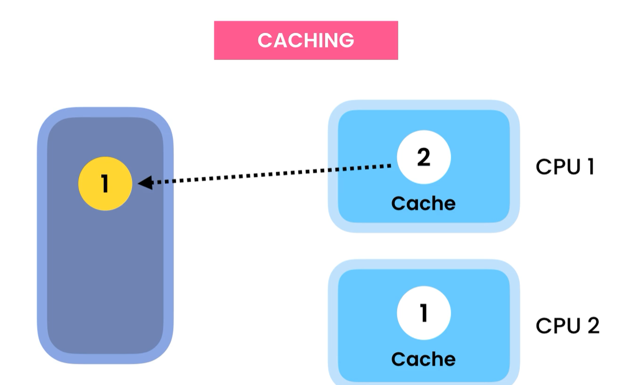



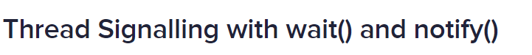

Every object in java has this wait() and notify() methods.



**The JVM expects to call the wait() method inside of a synchronized block**

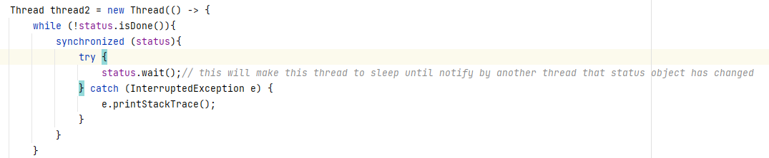

Notifying the thread, the state of status has changed. We use **notifyAll()** if multiple threads are waiting

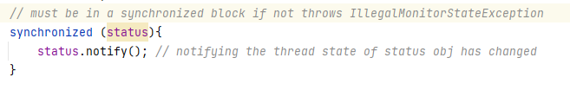

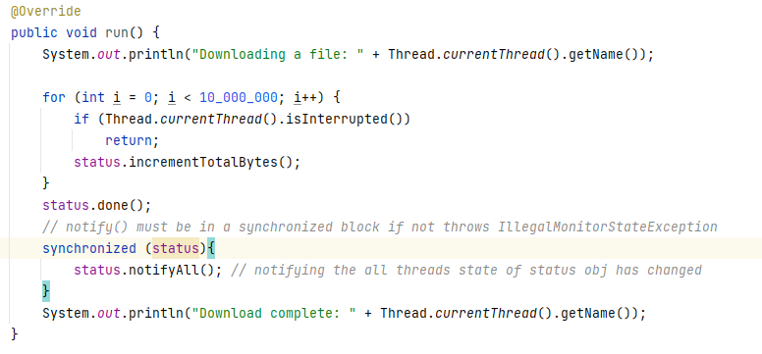

**We have better tools for synchronization, do not use this in new code**



Another way to achieve thread safe is using atomic objects.

**Atomic objects are great for implementing counters.**

Docs: <https://docs.oracle.com/javase/7/docs/api/java/util/concurrent/atomic/package-summary.html>

Non-Atomic, 3 Operations

totalBytes++;

* Get
* Increment
* Write

Using atomic classes, we can increase a value in an atomic way.

Changing int -> AtomicInteger



**Getter**

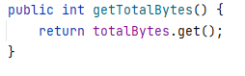

**Incrementing**

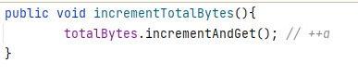



If we have multiple threads updating the value frequently is better to use one of the ADDERS classes in Java to avoid race condition.

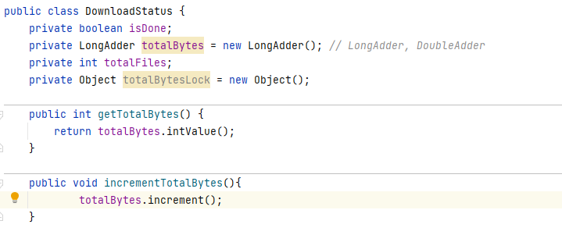



Sometimes we need to share a collection between many threads.

**Synchronized collection achieve thread safety by using locks, but it can have a negative impact on the performance as the number of threads increases.**

**Regular Collection**



**Synchronized Collection**



The synchronized collection wrapped a regular collection where its implementation has synchronized methods.

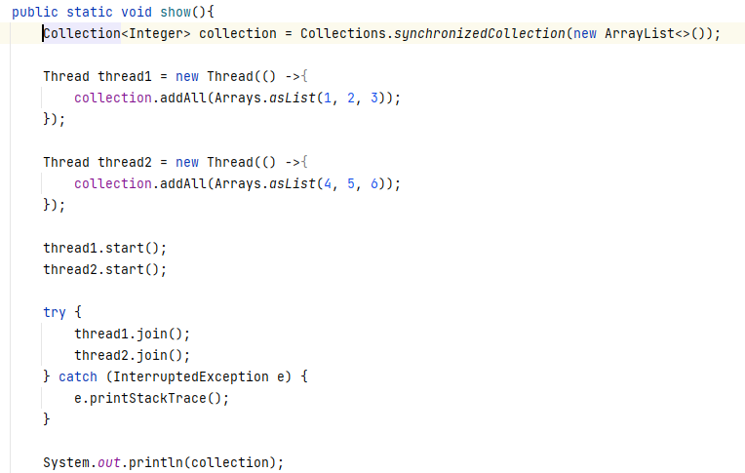

OUTPUT:



If we use a regular collection, we will lose changes made to it, since there is a race condition in the above code.

OUPUT

[1, 2 , 3]



Concurrent collection, classes that use the partitioning technique to allow concurrency so the divide the data into segments, and different threads can concurrently work with different segments, but only one thread at the time can access a given segment.

**Concurrent Collections are faster that synchronized collections because they do no use synchronization.**

Classes docs: <https://docs.oracle.com/javase/8/docs/api/index.html?java/util/concurrent/package-summary.html>

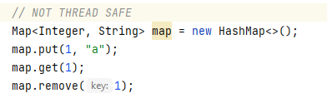

**We need to initialize our interface with one of the classes in the Concurrent collection that implements Map**

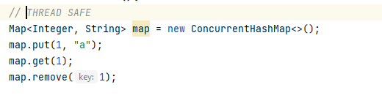

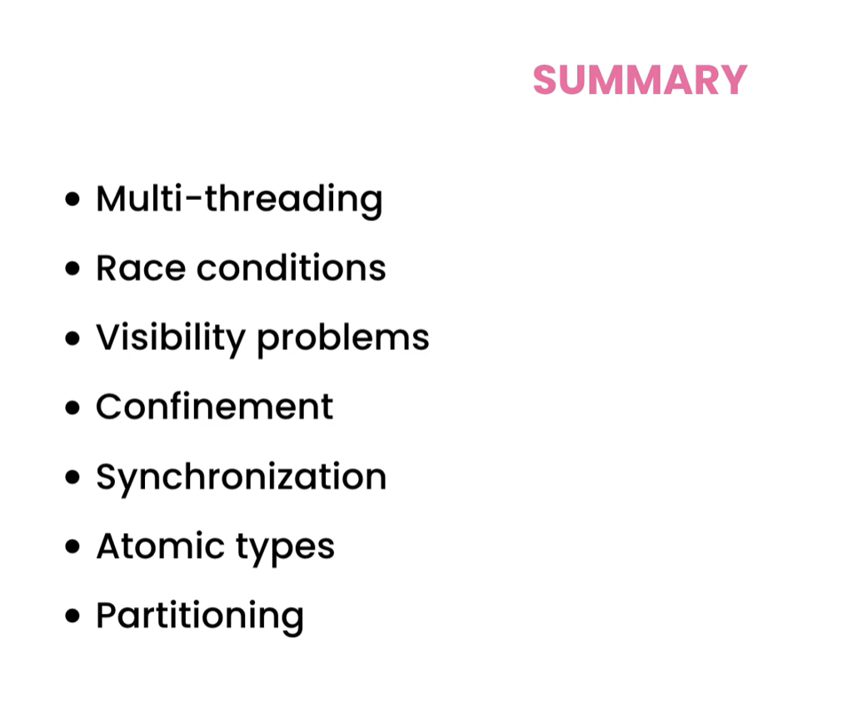



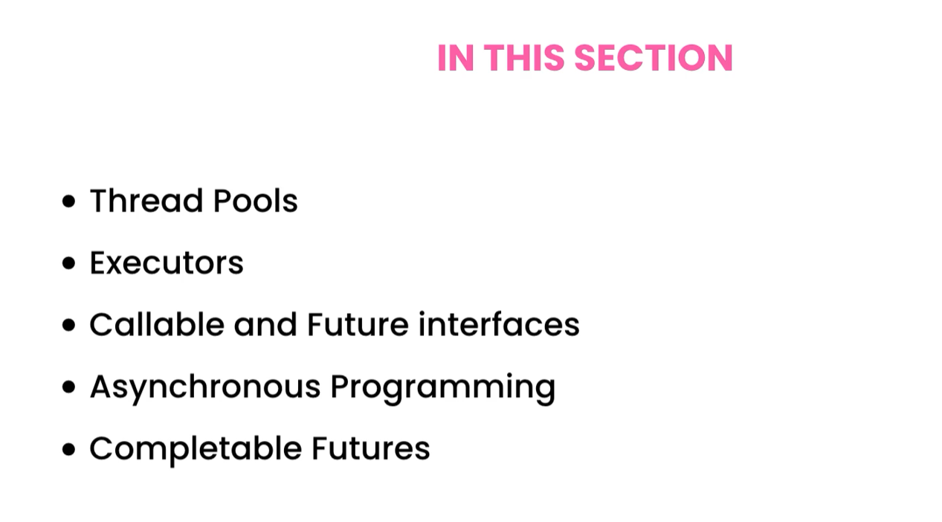



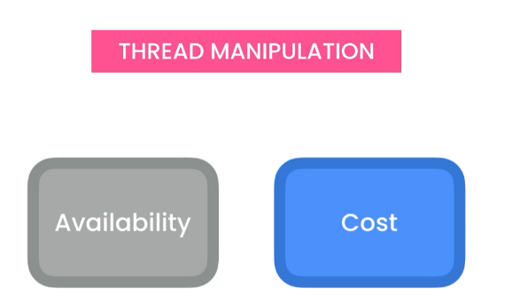

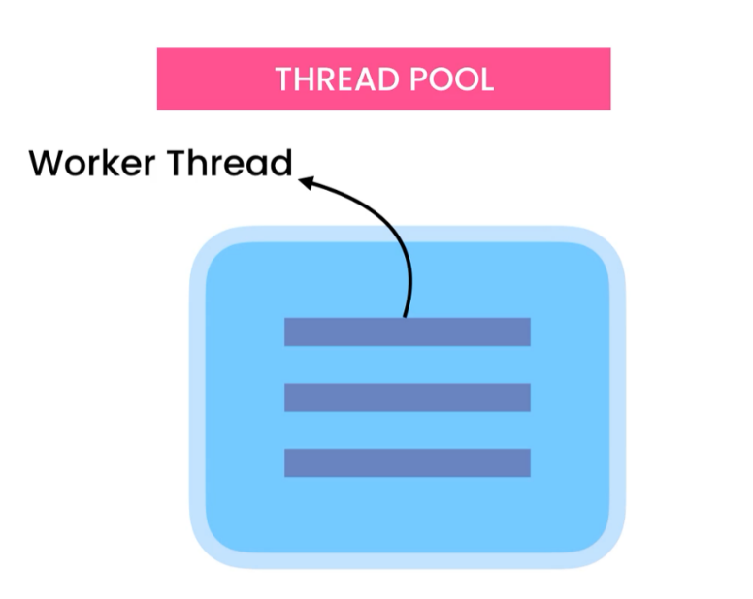**Pool of threads**

These threads are used to do some work and once it finishes, it goes back to the thread pool. They are not destroyed and recreated – fix amount of threads.

**If all threads are busy, the new task will wait in Queue**

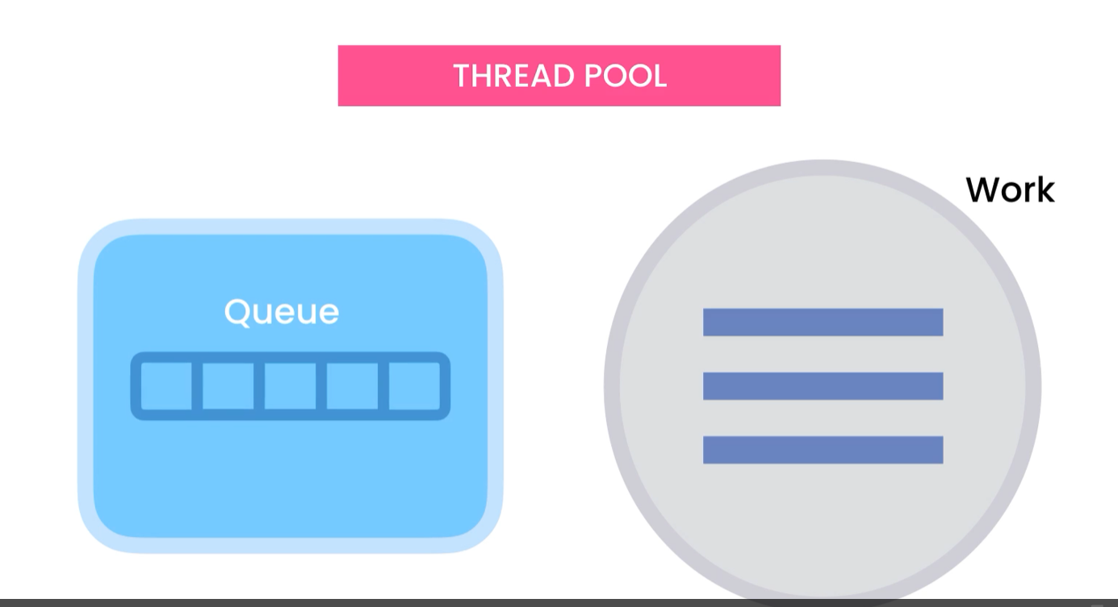

With this model, we do not need to worry about thread manipulation, we just submit our tasks to the thread pool.



The concept of thread pool is represented using the ExecutorService Interface

Doc Ref: <https://docs.oracle.com/javase/7/docs/api/java/util/concurrent/ExecutorService.html>

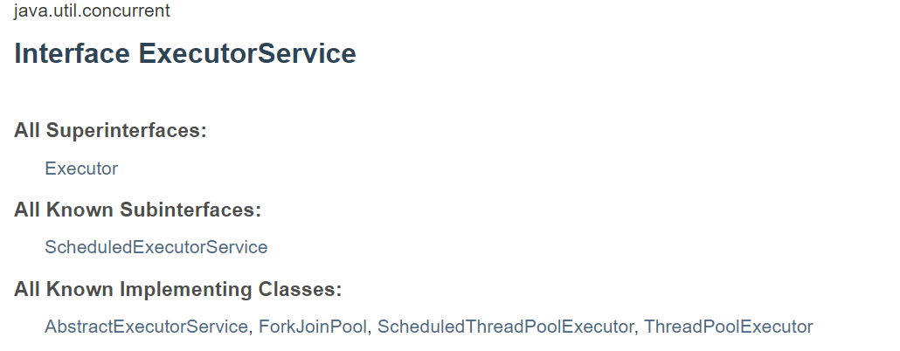

**This is the one we use must of the time.**



** We can schedule tasks to run after a delay or periodically**



**Splits a task into smaller tasks, then combines the result of each subtask to produce and overall result, DIVIDE AND CONQUER**

# Creating a thread pool -> using Executors Class static factory methods

We will use the static factory methods in Executors class, easier to create than using one of the classes that implement ExecutorService Interface. Too many arguments.

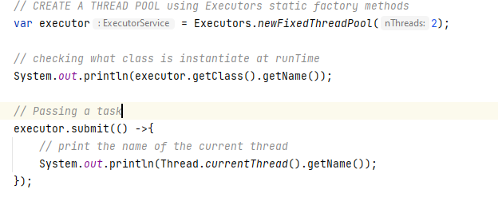

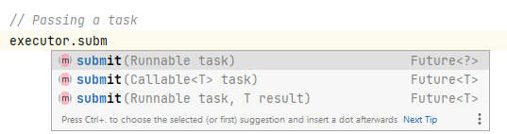

WE HAVE TO EXPLICITLY STOP THE PROGRAM

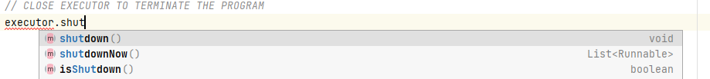

As best practice we should shutdown in a finally block, in case there is an exception thrown before.

Executors won’t provide thread safety, such a race condition and visibility problems, it simplify thread manipulation ONLY



Reference doc: <https://docs.oracle.com/javase/7/docs/api/java/util/concurrent/Callable.html>

**Passing a callable obj returns a value from a task.**



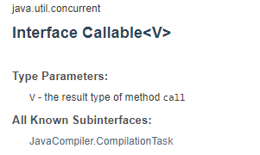

**CREATING A COMPLETABLE FUTURE**

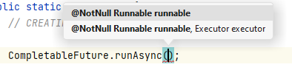

**If we do not pass an executor, it will run our task in a common pool (available cores * 2)**

** my case 4 * 2 = 8 pool of eight threads**  -> 8

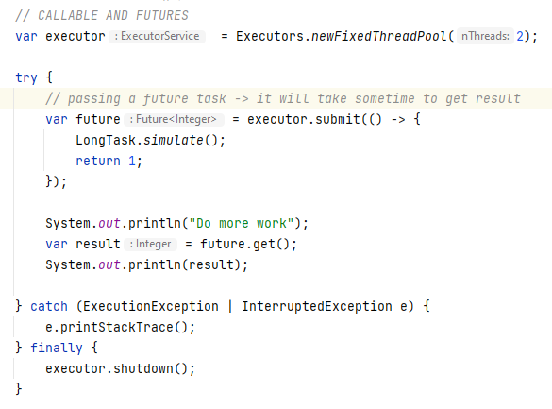

**OUTPUT**



**Waiting for result 3 seconds in this case**





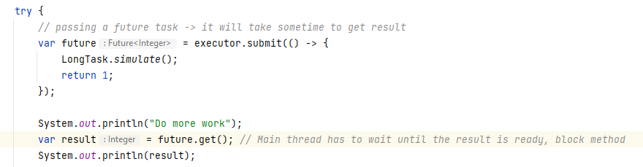



**We don’t want our main or other thread to wait for the completion of another thread as must as possible.**





**Doc Ref:** [**https://docs.oracle.com/javase/8/docs/api/java/util/concurrent/CompletableFuture.html**](https://docs.oracle.com/javase/8/docs/api/java/util/concurrent/CompletableFuture.html)





**Using runAsync does not return a value.**

**To return a value we call**

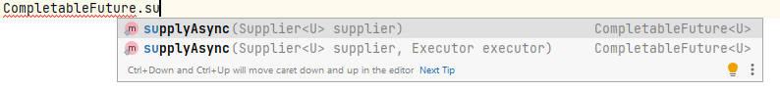

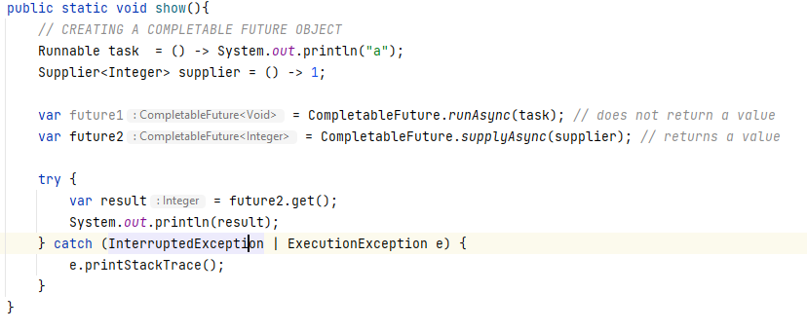



**Synchronous | Blocking code**

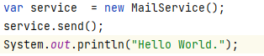

**Main thread waits -> 3 seconds**

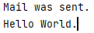

**In order to run a synchronous method in an asynchronous fashion we simple add Asynchronous and return the CompletableFuture<T>**

**Example:**

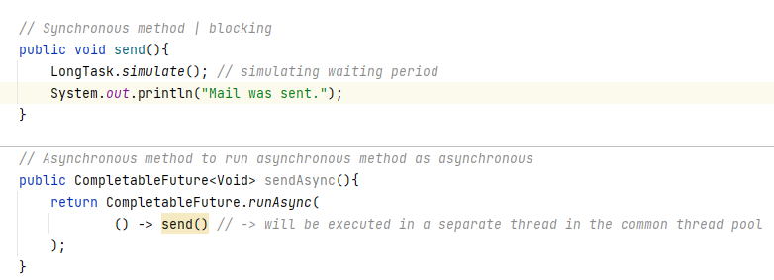

**Demo**

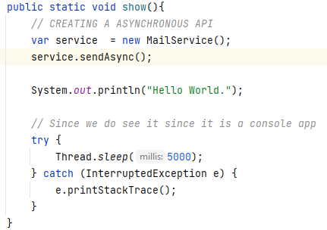

**OUTPUT:**

**Hello World.**

**Mail was sent.**



**If we want to run some code upon completion of some task we can use the methods thenRunAsync(), thenAcceptAsync()**

**We create a CompletableFuture Obj**



**We call the methods**

**Using the Async will do the task in a different thread NOT main**

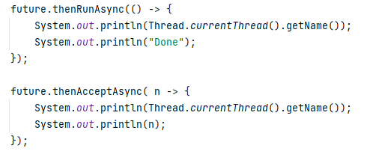

**Calling thenRun() and thenAccept(), will run in the Main thread.**

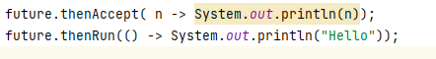



**Sometimes we must handle exceptions**

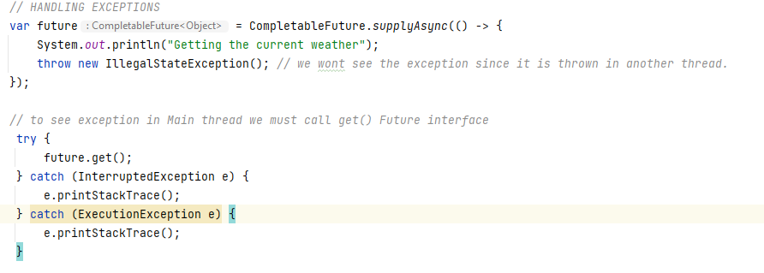

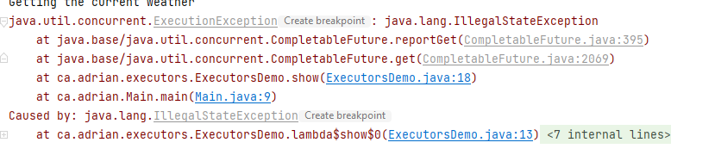

**How can handle if an exception is thrown**

**We use exceptionally()**

**This method will return a new CompletableFuture**

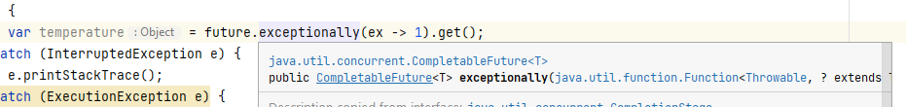

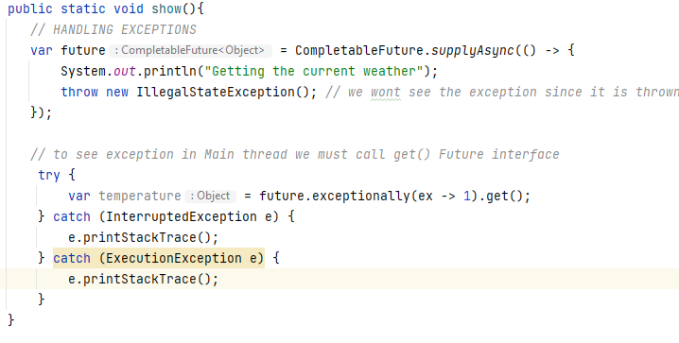

**No exception is thrown instead we get the default value 1.**



**Sometimes we need to transform a result of an asynchronous task. MAP IT**

**future.thenApply()**

**Example Weather service returns weather in Celsius we wat to show it in Fahrenheit**

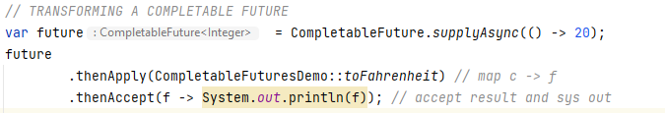



**Quite often we want to start a task upon completion of another task**